Appendices for Final Report  Advanced Vehicle-Based Countermeasures for Alcohol-Related Crashes | Document ID: N10-006 (appendices)  Author(s): John D. Lee, Dary Fiorentino, Michelle Reyes, Timothy L. Brown, Omar Ahmad, Robert Dufour, James Fell, Nic Ward  Date: May 14, 2010  National Advanced Driving Simulator  2401 Oakdale Blvd.  Iowa City, IA 52242-5003  Fax (319) 335-4658  © Copyright 2010 by the National Advanced Driving Simulator, The University of Iowa. All rights reserved.

Table of Contents
Appendix A: Phone Quantity, Frequency, Variability (QFV) A-1
Appendix B: Scenario Specifications Document B-1
Appendix C: Recruitment Materials C-1
Appendix D: Screening Procedures D-1
Appendix E: Audit Survey and Criteria E-1
Appendix F: Experimental Procedures for IMPACT main Study F-1
Appendix G: In-Cab Protocol G-1
Appendix H: Control Room Logs H-1
Appendix I: Informed Consent Document (Main IFC) I-1
Appendix J: Quantity, Frequency, Variability (QFV) Scale J-1
Appendix K: Driving Survey T2 K-1
Appendix L: Orientation Presentation L-1
Appendix M: Wellness Survey M-1
Appendix N: Realism Survey N-1
Appendix O: Sleep and Food Intake Survey O-1
Appendix P: Sample BAC Plots P-1
Appendix Q: Standard Field Sobriety Test Q-1
Appendix R: Sleepiness Scale R-1
Appendix S: Debriefing Statement S-1
Appendix T: Debriefing Questions T-1
Appendix U: Results U-1

Appendix A: Phone Quantity, Frequency, Variability (QFV)

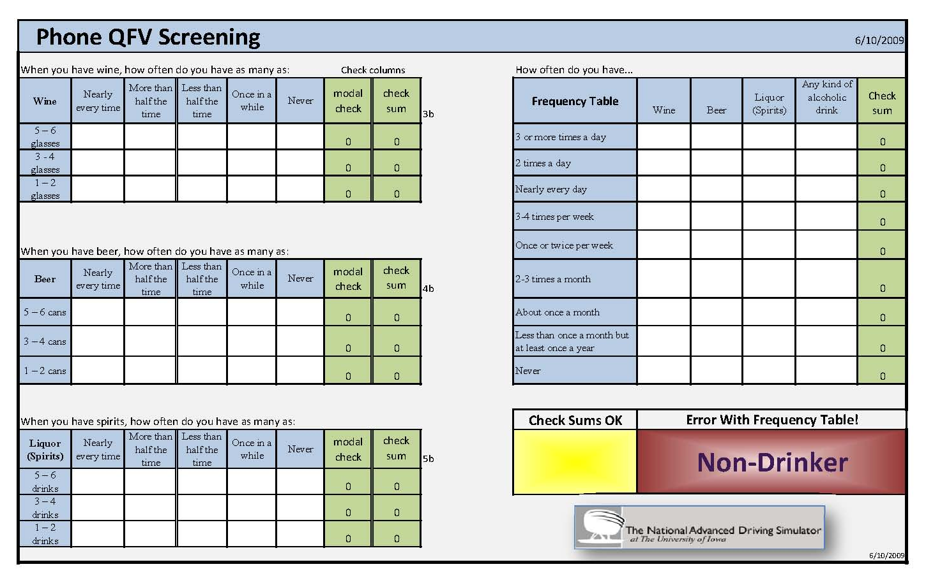
Q-F-V Scoring
CHART II
Q-V CLASS
Q-V CLASS | MODAL QUANTITY | MAXIMUM QUANTITY
1 | 5-6 | 5-6
2 | 3-4 | 5-6 less than half the time
3 | 3-4 | 5-6 once in awhile
4 | no mode | 5-6 less than half the time
5 | 3-4 | 3-4
6 | 1-2 | 5-6 less than half the time
7 | No mode | 5-6 once in awhile
8 | 1-2 | 5-6 once in awhile
9 | 1-2 | 3-4 less than half the time
10 | 1-2 | 3-4 once in awhile
11 | 1-2 | 1-2

CHART II
Q-F-V CLASS
Enroll ONLY individuals who are classified as a moderate or heavy drinker as defined below.
Q-F-V CLASS | FREQUENCY  (maximum frequency of any beverage | Q-V CLASS
Heavy drinkers | Three or more times a day | 1-11
 | Twice a day | 1-9
 | Every day or nearly every day | 1-8
 | 3-4 times a week | 1-5
 | 1-2 times a week | 1-4
 | 2-3 times a month | 1
Moderate drinkers | Twice a day | 10-11
 | Every day or nearly every day | 9-10
 | 3-4 times a week | 6-9
 | 1-2 times a week | 5-9
 | 2-3 times a month | 2-8
 | About once a month | 1-6

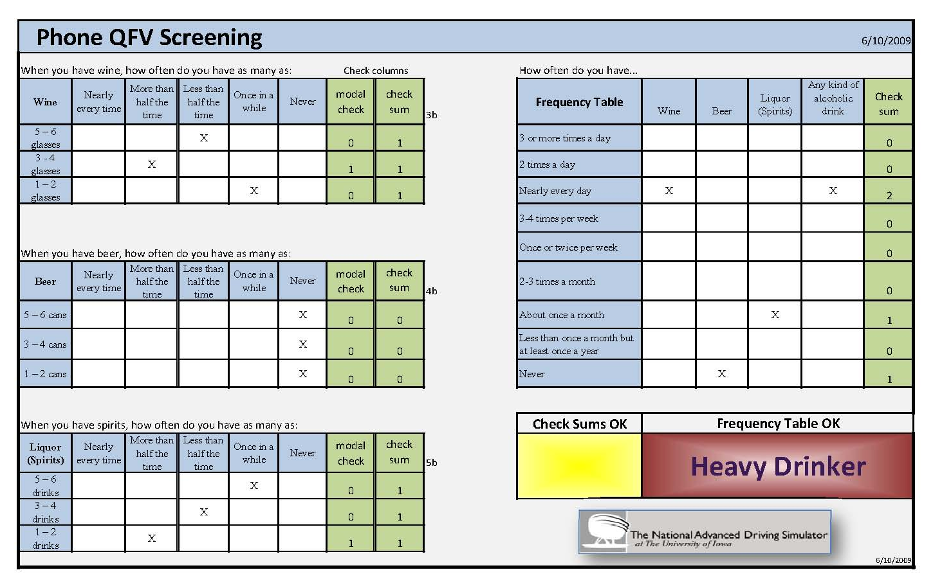

Appendix B: Scenario Specifications Document

SPECIFICATIONS DOCUMENT  NHTSA_IMPACT Task2 Scenario Specification | Document ID: N08-007  Author(s): David Heitbrink, Michelle Reyes, Julie Ulland, Omar Ahmad  Date: June 2008  National Advanced Driving Simulator  2401 Oakdale Blvd.  Iowa City, IA 52242-5003  Fax (319) 335-4658  © Copyright 2008 by the National Advanced Driving Simulator, The University of Iowa. All rights reserved.

List of Acronyms

BAC Blood Alcohol Concentration
CO Contract Officer
COTR Contract Officer’s Technical Representative
g/dL gram per deciliter
IRB Institutional Review Board
OEM Original Equipment Manufacturer
NADS National Advanced Driving Simulator
NHTSA National Highway Traffic Safety Administration
PI Principal Investigator
PM Program Manager
SDM Simulator Development Module
SOW Statement of Work
UI The University of Iowa
USDOT United States Department of Transportation
TOM Task Order Manager

Scenario/Experiment Overview

Introduction
The IMPACT study consists of three equivalent scenarios. Each scenario consists of a total of 19 events, and the estimated time of driving is about 25 minutes. Each scenario has urban, interstate, and rural settings.

Common Performance Measures
Each scenario is analyzed by computing common as well as scenario-specific performance measures. Scenario-specific measures are described within the individual scenario event descriptions, and the common measures are listed below.
Table 1 Definitions of dependent measures
Category |  | Dependent Measure | Source | Description
Lateral control
Input | Standard deviation of steering wheel position |  |  | Standard deviation of mean steering wheel position
 | Velocity of steering wheel |  |  | Mean absolute velocity in degrees per minute
 | Jerk of steering wheel |  |  | Mean absolute derivative of acceleration
 | Steering error |  |  | Deviation from Taylor series approximation
 | Steering wheel reversals |  | Mark Savino's thesis | Change from the negative (clockwise movement) to a positive (counterclockwise) rotational velocity OR the change from a positive rotational velocity to a negative rotational velocity. Absolute value of rotational velocity exceeds 3.0 degrees per second
 | Intersection turn signal use |  | (Crancer, Dille, Delay, Wallace, & Haykin, 1969) | Number of times participant used turn signal for left turn at light and right turn at stop sign
 | Highway turn signal use |  | (Crancer et al., 1969) | Ratio of lane changes while using turn signal in comparison to all lane changes
 | Transition turn signal use |  | (Crancer et al., 1969) | Number of times participant used turn signals in transitions
Output | Mean lane position |  | Triggs, & Redman, 1999) | Mean position in the lane relative to the center (positive to the right of center, negative to the left)
 | Standard deviation of lane position |  | (Gawron & Ranney, 1988; Ramaekers, Robbe, & O'Hanlon, 2000) | Standard deviation of mean lane position
 | Standard deviation of lane position from center |  | (Harrison, 2005) | Standard deviation of lane position from center of the lane
 | Time to line crossing |  |  | Mean absolute(s) toward lane boundary participant is headed toward lateral position/lateral velocity
 | Proportion of time TLC < 2 sec |  |  | Percentage of time TLC is less than 2 seconds for each lane boundary
 | 95% TLC |  |  | [5th] Percentile TLC
 | Exponentially weighted moving average of lane position |  |  | Mean lane position and previous few graphed over entire drive
 | Lateral acceleration |  |  | Change in velocity in lateral direction
 | Number of center line crossings |  |  | Number of times any part of the vehicle crossed the center line
 | Number of right line crossings |  |  | Number of times any part of the vehicle crossed the right line
 | Frequency of lane changes |  |  | Frequency per minute of when entire car switches from one lane to the other
Longitudinal control
Input |  | Accelerator holds |  | Percentage of time accelerator position is constant
 |  | Velocity of accelerator position |  | Velocity of changing accelerator position
 |  | Jerk of accelerator position |  | Derivative of acceleration
 |  | Standard deviation of accelerator position |  | Standard deviation of mean accelerator position
 |  | Mean brake force |  | Mean brake force applied
 |  | Standard deviation of brake force |  | Standard deviation of mean brake force
Output |  | Mean speed |  | Mean speed
 |  | Standard deviation of speed | (Arnedt, Wilde, Munt, & MacLean, 2001; Gawron & Ranney, 1988) | Standard deviation of mean speed
 |  | Deviation from Posted Speed Limit | (Arnedt, 2001) | Standard deviation of speed relative to posted speed limit
 |  | Exponentially weighted moving average of speed |  | Mean speed and previous few, graphed over entire drive
 |  | Time to collision (TTC) |  | Distance between front bumper of participant’s vehicle and the rear bumper of the vehicle in front divided by the difference in the two vehicles’ velocities
 |  | Time headway |  | Distance between front bumper of participant’s vehicle and the rear bumper of the vehicle in front divided by the velocity of the participant’s vehicle
 |  | Variation in time headway |  | SD of time headway
 |  | Did participant stop? (left turn, yellow light) |  | Minimum velocity
 |  | Stopping location |  | Location of front bumper when vehicle reached zero velocity
Event contingent
 |  | Time gap accepted | (Leung & Starmer, 2005) | Distance between the two vehicles divided by the speed of the second vehicle
 |  | Time between brake release and gap |  | The amount of time between when participant releases the brake and the front car’s rear bumper (car in front in gap chosen) is in line with participant’s car’s front bumper. Positive relates to releasing brake before gap is available, negative equates to after.
 |  | Time headway when centers of vehicles are in line |  | Time headway of second car in gap when center of participant’s vehicle is in line with the center of the second car in gap
 |  | Amount of time between initial stop to midpoint though intersection |  | Amount of time between first full stop and when midpoint of participant’s vehicle is in line with midpoint of second car in gap
 |  | Decision time | (Leung & Starmer, 2005) | Amount of time it took for participant to react to stimulus (ie: yellow light)
 |  | Number of traffic control violations | (Macdonald, Mann, Chipman, & Anglin-Bodrug, 2004) | Number of times participant violated traffic laws (speed limit, driving through red light, etc)
 |  | Number of collisions | (Flanagan, Strike, Rigby, & Lochridge, 1983) | Number of times participant’s vehicle collided with another object
 |  | Near misses |  | Number of times participant’s vehicle came within 2 feet of another object
 |  | Near misses | (Neale, 2002 ) 100 car study | Number of times a conflict situation requiring a rapid, severe evasive maneuver to avoid a crash occurred during the event
 |  | Degree of conflict | (Neale, 2002 ) 100 car study | Minimum time to contact
Smoothness: applicable to  acceleration, lane change |  | Delay time | (Ogata, 1997) | Time at which half settling (speed, lane position, etc.) is reached; see Figure 1
 |  | Rise time | (Ogata, 1997) | Time at which first reaches settling lane position, etc.); see Figure 1
 |  | Peak time | (Ogata, 1997) | Time the maximum (speed, lane position, etc.) occurs at; see Figure 1
 |  | Max overshoot | (Ogata, 1997) | The difference between the maximum and the settling lane position, etc); see Figure 1
 |  | Settling time | (Ogata, 1997) | The amount of time required for the lane position, to stay within a bounded allowable tolerance; see Figure 1
 |  | How well it fits the model (Robertson, 1996) |  | Correlation between model and performance of participant
Eye movement
Micro-movements |  | Horizontal gaze nystagmus | **NHTSA 2002 | Distance from center the jerkiness starts (in degrees?)
 |  | Smooth pursuit velocity | (Katoh, 1988) | Velocity of smooth pursuit eye movements
 |  | Smooth pursuit duration | (Moskowitz, Ziedman, & Sharma, 1976) | Time taken to smooth pursuit from one location to another
 |  | Smooth pursuit frequency | (Moskowitz et al., 1976) | Number of smooth pursuit movements per second
 |  | Smooth pursuit maximum velocity | (Stapleton, Guthrie, & Linnoila, 1986) | Maximum velocity of smooth pursuit eye movements
 |  | Smooth pursuit gain | (Fetter & Buettner, 1990) | Cumulative amplitude of smooth pursuit (subtracts away saccades) divided by the amplitude of the stimulus (%)
Statistical distribution |  | Standard deviation of gaze | (Victor, 2005) | Combine horizontal and vertical gaze position components using Pythagorean theorem
 |  | Another standard deviation of gaze | (Recarte, Nunes, 2000) | SD of horizontal gaze distribution * SD of vertical gaze distribution
 |  | Gaze kurtosis |  | The extent to which a frequency distribution is concentrated about its mean: “peakedness”
 |  | Dwell duration | (Moskowitz et al., 1976) | Total time the participant focused on a particular object
 |  | Frequency of rear view mirror glances | (Recarte & Nunes, 2000) | Frequency of participant’s glances at rear view mirror
 |  | Frequency of side mirror glances |  | Frequency of participant’s glances at side mirrors
 |  | Frequency of speedometer glances | (Recarte & Nunes, 2000) | Frequency of participant’s glances at speedometer
Event contingent |  | Glance direction (glance to hazards) |  | Number of times participant did not look at critical features or focused on unnecessary features
 |  | Head movement |  | Number of times participant did not look at critical features or focused on unnecessary features
 |  | Timing of participant looking at side mirror? |  | Amount of time between looking at mirror and taking action
 |  | Timing of participant looking at rear view mirror? |  | Amount of time between looking at mirror and taking action
 |  | Glance frequency at particular object |  | Number of times per minute participant glanced at particular object
Driver physical state
Postural stability |  | Pressure output (global and local) |  | Sum of pressures across all pressure points
 |  | Pressure and force over time |  | Distance between peak pressure points over time
 |  | Pressure point mapping |  | Location of peak pressure points
Eye blink |  | PERCLOS | (Hayami, 2002) | Percent eye closure
 |  | Eye blink frequency | (Beideman & Stern, 1977) | Number of blinks per minute
 |  | Eye blink duration | (Beideman & Stern, 1977) | Duration of eye blinks
Combined measures
 |  | Correlation between road curvature and eye movements | (Chattington, Wilson, Ashford, & Marple-Horvat, 2007) | Correlation between road curvature and eye movements
 |  | Correlation between eye movements and steering |  | Correlation between eye movements and steering
 |  | Correlation between steering and road curvature |  | Correlation between steering and road curvature
 |  | Correlation between eye movements and SDLP |  | Correlation between eye movements and SDLP
 |  | Correlation between head turn and steering wheel movement |  | Correlation between head turn and steering wheel movement

Table 2 Dependent measures by event
 |  | Events
 |  | Urban (1) |  |  |  |  |  | Highway (2) |  |  |  |  |  | Rural (3)
 | Dependent measure | 1 | 2 | 3 | 4 | 5 | 6 | 1 | 2 | 3 | 4 | 5 | 6 | 1 | 2 | 3 | 4 | 5 | 6 | 7
Lateral control
Input | SD of steering wheel position
 | Velocity of steering wheel
 | Jerk of steering wheel
 | Steering error
 | Steering wheel reversals
 | Intersection turn signal use
 | Highway turn signal use
 | Transition turn signal use
Output | Mean lane position
 | SD of lane position
 | SD from center
 | Time to line crossing (TLC)
 | Proportion of time TLC<2s
 | 95% TLC
 | Exponentially weighted moving average of lane position
 | Lateral Acceleration
 | Number of center line crossings
 | Number of right line crossings
 | Frequency of lane changes
Longitudinal
Input | Accelerator holds
 | Velocity of accelerator position
 | Jerk of accelerator position
 | SD of accelerator position
 | Mean brake force
 | SD of brake force
Output | Mean speed
 | SD of speed
 | Exponentially weighted moving average of speed
 | Time to collision (TTC)
 | Time headway
 | Variation in time headway
 | Did participant stop?
Event Contingent
Traffic related | Time gap accepted
 | Decision time
 | Number of traffic control violations
 | Number of collisions
 | Near misses
 | Degree of conflict
Smoothness | Delay time
 | Rise time
 | Peak time
 | Max overshoot
 | Settling time
 | How well it fits the model
Eye movement
Micro movements | Horizontal gaze nystagmus
 | Smooth pursuit velocity
 | Smooth pursuit duration
 | Smooth pursuit frequency
 | Smooth pursuit maximum velocity
 | Smooth pursuit gain
Statistical distribution | SD of gaze
 | Gaze kurtosis
 | Dwell duration
 | Frequency of rear view mirror glances
 | Frequency of side mirror glances
 | Frequency of speedometer glances
Event Contingent | Glance direction
 | Had movement
 | Timing of participant looking at side mirror
 | Timing of participant looking at rear view mirror
 | Glance frequency at particular object
Driver physical state
Postural stability | Pressure output (global and local)
 | Pressure and force over time
 | Pressure point mapping
Eye blink | PERCLOS
 | Eye blink frequency
 | Eye blink duration
Combined measures
 | Correlation between road curvature and eye movements
 | Correlation between eye movements and steering
 | Correlation between Steering and Road Curvature
 | Correlation between eye movements and SDLP
 | Correlation between head turn and steering wheel movement

Logstream Descriptions
A logstream is a data variable that can be set by the scenario. This is usually used to express in the data stream that the subject has reached a specific location or that a specific event has occurred.

Logstream 1: Event Count
Logstream 1 indicates a sequential count of scenario events from beginning to end. Since the order of events is different for the three equivalent scenarios, this number does not always correspond to the same scenario event.

Logstream 2: Event ID
Logstream 2 indicates the current active scenario event; each event has a unique ID that remains the same for each event across all three equivalent drives. The ID is 3 digits in length. The digit in the hundreds place is 1 for urban events, 2 for interstate events, and 3 for rural events. For example, for the second urban event, Logstream 2 is set to 102.

Logstream 3: Temporal Event Data
Logstream 3 indicates the occurrence of sub-events that have a temporal reference to the position of the subject vehicle or other objects or events in the scenario event. For example, information relating to the timing of stoplights is recorded in this logstream. The specific sub-events are described in the specification of each scenario event.

Logstream 4: Spatial Event Data
Logstream 4 indicates the occurrence of sub-events that have a spatial reference to the position of the subject vehicle or other objects or events in the scenario event. For example, this logstream will change when the subject vehicle is 500 ft from an intersection. The specific sub-events are described in the specification of each scenario event.

Logstream 5: Road Sub-Section
Logstream 5 indicates the current road section type. A value of:
- 11 indicates the participant is on an urban commercial segment
- 12 indicates the participant is on an urban residential segment
- 13 indicates the participant is on an urban section without parking
- 14 indicates the participant is leaving the residential section
- 21 indicates the participant is on an interstate entrance ramp
- 22 indicates the participant is on the interstate
- 23 indicates the participant is on the exit ramp
- 31 indicates the participant is on the rural lit segment
- 32 indicates the participant is on the rural unlit segment
- 33 indicates the participant is on the rural gravel segment
- 34 indicates the participant is on the driveway segment

Embed Audio
During the drive the participants will have prerecorded audio instructions played to them. The audio instructions will provide the participant with landmark-based navigational instructions. The restart instructions are played at the start of a “restart” drive. A restart drive is required if the participant misses a turn or makes an incorrect turn. The drive is restarted, and the participant is placed a short distance before the turn that was missed. The instruction number is the audio instruction that matches the value in the SCC_Audio_Trigger cell in the DAQ file.
Instruction Number | Title |  | Audio Message | Location Played
301 | Start Drive |  | Drive until you see the Shell gas station and then turn left at the intersection. | 125 ft after the participant pulls out.
302 | Urban Portion | Continue driving and take Interstate 30 South. |  | Shortly after beginning of Urban Event 106: Urban Curves
313 | Distraction 1 | At this time, please turn on the CD player, select track 17, then track 9, then press off. |  | As soon asparticipant gets within 5 seconds headway to the first heavy truck; no later than approximately 6500 ft from the end of the on-ramp
314 | Distraction 2 | At this time, please turn on the CD player, select track 2, then track 15, then press off. |  | Approximately 10000 ft from the end of the on-ramp
315 | Distraction 3 | At this time, please turn on the CD player, select track 6, then track 11, then press off. |  | Approximately 15000 ft from the end of the on-ramp
303 | Interstate 37 | Drive to the Highway 94 exit and continue towards Carbondale. |  | Start of Interstate Event 205: Interstate Curves
304 | Rural | Continue on Highway 94 and bear to the right after passing Earl’s service station. |  | 375 ft after start of Rural Event 302: Lighted Rural
305 | Destination | Your destination is the first residence on the right. |  | Start of Rural Event 306: Gravel Rural
306 | Stop | You have reached your destination. |  | 75 ft after entrance to driveway in Rural Event 307: Driveway
7 | Restart 1 | On the green light, drive until you see the Shell gas station and then turn left at the intersection. |  | The first intersection before Urban Event 105: Left Turn
322 | Restart 2 | Continue driving and take Interstate 30 South. |  | 500 ft before Interstate Event 201: Turn On Ramp
323 | Restart 3 | Drive to the Highway 94 exit and continue towards Carbondale. |  | Interstate Event 206: Exit Ramp
324 | Restart 4 | Continue on Highway 94 and bear to the right after passing Earl’s service station |  | Immediately after hairpin curve in Rural Event 304: Dark Rural
325 | Restart 5 | Continue on Highway 94 and bear to the right after passing Earl’s Service Station. |  | 500 ft before Rural Event 305: Gravel Transition

In-cab Instructions
The following instructions are given to the participants after they have been seated in the simulator cab and before they begin to drive.

Simulator motion
“The simulator is moving towards its start position. During this time you may hear rumbling and feel vibrations. This is perfectly normal. There are microphones in the cab so the simulator operator can hear you at all times. If for any reason you wish to stop driving, please let us know. The operator can bring you to a stop in just a few seconds.” This file is a recorded message that is played by the control room experimenter as the simulator is moving to the starting position.

Practice drive
“Your first drive will be a practice drive. It is designed to help you get used to the simulator. During this drive you should become familiar with driving at the various posted speed limits and recognizing traffic control devices. When it is time to begin, instructions will tell you to merge into traffic. Onboard navigational instructions will provide directions to the interstate. A recording will tell you when it is time to stop. Do you have any questions?” The ride-along experimenter reads these instructions before the start of the drive.

Data Collection Drive
“The main drive will start shortly. Remember to listen to the on-board instructions carefully. If you have any uncertainty about navigating during the drive, please ask. When the scenery comes on, please press on the brake, shift into drive and merge into traffic when it is safe to do so. Do you have any questions at this time?” (In-cab researcher responds to questions). The ride-along experimenter reads these instructions before the start of the drive.

Scenarios
This section describes the layout of the scenarios for this study. A scenario consists of several driving segments that combine to form an experimental drive. All scenarios in this study have three distinct driving segments in the following order: urban, interstate, and rural. The order of these segments remains the same in all scenarios. Only the order of the events within the segments changes between scenarios. Although the order of events changes between scenarios, the scenario is designed to remain similar in duration and comprises the same tiles. The urban section comprises three different versions of buildings, gas stations, and different rotations. The interstate and rural sections differences are related to curve direction and radii of curve. The table below illustrates the differences across the scenarios.

 | Scenario 1 | Scenario 2 | Scenario 3
1st Urban Intersection | 1 (rotation:0) | 2 (rotation: 90) | 3 (rotation: 180)
2nd Urban Intersection | 2 (rotation: 90) | 3 (rotation: 0) | 1 (rotation: 180)
3rd Urban Intersection | 3 (rotation: 0) | 2 (rotation: 90) | 1 (rotation: 180)
1st Freeway Curve | Left (4500) | Left (4500) | Right (3100)
2nd Freeway Curve | Right (3100) | Right (3100) | Left (4010)
3rd Freeway | Right (4010) | Left (4010) | Left (4500)
1st Rural Curve | Left (2100) | Right (2100) | Left (2100)
2nd Rural Curve | Right (456) | Left (456) | Right (456)
3rd Rural Curve | Left, Right (hill) (2446 total) | Left, Right (hill) (2446 total) | Left (3850)
4th Rural Curve | Left (3850) | Right (3850) | Left, Right (hill) (2446 total)

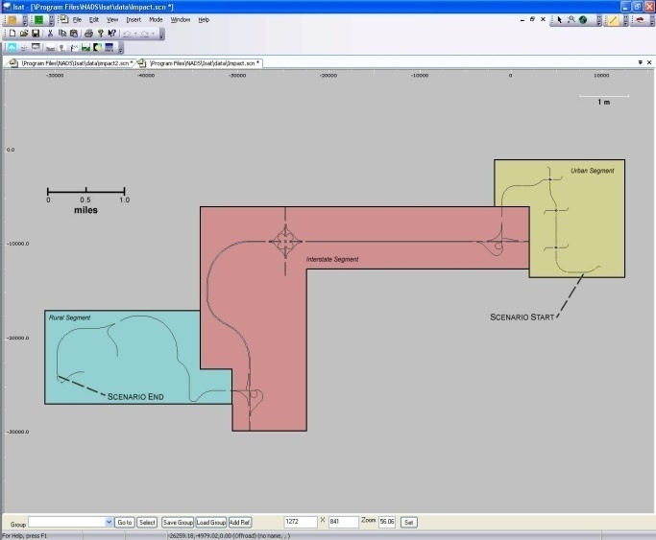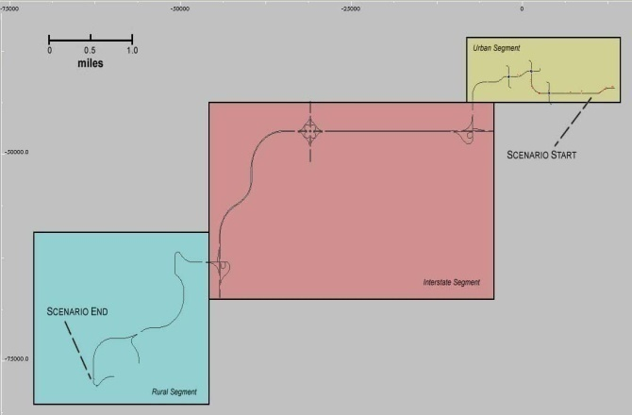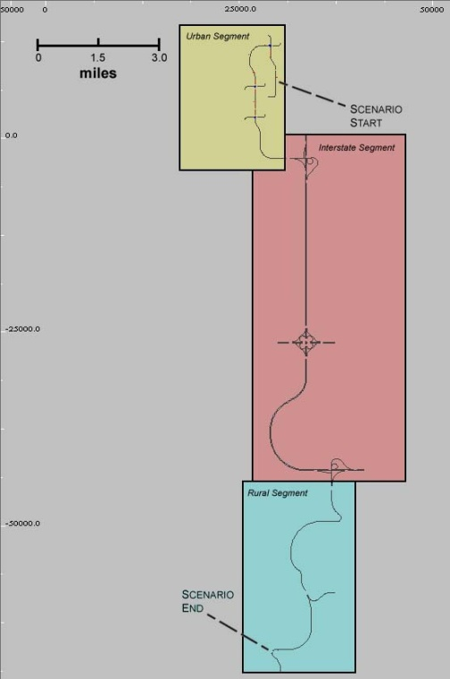
Figure 1 Road networks for Scenarios 1, 2, and 3 (counterclockwise from top)

The spatial and logical constraints require that the order of most events remains the same between scenarios. Those events that are different have been marked in gray in Table 3.

Table 3 Scenario event orders
Event | Scenario 1 | Scenario 2 | Scenario 3
1 | Urban Event 101: Pull Out | Urban Event 101: Pull Out | Urban Event 101: Pull Out
 |  | Urban Event 111: Urban Drive | Urban Event 111: Urban Drive
2 | Urban Event 102: Urban Drive | Urban Event 103: Green Light | Urban Event 105: Left Turn
3 | Urban Event 103: Green Light | Urban Event 102: Urban Drive | Urban Event 102: Urban Drive
4 | Urban Event 104: Yellow Light Dilemma | Urban Event 105: Left Turn | Urban Event 103: Green Light
5 | Urban Event 105: Left Turn | Urban Event 104: Yellow Light Dilemma | Urban Event 104: Yellow Light Dilemma
6 | Urban Event 106: Urban Curves | Urban Event 106: Urban Curves | Urban Event 106: Urban Curves
7 | Interstate Event 201: Turn On Ramp | Interstate Event 201: Turn On Ramp | Interstate Event 201: Turn On Ramp
8 | Interstate Event 202: Merge On | Interstate Event 202: Merge On | Interstate Event 202: Merge On
9 | Interstate Event 203: | Interstate Event 203: | Interstate Event 203:
10 | Interstate Event 204: Merging Traffic | Interstate Event 204: Merging Traffic | Interstate Event 204: Merging Traffic
11 | Interstate Event 205: Interstate Curves | Interstate Event 205: Interstate Curves | Interstate Event 205: Interstate Curves
12 | Interstate Event 206: Exit Ramp | Interstate Event 206: Exit Ramp | Interstate Event 206: Exit Ramp
13 | Rural Event 301: Turn Off Ramp (Transitional) | Rural Event 301: Turn Off Ramp (Transitional) | Rural Event 301: Turn Off Ramp (Transitional)
14 | Rural Event 302: Lighted Rural | Rural Event 302: Lighted Rural | Rural Event 302: Lighted Rural
15 | Rural Event 303: Transition to Dark Rural | Rural Event 303: Transition to Dark Rural | Rural Event 303: Transition to Dark Rural
16 | Rural Event 304: Dark Rural | Rural Event 304: Dark Rural | Rural Event 304: Dark Rural
17 | Rural Event 305: Gravel Transition | Rural Event 305: Gravel Transition | Rural Event 305: Gravel Transition
18 | Rural Event 306: Gravel Rural | Rural Event 306: Gravel Rural | Rural Event 306: Gravel Rural
19 | Rural Event 307: Driveway | Rural Event 307: Driveway | Rural Event 307: Driveway

Practice Drive
This scenario allows participants the opportunity to get familiar with the simulator and the study drive route. It comprises an urban section, an interstate ramp, and interstate driving. The drive begins in the urban area where participants are instructed to turn left at the first intersection and then listen to the navigational instructions provided. The practice route uses the same database as Scenario 1, with the exception of taking a different exit ramp.

Scenario 1
This scenario has three segments as shown in Figure 2. Each segment is shown in more detail in Figure 3, Figure 4, and Figure 5. Each figure is accompanied with a table that provides more detailed information about the duration and length of each event within the segment. It should be noted that the elevation throughout the scenario is the same with two exceptions: the exit ramp the participant takes and a curve in the rural segment. More detail is provided later.
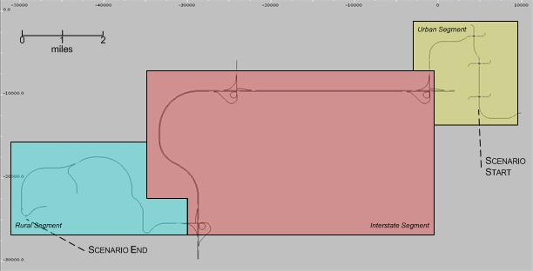
Figure 2 Scenario 1 road network

Urban Segment
The participant begins the urban portion of the scenario at the pullout event (location 101). The participant then continues through the events through the urban section (marked in yellow) toward the interstate segment.
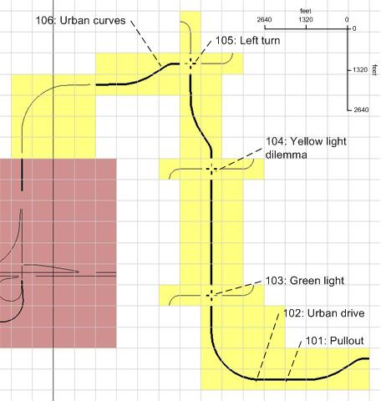
Figure 3 Segment 1, urban events
Table 4 indicates the distance required for each event and the approximate length of time that it takes a participant to traverse this segment at the posted speed limits. The urban events are designed to work at speeds from 15 to 45 mph.
Table 4 Scenario 1, urban segment times and distances
Event | Assumed Speed (mph) | Actual Distance (feet) | Cumulative Distance (feet) | Actual Time (minutes) | Cumulative Time (minutes)
101: Pull Out | 15 | 270 | 270 | 0.20 | 0.20
102: Urban Drive | 25 | 3670 | 3940 | 1.67 | 1.79
103: Green Light | 25 | 3970 | 7910 | 1.80 | 3.60
104: Yellow Dilemma | 25 | 3450 | 11360 | 1.57 | 5.16
105: Left Turn | 25 | 890 | 12250 | 0.40 | 5.57
106: Urban Curves | 30, 45 for last 400’ | 7310 | 19560
Total |  | 19300 |  | 8.31

Interstate Segment
Following the urban segment, the participant takes the on-ramp to get on the interstate.
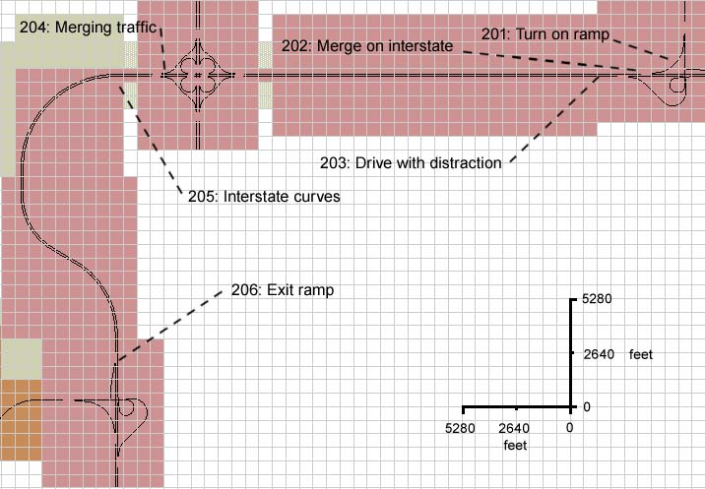
Figure 4 Segment 2, interstate events
Table 5 indicates the distance required and the approximate length of time that it takes a participant to traverse this segment at posted speed limits.

Table 5 Scenario 1, interstate segment times, and distances
Event | Assumed Speed (mph) | Actual Distance (feet) | Cumulative Distance (feet) | Actual Time (minutes) | Cumulative Time (minutes)
201: Turn On Ramp | 25 | 1000 | 1000 | 0.45 | 0.45
202: Merge On | 45 | 3500 | 4500 | 0.88 | 1.34
203: Drive with Distraction | 70 | 18000 | 22500 | 2.96 | 4.30
204: Merging Traffic | 70 | 6100 | 28600 | 0.99 | 5.29
205: Interstate Curves | 70 | 19300 | 47900 | 3.13 | 8.43
206: Exit Ramp | 35 | 1500 | 49400 | 0.49 | 8.91
Total |  | 49400 |  | 8.91

Rural Segment
Following the interstate segment, the participant takes the off-ramp to exit the interstate and takes a right turn at the intersection to turn toward the rural portion of the scenario.
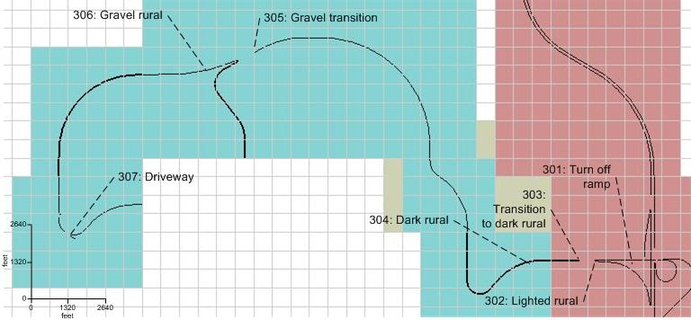
Figure 5 Segment 3, rural events
Table 6 indicates the distance required and the approximate length of time that it takes a participant to traverse this segment at posted speed limits.
Table 6 Scenario 1, rural segment times, and distances
Event | Assumed Speed (mph) | Actual Distance (feet) | Cumulative Distance (feet) | Actual Time (minutes) | Cumulative Time (minutes)
301: Turn Off Ramp | 30 | 1500 | 1500 | 0.5 | 0.5
302: Lighted Rural | 55 | 750 | 2250 | 0.15 | 0.65
303: Transition to Dark | 55 | 1500 | 3750 | 0.30 | 0.95
304: Dark Rural | 55 | 14510 | 18260 | 3 | 4
305: Gravel Transition | 55 | 2420 | 20680 | 0.5 | 4.5
306: Gravel Rural | 45 | 5940 | 26620 | 1.5 | 6
307: Driveway | 15 | 660 | 27280 | 0.5 | 6.5
Total |  | 27280 |  | 6.5

Scenario 2
The segments for this scenario are shown in Figure 6.
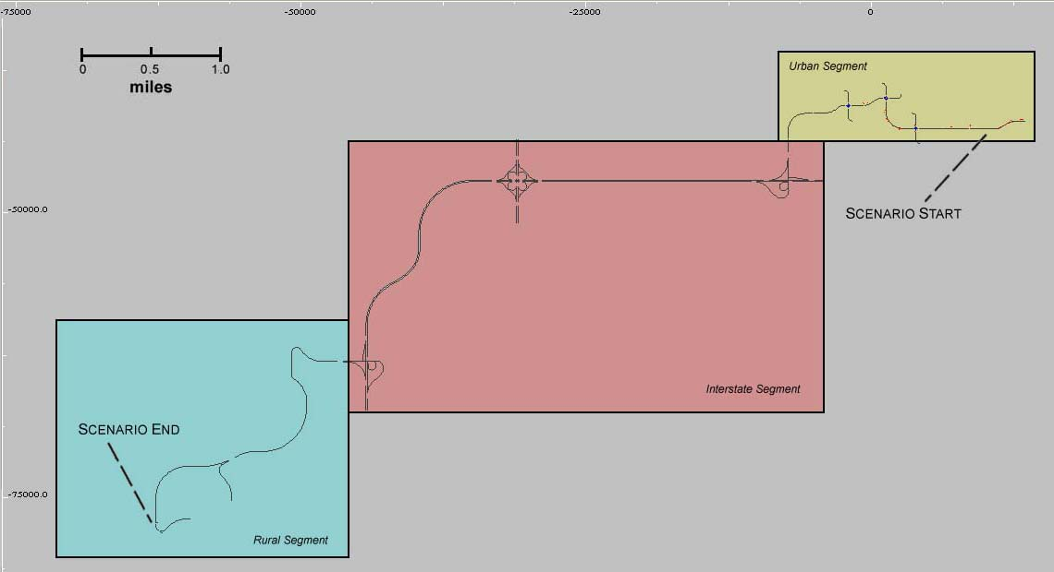
Figure 6 Scenario 2 road network

Scenario 3
The segments for this scenario are shown in Figure 7.
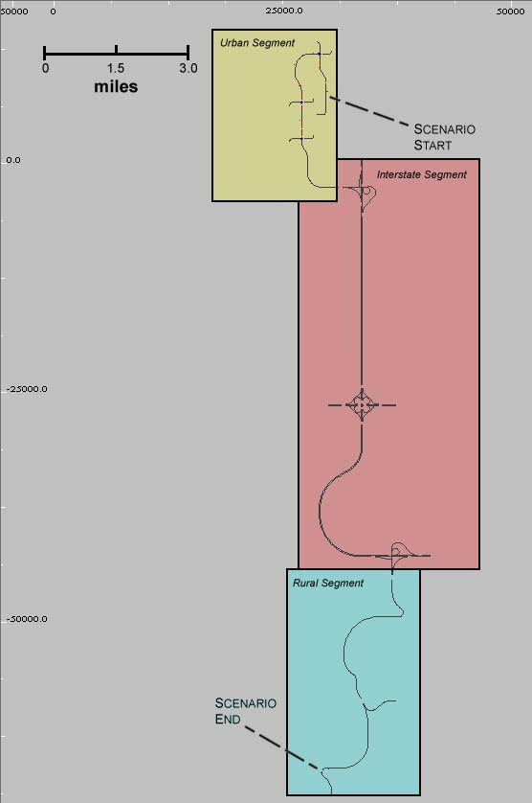
Figure 7 Scenario 3 road network

Event Specification
This section describes each event in detail. The order of the events will change across the three scenarios.

Urban Event 101: Pull Out
The vehicle is parallel parked along the side of the road. The participant will start the drive by pulling out onto a main road and driving in the same direction. The participant is pulling out into traffic with intermittent gaps. The gaps will vary in distance, and the participant will have to decide when to pull out.
Urban Event 101: Pull Out
Rationale | The assumption is that the participant is driving home at night after being at a bar. The drive starts from a parking spot parallel to the driving lane on an urban street. There are cars in front and behind the driver’s vehicle. He must look for traffic in the rear and pull out when it is clear. There is no FARS rationale for this, but it represents a typical situation for a drinking driver and presents some challenges for an impaired driver--judging the distance from the car in front and in the rear and pulling out onto the street when traffic is clear from behind. Police blotters are filled with complaints by citizens of damage to their cars while they were parked. Many impaired drivers strike these cars and then leave the scene. This is a judgment situation for the driver and comes in the first scenario event. Drivers can easily leave this parking spot when sober. When impaired at .08 BAC, it may present a challenge.
Road Network Requirements | Overall length/distance needed to support event (in feet): 660  Road type (lanes, surface): 2 driving lanes with on-road parking  Speed limit (in mph): 25  Curvature: none  Intersection type: none  Time of day/date: night
Preparation | The simulation starts; the participant is parked in parking lane 21.5 ft behind one vehicle and 137 ft in front of a second vehicle.  A series of cars pass the participant in the driving lane at varying gaps; the first gap that is presented is short  (The participant waits for a reasonable gap between cars to pull out )
Start Conditions | Start of Simulation
Actual Event | The simulation starts; logstream 1 is incremented, logstream 2 is set to 101, logstream 3 is set to 0, logstream 4 is set to 1, logstream 5 is set to 11. A series of cars is created behind the participant at the start of the drive. The cars are located approximately 60, 200, 465, and 1000 ft (CG to CG) behind the participant in the driving lane.  The participant pulls out once a reasonable gap has presented itself.  (The participant waits for a reasonable gap.)  (The participant pulls out into the driving lane.)  After participant has pulled out, a vehicle parked behind the driver pulls out into the driving lane.  After the participant crosses the back of the first parked car, logstream 4 is set to 100  Approximately 125 feet after the driver pulls out of the parking lane, instruction #1 is played.
End Conditions | The participant has pulled out into traffic and is 250 feet from the initial start location.
Cleanup | None
Scenario Performance  (Measures that indicate if the event is operating as expected) | Description | Identifier | Units
 | Length of gaps | E101_gap_d_X (where X is the gap number, 1-6) | ft
 | Length of gaps | E101_gap_t_X (where X is the gap number, 1-6) | Sec
 | Vehicle creation distance from subject | E101_vehX_create_d (where X is passing vehicle 1-6) | ft
 | Distance to vehicle parked in front of subject | E101_front_veh_d | ft
 | Distance to vehicle parked behind subject | E101_rear_veh_d | ft
Assumed Driver Behavior  (Measures that indicate whether the participant behaves according to the assumptions) | Description | Identifier | Units
 | Pull-out time (time from start of simulation until participant passes rear of forward parked car) | E101_pullout_t | sec
 | Time to finish accelerating (time from pull out until absolute value of acceleration averaged over 1 sec is less than a TBD threshold) | E101_acc_done_t | sec
 | Distance to finish accelerating (time from pull out until absolute value of acceleration averaged over 1 sec is less than a TBD threshold) | E101_acc_done_d | ft
 | Steering angle (min and max) | E101_steer_min  E101_steer_max | deg
 | Pulls forward (check to make sure participant does not put vehicle into reverse and back up before pulling out) | E101_pull_forward | binary  1=yes, 0 = no
Alcohol Impairment Indicators  (Measures that assess whether the event is sensitive to alcohol impairment) | Description | Identifier | Units
 | Number of head turns to left before pulling out (threshold angle that defines a turn needs TBD) | E101_head_turn | count
 | Number of glances at side mirror before pulling out (definition TBD once we have eye data) | E101_side_mirror | count
 | Number of glances at rear mirror before pulling out (definition TBD once we have eye data) | E101_rear_mirror | binary  1=yes, 0 = no
 | Time from last glance (head turn, side mirror, or rear mirror) until pullout | E101_last_glance | sec
 | Gap participant takes | E101_gap_taken  E101_gap_taken_d  E101_gap_taken_t | number  ft  sec
 | Collision | E101_collision | binary  1=yes, 0 = no
 | Collision object | E101_collision_obj | Text descriptor of object
 | Turn signal use | E101_turn_signal | Binary  1=yes, 0 = no
 | Smoothness of lane change | E101_smooth_lat
 | Smoothness of acceleration | E101_smooth_long
 | Degree of conflict
 | Velocity of steering wheel | E101_steer_vel
 | Jerk of steering wheel | E101_steer_jerk
 | Velocity of accelerator position | E101_accel_vel
 | Jerk of accelerator position | E101_accel_jerk
 | SD of accelerator position | E101_accel_sd
 | Pressure output (global and local) | E101_out_pres
 | Pressure and force over time | E101_force_pres
 | Pressure point mapping | E101_map_pres
 | PERCLOS | E101_perclos
 | Eye blink frequency | E101_blink_freq
 | Eye blink duration | E101_blink_dur
 | Percent in center based on median location of gaze | E101_cent_base
 | Correlation between head turn and steering wheel movement | E101_headturn_wheel
 | Number of collisions | E101_num_col
 | Near misses | E101_num_miss
 | Degree of conflict | E101_deg_conflict
 | Delay time | E101_delay_time
 | Rise time | E101_rise_time
 | Peak time | E101_peak_time
 | Max overshoot | E101_over_max
 | Settling time | E101_set_time
 | How well it fits the model | E101_model_fit
 | Smooth pursuit velocity | E101_smpur_vel
 | Smooth pursuit duration | E101_smpur_dur
 | Smooth pursuit frequency | E101_smpur_freq
 | Smooth pursuit maximum velocity | E101_smpur_maxvel
 | Smooth pursuit gain | E101_smpur_gain
 | SD of gaze | E101_gaze_sd
 | Gaze kurtosis | E101_gaze_kurt
 | Dwell duration | E101_dwell_time
Algorithm Input  (Measures that is input to the algorithm) | Description | Identifier | Units
 | Time from last glance (head turn, side mirror, or rear mirror) until pullout | E101_last_glance | sec
 | Gap participant takes | E101_gap_taken  E101_gap_taken_d  E101_gap_taken_t | number  ft  sec
 | Mean accelerator position
 | Time from last glance (head turn, side mirror, or rear mirror) until pullout
 | Smoothness of lane change
 | Smoothness of acceleration
- Jerk of accelerator position
- Jerk of steering wheel position
- Velocity of accelerator position
- Smoothness of lane change
- Over- or undershoot in lane position relative to nominal pullout maneuver
- Time from last glance (head turn, side mirror, or rear mirror) until pullout
- Max overshoot
- Minimum TTC to following vehicle during pullout
- Minimum TTC to parked vehicle ahead
- Relationship to passing vehicle as pullout
The major variables to take into consideration when comparing an alcohol-impaired driver and an unimpaired driver when pulling out of a parking space are: time from last glance until pulling out, how close the vehicle came to another moving vehicle, the smoothness of pulling out, max overshoot, and jerk and velocity of accelerator position. As a person pulls out of the parking space, looking for other traffic is essential to safe driving and is something that alcohol-impaired drivers tend to ignore**. The smoothness of lane change and max overshoot go hand in hand in the way a person pulls out of the parking space as unimpaired drivers will get into the lane fairly quickly and impaired drivers will have to adjust their position before settling on an adequate location (Stuster, 1997). Jerk and velocity of accelerator position look at how smoothly the participant pulled out of the parking space in a longitudinal perspective. Alcohol-impaired drivers have trouble slowing and speeding up in a smooth manner (Stuster, 1997).

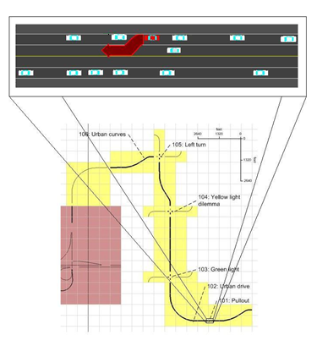

Figure 8 Participant pulling out: participant is driving the red vehicle

Urban Event 111: Urban Drive
The main street onto which the participant will have pulled out is relatively narrow, with cars parked on both sides of the road. This event exists only in drives 2 and 3. This section was added to give the participant space to get up to speed before the second event in the drive. There is oncoming traffic and traffic behind and in front of the participant.

Urban Event 111: Urban Drive
Rationale | This involves driving on a narrow urban road with parked cars on both sides and oncoming traffic about once every 10 seconds. FARS rationale includes over-representations in nighttime conditions on a dark but lighted road which is two lanes and undivided with oncoming traffic (over-representation of driving over center line). Impaired drivers also tend to drive too fast for these conditions.
Road Network Requirements | Overall length/distance needed to support event (in feet): 4620  Road type (lanes, surface): 2 driving lanes with on-road parking  Speed limit (in mph): 25  Curvature: 90 deg turn, radius of 1100 ft  Intersection type: none  Time of Day/Date: night
Preparation | The participant drives on a narrow urban road with parking on both sides of the street and oncoming traffic approximately once per 10 seconds  (The participant is traveling 25 miles per hour)
Start Conditions | End of previous event
Actual Event | Logstream 1 is be incremented, logstream 2 is set to 111, logstream 5 is set to 100  (The participant is traveling 25 miles per hour)  A lead vehicle is approximately 6 seconds ahead of the participant with a minimum speed of 15 and a maximum speed of 50, and maximum acceleration rate of 4.9 meters per second squared, and maximum deceleration of -0.68 meters per second squared.  A series of oncoming cars is created ahead of the participant at around one per 10 seconds; a few cars are behind the participant.  (The participant does not cross the center line.)
End Conditions | The participant is 500 ft from the next intersection.
Cleanup | None
Event Contingency  (Variables that define dependence of the current event on the interpretation of the previous event) | Description | Identifier | Units
 | Participant has finished accelerating from parking space before start of this event. | E101_acc_done | binary  1=yes, 0 = no
Scenario Performance  (Measures that indicate if the event is operating as expected) | Description | Identifier | Units
 | Minimum time headway to lead vehicle | E102_ttc_t_min | sec
 | Maximum time headway to lead vehicle | E102_ttc_t_max | sec
 | Oncoming traffic every 10 seconds | E102_oncoming_freq | avg. sec between cars
Assumed Driver Behavior  (Measures that indicate whether the participant behaves according to the assumptions) | Description | Identifier | Units
 | Speed (average, min, and max) | E102_sp_avg  E102_sp_min  E102_sp_max | Mph
 | Speed entering and leaving curve | E102_sp_init  E102_sp_end | Mph
Alcohol Impairment Indicators  (Measures that assess whether the event is sensitive to alcohol impairment) | Description | Identifier | Units
 | Lane Position | E102_lp_avg | Ft
 | SD of lane position (relative to mean lane position) | E102_lp_sd | Ft
 | SD of lane position (relative to center of lane) | E102_lpn_sd | Ft
 | Speed | E102_sp_avg | Mph
 | Speed (relative to posted or assumed speed limit) | E102_spn_avg | Mph
 | SD of speed (during “steady state”) relative to mean speed | E102_sp_sd | Mph
 | SD of speed (during “steady state”) relative to posted speed limit | E102_spn_sd | Mph
 | Number of center line crossings (any part of the car leaves the lane) | E102_center_cross | Count
 | Number of right line crossings (any part of the car leaves the lane) | E102_right_cross | Count
 | Did participant glance toward hazard X (hazards are described and numbered in 3.21)? | E102_haz_glance_X | binary  1 = yes, 0 = no
 | Steering wheel reversals | E102_steer_rev
 | SD of steering wheel position | E102_steer_sd
 | Velocity of steering wheel | E102_steer_vel
 | Jerk of steering wheel | E102_steer_jerk
 | Steering error | E102_steer_error
 | Time to line crossing (TLC) | E102_tlc
 | Proportion of time TLC>2s | E102_tlc_2 | proportion
 | 95% TLC | E102_tlc_95
 | Accelerator holds | E102_accel_holds
 | Velocity of accelerator position | E102_accel_vel
 | Jerk of accelerator position | E102_accel_jerk
 | SD of accelerator position | E102_accel_sd
 | Glance frequency at particular object | E102_freq_glance
 | Pressure output(global and local) | E102_out_pres
 | Pressure and force over time | E102_force_pres
 | Pressure point mapping | E102_map_pres
 | PERCLOS | E102_perclos
 | Eye blink frequency | E102_blink_freq
 | Eye blink duration | E102_blink_dur
 | Percent in center based on median location of gaze | E102_cent_base
 | Correlation between road curvature and eye movements | E102_eye_curve
 | Correlation between steering and road curvature | E102_steer_curve
 | Correlation between eye movements and SDLP | E102_eye_sdlp
 | Number of collisions | E102_num_col
 | Near misses | E102_num_miss
 | Smooth pursuit velocity | E102_smpur_vel
 | Smooth pursuit duration | E102_smpur_dur
 | Smooth pursuit frequency | E102_smpur_freq
 | Smooth pursuit maximum velocity | E102_smpur_maxvel
 | Smooth pursuit gain | E102_smpur_gain
 | SD of gaze | E102_gaze_sd
 | Gaze kurtosis | E102_gaze_kurt
 | Dwell duration | E102_dwell_time
 | Frequency of side mirror glances | E102_glance_freq_side
 | Frequency of speedometer glances | E102_glance_freq_speed
 | Glance direction | E102_glance_dir
Algorithm Input  (Measures that is input to the algorithm) | Description | Identifier | Units
 | SD of lane position
 | SD of speed
 | Steering wheel reversals
 | Number of center line crossings
 | Number of right line crossings

Urban Event 102: Urban Drive
The main street onto which the participant will have pulled out is relatively narrow, with cars parked on both sides of the road. There is oncoming traffic and traffic behind and in front of the participant.

Urban Event 102: Urban Drive
Rationale | This involves driving on a narrow urban road with parked cars on both sides and oncoming traffic about once every 10 seconds. FARS rationale include over-representations in nighttime conditions on a dark but lighted road which is two lanes and undivided with oncoming traffic (over-representation of driving over center line). Impaired drivers also tend to drive too fast for these conditions.
Road Network Requirements | Overall length/distance needed to support event (in feet): 4620  Road type (lanes, surface): 2 driving lanes with on-road parking  Speed limit (in mph): 25  Curvature: 90 deg turn, radius of 1100 ft  Intersection type: none  Time of Day/Date: night
Preparation | The participant drives on a narrow urban road with parking on both sides of the street and oncoming traffic approximately once per 10 seconds  (The participant is traveling 25 miles per hour)
Start Conditions | End of previous event
Actual Event | Logstream 1 is be incremented, logstream 2 is set to 102, logstream 5 is set to 100  (The participant is traveling 25 miles per hour)  A lead vehicle is approximately 6 seconds ahead of the participant with a minimum speed of 15 and a maximum speed of 50 and a maximum acceleration rate of 4.9 meters per second squared, and maximum deceleration of -0.68 meters per second squared.  A series of oncoming cars is created ahead of the participant at around one per 10 seconds; a few cars are behind the participant.  (The participant does not cross the center line.)
End Conditions | The participant is 500 ft from the next intersection.
Cleanup | None
Event Contingency  (Variables that define dependence of the current event on the interpretation of the previous event) | Description | Identifier | Units
 | Participant has finished accelerating from parking space before start of this event. | E101_acc_done | binary  1=yes, 0 = no
Scenario Performance  (Measures that indicate if the event is operating as expected) | Description | Identifier | Units
 | Minimum time headway to lead vehicle | E102_ttc_t_min | sec
 | Maximum time headway to lead vehicle | E102_ttc_t_max | sec
 | Oncoming traffic every 10 seconds | E102_oncoming_freq | avg. sec between cars
Assumed Driver Behavior  (Measures that indicate whether the participant behaves according to the assumptions) | Description | Identifier | Units
 | Speed (average, min, and max) | E102_sp_avg  E102_sp_min  E102_sp_max | Mph
 | Speed entering and leaving curve | E102_sp_init  E102_sp_end | Mph
Alcohol Impairment Indicators  (Measures that assess whether the event is sensitive to alcohol impairment) | Description | Identifier | Units
 | Lane Position | E102_lp_avg | Ft
 | SD of lane position (relative to mean lane position) | E102_lp_sd | Ft
 | SD of lane position (relative to center of lane) | E102_lpn_sd | Ft
 | Speed | E102_sp_avg | Mph
 | Speed (relative to posted or assumed speed limit) | E102_spn_avg | Mph
 | SD of speed (during “steady state”) relative to mean speed | E102_sp_sd | Mph
 | SD of speed (during “steady state”) relative to posted speed limit | E102_spn_sd | Mph
 | Number of center line crossings (any part of the car leaves the lane) | E102_center_cross | Count
 | Number of right line crossings (any part of the car leaves the lane) | E102_right_cross | Count
 | Did participant glance toward hazard X (hazards described and numbered in 3.21)? | E102_haz_glance_X | binary  1 = yes, 0 = no
 | Steering wheel reversals | E102_steer_rev
 | SD of steering wheel position | E102_steer_sd
 | Velocity of steering wheel | E102_steer_vel
 | Jerk of steering wheel | E102_steer_jerk
 | Steering error | E102_steer_error
 | Time to line crossing (TLC) | E102_tlc
 | Proportion of time TLC>2s | E102_tlc_2 | proportion
 | 95% TLC | E102_tlc_95
 | Accelerator holds | E102_accel_holds
 | Velocity of accelerator position | E102_accel_vel
 | Jerk of accelerator position | E102_accel_jerk
 | SD of accelerator position | E102_accel_sd
 | Glance frequency at particular object | E102_freq_glance
 | Pressure output(global and local) | E102_out_pres
 | Pressure and force over time | E102_force_pres
 | Pressure point mapping | E102_map_pres
 | PERCLOS | E102_perclos
 | Eye blink frequency | E102_blink_freq
 | Eye blink duration | E102_blink_dur
 | Percent in center based on median location of gaze | E102_cent_base
 | Correlation between road curvature and eye movements | E102_eye_curve
 | Correlation between steering and road curvature | E102_steer_curve
 | Correlation between eye movements and SDLP | E102_eye_sdlp
 | Number of collisions | E102_num_col
 | Near misses | E102_num_miss
 | Smooth pursuit velocity | E102_smpur_vel
 | Smooth pursuit duration | E102_smpur_dur
 | Smooth pursuit frequency | E102_smpur_freq
 | Smooth pursuit maximum velocity | E102_smpur_maxvel
 | Smooth pursuit gain | E102_smpur_gain
 | SD of gaze | E102_gaze_sd
 | Gaze kurtosis | E102_gaze_kurt
 | Dwell duration | E102_dwell_time
 | Frequency of side mirror glances | E102_glance_freq_side
 | Frequency of speedometer glances | E102_glance_freq_speed
 | Glance direction | E102_glance_dir
Algorithm Input  (Measures that is input to the algorithm) | Description | Identifier | Units
 | SD of lane position
 | SD of speed
 | Steering wheel reversals
 | Number of center line crossings
 | Number of right line crossings

- SD of lane position (relative to mean lane position)
- SD speed (relative to mean)
The major variables to take into consideration when comparing an alcohol-impaired driver and an unimpaired driver when going through a green lighted intersection are: SDLP and SD speed relative to mean speed. One of the most widely thought of behaviors of alcohol-impaired drivers is weaving around the lane. This can be represented by the variable SDLP, which has been shown to be sensitive to alcohol (Calhoun et al., 2005; Gawron & Ranney, 1988; Reed & Green, 1999). The same has been shown for variation in speed which can be measured by SD speed (Arnedt et al., 2001; Gawron & Ranney, 1988).

Urban Event 103: Green Light
The participant continues to drive down the narrow street with cars parked on both sides of the road with oncoming traffic and traffic behind the participant. The participant encounters an intersection with a green traffic light.

Urban Event 103: Green Light
Rationale | This scenario involves approaching an intersection where the light is green. The driver must drive through the intersection (no turns) with oncoming traffic. There is no specific FARS rationale for this, but it could involve some lane maintenance problems and some judgment problems that are described in the DWI Detection Guide.
Road Network Requirements | Overall length/distance needed to support event (in feet): 3080  Road type (lanes, surface): 2 driving lanes with on-road parking  Speed limit (in mph): 25  Curvature: none  Intersection type: 4 way  Time of Day/Date: night
Preparation | The participant approaches an intersection; the light is green  (The participant is traveling 25 miles per hour)
Start Conditions | The participant is 500 feet from the intersection
Actual Event | When the participant is 500 feet from the intersection, logstream 1 is incremented, logstream 2 is set to 103, logstream 4 is set to 1  When the participant is 250 feet from the intersection, logstream 4 is set to 2  As the participant crosses the stop line, logstream 4 is set to 3  The participant drives through the intersection, the light is green, and the participant experiences oncoming traffic  (The participant does not turn at the intersection)  (The participant is traveling 25 miles per hour)  Once the participant passes the stop line on the far side of the intersection, logstream 4 is set to 100
End Conditions | The participant is 500 feet from the next intersection
Cleanup | None
Event Contingency  (Variables that define dependence of the current event on the interpretation of the previous event) | Description | Identifier | Units
Scenario Performance  (Measures that indicate if the event is operating as expected) | Description | Identifier | Units
 | Distance from start of event to intersection | E103_start_d | ft
 | Distance from 250 ft logstream change to intersection | E103_250_d | ft
 | Scenario cars from left/right don’t enter intersection
 | Any oncoming cars go through light
 | Oncoming traffic (on average once every 6 sec) | E103_oncoming_freq | avg. sec between cars
Assumed Driver Behavior  (Measures that indicate whether the participant behaves according to the assumptions) | Description | Identifier | Units
 | SV goes through light | E103_go_thru | binary  1=yes, 0 = no
 | Speed (average, min, and max) as participant approaches intersection | E103_sp_avg  E103_sp_min  E103_sp_max | mph
 | Brake press | E103_brake_press | binary  1=yes, 0 = no
Alcohol Impairment Indicators  (Measures that assess whether the event is sensitive to alcohol impairment) | Description | Identifier | Units
 | Frequency of glances to own traffic light | E103_glance_freq_light | glances/sec
 | Frequency of glances to cross traffic light | E103_glance_freq_cross_light | glances/sec
 | Frequency of glances to traffic on left | E103_glance_freq_left | glances/sec
 | Frequency of glances to traffic on right | E103_glance_freq_right | glances/sec
 | Did participant glance toward hazard X (hazards TBD)? | E103_haz_glance_X | binary  1 = yes, 0 = no
 | Lane Position | E103_lp_avg | ft
 | SD of lane position relative to mean lane position | E103_lp_sd | ft
 | SD of lane position relative to center of lane | E103_lpn_sd | ft
 | Speed | E103_sp_avg | mph
 | Speed (relative to posted or assumed speed limit) | E103_spn_avg | mph
 | SD of speed relative to mean speed | E103_sp_sd | mph
 | SD of speed relative to posted speed limit | E103_spn_sd | mph
 | Number of center line crossings | E103_center_cross | count
 | Number of right light crossings | E103_right_cross | count
 | Head Turn |  | Binary 1=yes  0=no
 | SD of steering wheel position | E103_steer_sd
 | Velocity of steering wheel | E103_steer_vel
 | Jerk of steering wheel | E103_steer_jerk
 | Steering error | E103_steer_error
 | Steering wheel reversals | E103_steer_rev
 | Time to line crossing (TLC) | E103_tlc
 | Proportion of time TLC>2s | E103_tlc_2 | proportion
 | 95% TLC | E103_tlc_95
 | Accelerator holds | E103_accel_holds
 | Velocity of accelerator position | E103_accel_vel
 | Jerk of accelerator position | E103_accel_jerk
 | SD of accelerator position | E103_accel_sd
 | Glance frequency at particular object | E103_freq_glance
 | Pressure output(global and local) | E103_out_pres
 | Pressure and force over time | E103_force_pres
 | Pressure point mapping | E103_map_pres
 | PERCLOS | E103_perclos
 | Eye blink frequency | E103_blink_freq
 | Eye blink duration | E103_blink_dur
 | Percent in center based on median location of gaze | E103_cent_base
 | Correlation between road curvature and eye movements | E103_eye_curve
 | Correlation between steering and road curvature | E103_steer_curve
 | Correlation between eye movements and SDLP | E103_eye_sdlp
 | Number of collisions | E103_num_col
 | Near misses | E103_num_miss
 | Smooth pursuit velocity | E103_smpur_vel
 | Smooth pursuit duration | E103_smpur_dur
 | Smooth pursuit frequency | E103_smpur_freq
 | Smooth pursuit maximum velocity | E103_smpur_maxvel
 | Smooth pursuit gain | E103_smpur_gain
 | SD of gaze | E103_gaze_sd
 | Gaze kurtosis | E103_gaze_kurt
 | Dwell duration | E103_dwell_time
 | Frequency of side mirror glances | E103_glance_freq_side
 | Frequency of speedometer glances | E103_glance_freq_speed
 | Glance direction | E103_glance_dir
 | Head movement | E103_head_mov
Algorithm Input  (Measures that is input to the algorithm) | Description | Identifier | Units
 | SD of lane position relative to mean
 | SD of speed relative to mean
 | SD of speed relative to posted
 | Steering wheel reversals
- SD of lane position (relative to mean lane position)
- SD speed (relative to mean)
The major variables to take into consideration when comparing an alcohol-impaired driver and an unimpaired driver when going through a green lighted intersection are: SDLP and SD speed relative to mean speed. One of the most widely thought of behaviors of alcohol-impaired drivers is weaving around the lane. This can be represented by the variable SDLP, which has been shown to be sensitive to alcohol (Calhoun et al., 2005; Gawron & Ranney, 1988; Reed & Green, 1999). The same has been shown for variation in speed which can be measured by SD Speed (Arnedt et al., 2001; Gawron & Ranney, 1988).

Urban Event 104: Yellow Light Dilemma
The participant approaches an intersection; the light is green. The light turns yellow at a time when the participant must decide if whether to stop or drive through the intersection.

Urban Event 104: Yellow Light Dilemma
Rationale | In this segment, the driver approaches a 4-way intersection with oncoming traffic. When the driver is 4.00 seconds from the stop line at the intersection, the signal turns yellow. The light turns red after 3.0 seconds. The driver either stops or drives through the intersection risking going through a red light. This is the yellow light dilemma. There is no particular FARS rationale for this (except clearly running the red light), however, several DWI detection cues could arise: e.g., stopping problems, slow response to traffic signal, lane maintenance, etc.
Road Network Requirements | Overall length/distance needed to support event (in feet): 4620  Road type (lanes, surface): 2 driving lanes with on-road parking  Speed limit (in mph): 25  Curvature: S-curve after intersection, radius of 365 ft entry, 1460 exit  Intersection type: 4-way  Time of Day/Date: night
Preparation | The participant approaches a 4-way intersection with oncoming traffic  (The participant is traveling 25 miles per hour)  When the participant is 4.00seconds from the stop line, the light turns yellow  (The participant either stops at the stop line or drives through the intersection)  The light turns red after 3.0 seconds  (The participant has either stopped or cleared the intersection )  If participant stops, the vehicle from the right turns right (Scenario 1). Vehicle from left (Scenarios 2 and 3) passes through the intersection  (The participant remains in stopped position.)  The light turns green.  (If the participant stopped at the intersection, they then accelerate forward)
Start Conditions | The participant is 500 feet from the intersection
Actual Event | When the participant is 500 feet from the traffic light, logstream 1 is incremented, logstream 2 is set to 104, logstream 4 is set to 1  (The participant is traveling 25 miles per hour.)  When the participant is within 250 feet of the intersection, logstream 4 is set to 2  When the participant’s time to arrival is 4.00 seconds from the stop line, the light turns yellow, and logstream 3 is set to 1  (Some participants go through the intersection without stopping and some stop.)  As the participant crosses the stop line, logstream 4 is set to 3  (The participant does not turn at the intersection)  The light is set to red after 3.0 seconds, based on:  (http://www.ct.gov/dot/lib/dot/Documents/dpublications/Capacity_Analysis_&_Signal_Timing.pdf)  Y = t + V/(2a+2Ag)  Where:  Y = yellow clearance interval in seconds  t = reaction time (no reaction time assumed in pilot)  V = 85% percentile approach speed in ft/sec or m/sec (40 mph used)  a = deceleration rate of a vehicle (use 10 ft/sec/sec )  A = acceleration due to gravity (32.2 ft/sec/sec )  g = percent grade in decimal form (+ for upgrade, - for downgrade) (0 used)  - Calculate the yellow clearance interval to the nearest 0.1 second.  -Do not use a yellow clearance interval of less than 3 seconds.  When the light turns red, logstream 3 is set to 2.  After a delay of .5 seconds from the light turning red, the light turns green for the cross traffic. A vehicle in the cross street on the participant’s travels across the intersection (go straight). Another vehicle in the cross street on the participant’s right makes a right turn onto the same street and travels the same direction as the participant. Logstream 3 is set to 3  The light turns yellow for the cross traffic 15 seconds after turning green, and logstream 3 is set to 4  (The participant drives through the intersection)  3 seconds after the yellow light, all the lights is turned red. Logstream 3 is set to 5  0.5 seconds after the all red state, the light changes to green for the participant, logstream 5 is set to 6.  When the participant has passed through the intersection, logstream 4 is set to 100. Logstream 3 is set to 0, and the sequence changing the logstreams based on the current light pattern is stopped.
End Conditions | The participant is 500 feet from next intersection.
Cleanup | None
Event Contingency  (Variables that define dependence of the current event on the interpretation of the previous event) | Description | Identifier | Units

Scenario Performance  (Measures that indicate if the event is operating as expected) | Description | Identifier | Units
 | Distance from start of event to intersection | E104_start_d | ft
 | Distance from 250 ft marker to intersection | E104_250_d | ft
 | Time to arrive at stop line when light changes to yellow (should be 3.16 seconds) | E104_change_to_yellow | sec
 | Time after yellow until light changes to red (should be 3 sec after yellow light) | E104_change_to_red | sec
 | Others lead scenario car to go through yellow Y/N
 | Scenario cars from left and right behave as specified
 | Any oncoming cars go through light
 | Oncoming traffic every 30 seconds | E104_oncoming_freq | avg. sec between cars
Assumed Driver Behavior  (Measures that indicate whether the participant behaves according to the assumptions) | Description | Identifier | Units
 | Speed (average, min, and max) as participant approaches intersection | E104_sp_avg  E104_sp_min  E104_sp_max | mph
 | Go through light | E104_complete_stop | binary  1=yes, 0 = no
 | Accelerator release | E104_accel_release | binary  1=yes, 0 = no
 | Brake press | E104_brake_press | binary  1=yes, 0 = no
 | Acceleration (greater than some threshold value TBD) | E104_accelerate | binary  1=yes, 0 = no
Alcohol Impairment Indicators  (Measures that assess whether the event is sensitive to alcohol impairment) | Description | Identifier | Units
 | Frequency of glances to traffic light | E104_glance_freq_light | glances/sec
 | Frequency of glances to traffic on left | E104_glance_freq_left | glances/sec
 | Frequency of glances to traffic on right | E104_glance_freq_right | glances/sec
 | Did participant glance toward hazard X (hazards TBD)? | E104_haz_glance_X | binary  1 = yes, 0 = no
 | Lane Position | E104_lp_avg | ft
 | SD of lane position relative to mean lane position | E104_lp_sd | ft
 | SD of lane position relative to center | E104_lpn_sd | ft
 | Speed | E104_sp_avg | mph
 | Speed (relative to posted or assumed speed limit) | E104_spn_avg | mph
 | SD of speed | E104_sp_sd | mph
 | SD of speed relative to posted speed limit | E104_spn_sd | mph
 | Number of center line crossings | E104_center_cross | count
 | Number of right light crossings | E104_right_cross | count
 | Decision time (time from fixation on light until release or depression of accelerator) | E104_decison_t | sec
 | Stopping location (relative to stop line, negative value means before line) | E104_stop_pos | ft
 | Smoothness of deceleration | E104_smooth_decel
 | Smoothness of acceleration | E104_smooth_acc
 | Dwell time
 | SD of steering wheel position | E104_steer_sd
 | Velocity of steering wheel | E104_steer_vel
 | Jerk of steering wheel | E104_steer_jerk
 | Steering error | E104_steer_error
 | Steering wheel reversals | E104_steer_rev
 | Time to line crossing (TLC) | E104_tlc
 | Proportion of time TLC>2s | E104_tlc_2 | proportion
 | 95% TLC | E104_tlc_95
 | Mean Brake Force
 | Accelerator holds | E104_accel_holds
 | Velocity of accelerator position | E104_accel_vel
 | Jerk of accelerator position | E104_accel_jerk
 | SD of accelerator position | E104_accel_sd
 | Mean brake force | E104_brake_avg
 | SD of brake force | E104_brake_sd
 | Decision time | E104_dec_time
 | Glance frequency at particular object | E104_freq_glance
 | Pressure output(global and local) | E104_out_pres
 | Pressure and force over time | E104_force_pres
 | Pressure point mapping | E104_map_pres
 | PERCLOS | E104_perclos
 | Eye blink frequency | E104_blink_freq
 | Eye blink duration | E104_blink_dur
 | Percent in center based on median location of gaze | E104_cent_base
 | Correlation between road curvature and eye movements | E104_eye_curve
 | Correlation between steering and road curvature | E104_steer_curve
 | Correlation between eye movements and SDLP | E104_eye_sdlp
 | Number of collisions | E104_num_col
 | Near misses | E104_num_miss
 | Delay time | E104_delay_time
 | Rise time | E104_rise_time
 | Peak time | E104_peak_time
 | Max overshoot | E104_over_max
 | Settling time | E104_set_time
 | How well it fits the model | E104_model_fit
 | Smooth pursuit velocity | E104_smpur_vel
 | Smooth pursuit duration | E104_smpur_dur
 | Smooth pursuit frequency | E104_smpur_freq
 | Smooth pursuit maximum velocity | E104_smpur_maxvel
 | Smooth pursuit gain | E104_smpur_gain
 | SD of gaze | E104_gaze_sd
 | Gaze kurtosis | E104_gaze_kurt
 | Dwell duration | E104_dwell_time
 | Frequency of side mirror glances | E104_glance_freq_side
 | Frequency of speedometer glances | E104_glance_freq_speed
 | Glance direction | E104_glance_dir
 | Head movement | E104_head_mov
Algorithm Input  (Measures that is input to the algorithm) | Description | Identifier | Units
 | SD of lane position relative to mean
 | Mean brake force
 | Number of center line crossings
 | Number of right line crossings
- RT to yellow light onset (after accelerator release or brake pedal depressed)
- SD of lane position (relative to mean lane position)
- Hover time (after accelerator release, time not depressing either pedal, sum across time to catch multiple)
The major variables to take into consideration when comparing an alcohol impaired driver and an unimpaired driver when encountering a yellow light dilemma are: reaction time and SDLP. One of the most widely thought of behaviors of alcohol impaired drivers is weaving around the lane. This can be represented by the variable SDLP, which has been shown to be sensitive to alcohol (Calhoun et al., 2005; Gawron & Ranney, 1988; Reed & Green, 1999). Reaction time has been known to be affected by alcohol long before research was being done on alcohol and driving (Liguori, D'Agostino, Dworkin, Edwards, & Robinson, 1999; Maylor, Rabbitt, James, & Kerr, 1990; Strayer, Drews, & Crouch, 2006). Provided the participant reacts to the yellow light, this variable should be sensitive to alcohol impairment.

Urban Event 105: Left Turn
The participant passes through an intersection with a green traffic light on an urban two-lane road with parked vehicles in the right lane, oncoming traffic, and traffic behind the participant. The participant turns left at this intersection and has to wait for a gap in oncoming traffic to make the turn.

Urban Event 105: Left Turn
Rationale | This scenario involves the participant approaching a 4-way intersection with a green light (they will have received landmark based instruction telling them to turn at the light). The driver must wait until oncoming traffic clears to make the turn. There is no specific FARS rationale for this, but it does involve judgment and is a typical maneuver in a drive home from a bar. This could involve some driving cues that indicate impairment (from NHTSA’s DWI Detection Guide): e.g., turning with a wide radius, misjudgment of the oncoming vehicle speed, turning too fast, too sharp or in a jerky manner.
Road Network Requirements | Overall length/distance needed to support event (in feet): 3300  Road type (lanes, surface): 2 driving lanes with on-road parking  Speed limit (in mph): 25 mph  Curvature: none  Intersection type: 4-way, no dedicated left turn lane  Time of Day/Date: night
Preparation | The light is green at the intersection with oncoming traffic; the participant pulls into the intersection  (The participant attempts to make a left turn)  A series of gaps in oncoming traffic is presented to the participant (the participant waits for a gap of appropriate length )  The participant makes a left turn at the intersection
Start Conditions | Distance 500 ft from the stop line of the intersection
Actual Event | There are five oncoming vehicles at the intersection waiting for the red light to turn green. When the participant is 21 seconds from the intersection, an additional stream of cars at various gaps (gap times specified below) is created in the oncoming lane, approaching the red light.  When the lead car of the oncoming traffic stream is 650 feet from the intersection, the light turns green and logstream 3 is set to 80. Also at the same time, a car is created in the inner lane of the cross street on the left (with respect to the driver); this car will restrict the participant’s path as they execute left turn maneuver.  The lead vehicle in front of the participant will continue on straight through the intersection without turning.  When the participant is 500 feet from the intersection , logstream 1 is incremented, logstream 2 is set to 105, and logstream 4 is set to 1  When the participant is 250 feet from the intersection, logstream 4 is set to 2  When the participant crosses the stop line, logstream 4 is set to 3  At the intersection, 8 gaps of varying size is presented to the participant in this order (gap size is approximate): 4 seconds, 2 seconds, 3 seconds, 4.2 seconds, 6.7 seconds, 5.7 seconds, 8.2 seconds, and 10.2 seconds. After these gaps, no more cars appear.  (The participant has stopped at the intersection and is attempting to make a left turn )  Once the participant has made the left turn, logstream 3 is set to 0, logstream 4 is set to 100, logstream 5 is set to 12  (The participant has made a left turn at the intersection )
End Conditions | Driver has completed left hand turn and is 266 ft beyond the intersection.
Cleanup | None
Event Contingency  (Variables that define dependence of the current event on the interpretation of the previous event) | Description | Identifier | Units
 | The light turns from green to red (Logstream 3 set to 80 to reflect this change) before the end of the previous event.
Scenario Performance  (Measures that indicate if the event is operating as expected) | Description | Identifier | Units
 | Light turns green at 11.5 sec TTA (time to arrival to intersection) | E105_change_to_green | binary  1=yes, 0 = no
 | Length of gaps | E105_gap_d_X (where X is the gap number, 1 to 8) | ft
 | Length of gaps | E105_gap_t_X (where X is the gap number, 1 to 8) | sec
 | Other scenario cars in front go through light
Assumed Driver Behavior  (Measures that indicate whether the participant behaves according to the assumptions) | Description | Identifier | Units
 | Speed (average, min, and max) as participant approaches intersection | E105_sp_avg  E105_sp_min  E105_sp_max | mph
 | Turn left | E105_nav_error | binary  1=yes, 0 = no
 | Accelerator release | E105_accel_release | binary  1=yes, 0 = no
 | Brake press | E105_brake_press | binary  1=yes, 0 = no
 | Mean brake force
 | Complete stop before turn (min speed less than 1 mph) | E105_complete_stop | binary  1=yes, 0 = no
 | Stop distance from stop line | E105_stop_pos | ft
 | Lane position at stop | E105_stop_lp | ft
 | Heading at stop (relative to original direction of travel) | E105_stop_hdng | deg
Alcohol Impairment Indicators  (Measures that assess whether the event is sensitive to alcohol impairment) | Description | Identifier | Units
 | Head turn (threshold angle that defines a turn needs TBD) | E105_head_turn | count
 | Turn signal use | E105_turn_signal | binary  1=yes, 0 = no
 | Time from stop until turn begins (when vehicle heading has rotated 90 deg) | E105_turn_start_t | sec
 | Gap participant takes | E105_gap_taken_d  E105_gap_taken_t | ft  sec
 | Size of gap taken relative to size of previous gaps
 | Time distance of following vehicle in gap when participant releases brake and begins turn | E105_gap_t_start | sec
 | TTC of oncoming vehicle when vehicle heading has rotated to 90 deg | E105_gap_t_turn | sec
 | Time to complete turn (gap clearance time) | E105_turn_t | sec
 | Overshoot (distance from center of lane to vehicle center when vehicle heading has rotated to 90 deg) | E105_overshoot | ft
 | Lateral acceleration (max during turn) | E105_lat_acc_max | ft/s²
 | Frequency of glances to the light | E105_glance_freq_light | glances/sec
 | Did participant glance toward hazard X (hazards TBD)? | E105_haz_glance_X | binary  1 = yes, 0 = no
 | Smoothness of deceleration | E105_smooth_decel
 | Smoothness of acceleration | E105_smooth_acc
 | Velocity of steering wheel | E105_steer_vel
 | Jerk of steering wheel | E105_steer_jerk
 | Steering error | E105_steer_error
 | Intersection turn signal use | E105_turn_sig
 | Time to line crossing (TLC) | E105_tlc
 | Proportion of time TLC>2s | E105_tlc_2 | proportion
 | 95% TLC | E105_tlc_95
 | Velocity of accelerator position | E105_accel_vel
 | Jerk of accelerator position | E105_accel_jerk
 | SD of accelerator position | E105_accel_sd
 | Mean brake force | E105_brake_avg
 | SD of brake force | E105_brake_sd
 | Time gap accepted | E105_time_gap
 | TTC to oncoming vehicle during turn | E105_ttc
 | Glance frequency at particular object | E105_freq_glance
 | Pressure output(global and local) | E105_out_pres
 | Pressure and force over time | E105_force_pres
 | Pressure point mapping | E105_map_pres
 | PERCLOS | E105_perclos
 | Eye blink frequency | E105_blink_freq
 | Eye blink duration | E105_blink_dur
 | Percent in center based on median location of gaze | E105_cent_base
 | Correlation between eye movements and steering | E105_eye_steer
 | Number of collisions | E105_num_col
 | Near misses | E105_num_miss
 | Degree of conflict | E105_deg_conflict
 | Delay time | E105_delay_time
 | Rise time | E105_rise_time
 | Peak time | E105_peak_time
 | Max overshoot | E105_over_max
 | Settling time | E105_set_time
 | How well it fits the model | E105_model_fit
 | Smooth pursuit velocity | E105_smpur_vel
 | Smooth pursuit duration | E105_smpur_dur
 | Smooth pursuit frequency | E105_smpur_freq
 | Smooth pursuit maximum velocity | E105_smpur_maxvel
 | Smooth pursuit gain | E105_smpur_gain
 | SD of gaze | E105_gaze_sd
 | Gaze kurtosis | E105_gaze_kurt
 | Dwell duration | E105_dwell_time
 | Frequency of side mirror glances | E105_glance_freq_side
 | Frequency of speedometer glances | E105_glance_freq_speed
 | Glance direction | E105_glance_dir
 | Head movement | E105_head_mov
Algorithm Input  (Measures that is input to the algorithm) | Description | Identifier | Units
 | Mean accelerator position
Figure 9 Left turn
- Jerk of accelerator position
- Velocity of accelerator position
- Smoothness of lane change
- Max overshoot
- Velocity of steering wheel
- Jerk of steering wheel

The major variables to take into consideration when comparing an alcohol-impaired driver and an unimpaired driver when turning left are: the smoothness of pulling out, max overshoot, and jerk and velocity of accelerator position. The smoothness of lane change and max overshoot go hand in hand in the way a person pulls out of the parking space as unimpaired drivers will get into the lane fairly quickly and impaired drivers will have to adjust their position before settling on an adequate location (Stuster, 1997). Jerk and velocity of accelerator position look at how smoothly the participant pulled out of the parking space in a longitudinal perspective. Alcohol-impaired drivers have trouble slowing and speeding up in a smooth manner (Stuster, 1997).

Urban Event 106: Urban Curves
The participant drives through a series of three curves of mixed radius of curvature (non-steady radius). The entrances of the curves is blinded (the participant’s view of the rest of the curve is obstructed).

Urban Event 106: Urban Curves
Rationale | This event involves navigating a series of curves on an urban two-lane road with cars parked on both sides and oncoming traffic approximately once every 30 seconds. The FARS rationale is the over-representation of impaired driving fatal crashes on curves, at non-junctions and on two-lane roadways. FARS driving-related factors that are over-represented for impaired participants could also come into play in this scenario: e.g., steering only as a crash avoidance maneuver, running off the road, failure to keep in proper lane, driving too fast for conditions.
Road Network Requirements | Overall length/distance needed to support event (in feet): 7920  Road type (lanes, surface): 2 driving lanes with on-road parking  Speed limit (in mph): 30 increasing to 45 mph for last 400 ft  Curvature: Blind mixed radius (S-curve with 365 ft radius entry, 1460 ft radius exit; 90 deg curve with 1100 ft radius)  Intersection type: None  Time of Day/Date: Night
Preparation | Just after the start of the event, instruction #2 is played, instructing the participant to turn onto the interstate  The participant navigates a series of curves  The participant experiences oncoming traffic once per 30 seconds on average  Towards the end of the event the speed limit changes from 30 mph to 45 mph.
Start Conditions | Finished Left Turn onto Urban Residential Section
Actual Event | Logstream 1 is incremented, Logstream 2 is set to 106  (The participant is driving 25 mph.)  (The participant stays in their lane.)  Instruction #2 is played, instructing the participant to turn onto the interstate  The participant experiences oncoming traffic once per 30 seconds on average.  (The participant maintains a speed of 25 miles per hour)  When parking lane ends, logstream 5 is set to 13 (after corridor).  Approximately 1000 feet from the end of the curve there is a 45 mph speed limit sign.  When the driver is 850 feet before the sign, logstream 5 is set to 14.
End Conditions | Start of Next Event
Cleanup | None
Event Contingency  (Variables that define dependence of the current event on the interpretation of the previous event) | Description | Identifier | Units
 | None
Scenario Performance  (Measures that indicate if the event is operating as expected) | Description | Identifier | Units
 | Oncoming traffic every 30 seconds | E106_oncoming_freq | avg. sec between cars
Assumed Driver Behavior  (Measures that indicate whether the participant behaves according to the assumptions) | Description | Identifier | Units
 | Speed (average, min, and max) | E106_sp_avg  E106_sp_min  E106_sp_max | mph
 | Lane position | E106_lp_avg
Alcohol Impairment Indicators  (Measures that assess whether the event is sensitive to alcohol impairment) | Description | Identifier | Units
 | Lane position | E106_lp_avg | ft
 | SD of lane position relative to mean lane position | E106_lp_sd | ft
 | SD of lane position relative to center of lane | E106_lpn_sd | ft
 | Speed | E106_sp_avg | mph
 | Speed (relative to posted or assumed speed limit) | E106_spn_avg | mph
 | SD of speed relative to mean speed | E106_sp_sd | mph
 | SD of speed relative to posted speed limit | E106_spn_sd | mph
 | Number of center line crossings | E106_center_cross | count
 | Number of right line crossings | E106_right_cross | count
 | Glance(s) to speed limit sign(s) | E106_glance_sign_X
 | SD of steering wheel position | E106_steer_sd
 | Velocity of steering wheel | E106_steer_vel
 | Jerk of steering wheel | E106_steer_jerk
 | Steering error | E106_steer_error
 | Steering wheel reversals | E106_steer_rev
 | Time to line crossing (TLC) | E106_tlc
 | Proportion of time TLC>2s | E106_tlc_2 | proportion
 | 95% TLC | E106_tlc_95
 | Accelerator holds | E106_accel_holds
 | Velocity of accelerator position | E106_accel_vel
 | Jerk of accelerator position | E106_accel_jerk
 | SD of accelerator position | E106_accel_sd
 | Glance frequency at particular object | E106_freq_glance
 | Pressure output(global and local) | E106_out_pres
 | Pressure and force over time | E106_force_pres
 | Pressure point mapping | E106_map_pres
 | PERCLOS | E106_perclos
 | Eye blink frequency | E106_blink_freq
 | Eye blink duration | E106_blink_dur
 | Percent in center based on median location of gaze | E106_cent_base
 | Correlation between road curvature and eye movements | E106_eye_curve
 | Correlation between steering and road curvature | E106_steer_curve
 | Correlation between eye movements and SDLP | E106_eye_sdlp
 | Correlation between eye movements and steering | E106_eye_steer
 | Correlation between head turn and steering wheel movement | E106_headturn_wheel
 | Number of collisions | E106_num_col
 | Near misses | E106_num_miss
 | Smooth pursuit velocity | E106_smpur_vel
 | Smooth pursuit duration | E106_smpur_dur
 | Smooth pursuit frequency | E106_smpur_freq
 | Smooth pursuit maximum velocity | E106_smpur_maxvel
 | Smooth pursuit gain | E106_smpur_gain
 | SD of gaze | E106_gaze_sd
 | Gaze kurtosis | E106_gaze_kurt
 | Dwell duration | E106_dwell_time
 | Frequency of side mirror glances | E106_glance_freq_side
 | Frequency of speedometer glances | E106_glance_freq_speed
 | Glance direction | E106_glance_dir
Algorithm Input  (Measures that is input to the algorithm) | Description | Identifier | Units
 | SD of lane position relative to mean
 | SD of speed relative to mean
 | SD of speed relative to posted
 | Mean Speed
 | Number of center line crossings
 | Number of right line crossings
 | Steering wheel reversals
Figure 10 Urban Curves
- SD of lane position (relative to mean lane position)
- Speed (relative to posted or assumed speed limit)
- SD of speed (during “steady state”) relative to mean speed
- Eye gaze distribution measures
The major variables to take into consideration when comparing an alcohol-impaired driver and an unimpaired driver when driving down a road are: SDLP, SD speed, and speed relative to the posted or assumed speed limit. One of the most widely thought of behaviors of alcohol-impaired drivers is weaving around the lane. This can be represented by the variable SDLP, which has been shown to be sensitive to alcohol (Calhoun et al., 2005; Gawron & Ranney, 1988; Reed & Green, 1999). The same has been shown for variation in speed which can be measured by SD speed (Arnedt et al., 2001; Gawron & Ranney, 1988). A standard set of qualitative behaviors for police to follow mentions that alcohol-impaired drivers tend to drive slower than the speed limit by more than 10 mph (Stuster, 1997).

Interstate Event 201: Turn On Ramp
The participant turns onto the interstate on-ramp; the turn is gentle. This ends the urban section of the drive.

Interstate Event 201: Turn On Ramp (transitional)
Rationale | This event involves turning onto a ramp for transition to an interstate highway. The rationale for this event is that impaired drivers will often make driving errors such as missing a turn, inappropriate speed, or over/undershooting a turn. Some DWI detection cues could occur: e.g., turning with a wide radius, signaling intentions, accelerating and decelerating.
Road Network Requirements | Overall length/distance needed to support event (in feet): 1100  Road type (lanes, surface): 2 driving lanes  Speed limit (in mph): 25  Curvature: Gentle curve to the right  Intersection type: Interstate onramp  Time of Day/Date: night lit
Preparation | The participant turns onto the entrance ramp  (The participant correctly turns onto the ramp, and does not continue on straight)
Start Conditions | The participant is 500 feet from the beginning of the on ramp
Actual Event | When the participant is 500 feet from the highway on ramp, logstream 1 is incremented, logstream 2 is set to 201, logstream 4 is set to 1  (The participant remembers the navigation instructions given at the end of the last turn)
End Conditions | When the participant crosses onto the on ramp
Cleanup | None
Event Contingency  (Variables that define dependence of the current event on the interpretation of the previous event) | Description | Identifier | Units
Scenario Performance  (Measures that indicate if the event is operating as expected) | Description | Identifier | Units
Assumed Driver Behavior  (Measures that indicate whether the participant behaves according to the assumptions) | Description | Identifier | Units
 | Participant does not take ramp | E201_nav_error | binary  1=yes, 0 = no
 | Initial speed (speed at beginning of event) | E201_sp_init | mph
 | End speed (speed at end of event) | E201_sp_mavgnd | mph
 | Accelerator release | E201_accel_release | binary  1=yes, 0 = no
 | Brake press | E201_brake_press | binary  1=yes, 0 = no
 | Acceleration (mean over entire event) | E201_acc_avg | ft/s²
Alcohol Impairment Indicators  (Measures that assess whether the event is sensitive to alcohol impairment) | Description | Identifier | Units
 | Turn signal use | E201_turn_signal | binary  1=yes, 0 = no
 | Smoothness of transition onto ramp (longitudinal) | E201_smooth_long
 | Smoothness of transition onto ramp (lateral) | E201_smooth_lat
 | SD of steering wheel position | E201_steer_sd
 | Velocity of steering wheel | E201_steer_vel
 | Jerk of steering wheel | E201_steer_jerk
 | Steering error | E201_steer_error
 | Steering wheel reversals | E201_steer_rev
 | Head movement |  | binary  1=yes, 0=no
 | Lane position | E201_lp_avg | ft
 | Time to line crossing (TLC) | E201_tlc
 | Proportion of time TLC>2s | E201_tlc_2 | proportion
 | 95% TLC | E201_tlc_95
 | Accelerator holds | E201_accel_holds
 | Number of center line crossings | E201_center_cross | count
 | Number of right light crossings | E201_right_cross | count
 | Velocity of accelerator position | E201_accel_vel
 | Jerk of accelerator position | E201_accel_jerk
 | SD of accelerator position | E201_accel_sd
 | Mean brake force | E201_brake_avg
 | SD of brake force | E201_brake_sd
 | Speed | E201_sp_avg | mph
 | Speed (relative to posted or assumed speed limit) | E201_spn_avg | mph
 | Glance frequency at particular object | E201_freq_glance
 | Pressure output(global and local) | E201_out_pres
 | Pressure and force over time | E201_force_pres
 | Pressure point mapping | E201_map_pres
 | PERCLOS | E201_perclos
 | Eye blink frequency | E201_blink_freq
 | Eye blink duration | E201_blink_dur
 | Percent in center based on median location of gaze | E201_cent_base
 | Correlation between eye movements and SDLP | E201_eye_sdlp
 | Correlation between head turn and steering wheel movement | E201_headturn_wheel
 | Number of collisions | E201_num_col
 | Near misses | E201_num_miss
 | Delay time | E201_delay_time
 | Rise time | E201_rise_time
 | Peak time | E201_peak_time
 | Max overshoot | E201_over_max
 | Settling time | E201_set_time
 | How well it fits the model | E201_model_fit
 | Smooth pursuit velocity | E201_smpur_vel
 | Smooth pursuit duration | E201_smpur_dur
 | Smooth pursuit frequency | E201_smpur_freq
 | Smooth pursuit maximum velocity | E201_smpur_maxvel
 | Smooth pursuit gain | E201_smpur_gain
 | SD of gaze | E201_gaze_sd
 | Gaze kurtosis | E201_gaze_kurt
 | Dwell duration | E201_dwell_time
 | Frequency of side mirror glances | E201_glance_freq_side
 | Frequency of speedometer glances | E201_glance_freq_speed
 | Glance direction | E201_glance_dir
 | Head movement | E201_head_mov
Algorithm Input  (Measures that is input to the algorithm) | Description | Identifier | Units
 | Mean brake force
 | Mean accelerator position
 | Steering wheel reversals
- Jerk of accelerator position
- Velocity of accelerator position
- Velocity of steering wheel
- Jerk of steering wheel
The major variables to take into consideration when comparing an alcohol-impaired driver and an unimpaired driver when turning onto a ramp are: jerk and velocity of accelerator position and jerk and velocity of steering wheel position. Jerk and velocity of accelerator position look at how smoothly the participant pulled out of the parking space in a longitudinal perspective. Alcohol-impaired drivers have trouble slowing and speeding up in a smooth manner (Stuster, 1997). The jerk and velocity of the steering wheel position look at how smoothly the participant turned onto the ramp. Research has shown that alcohol impairs a person’s ability to maintain lateral control (Calhoun et al., 2005).

Interstate Event 202: Merge On
The participant will merge onto the interstate.
Interstate Event 202: Merge On
Rationale | This event involves merging onto the interstate highway from the ramp. This interchange is required to provide a transition to the higher-speed interstate environment. Despite the fact that there is not a conflict situation when entering the roadway, the geometry of the interchange would require the driver to scan the visual environment to confirm this. Additionally, it provides data on driver acceleration switching between speed limits. There is no specific FARS data on which this event is based.
Road Network Requirements | Overall length/distance needed to support event (in feet): 3960  Road type (lanes, surface): Asphalt entrance ramp  Speed limit (in mph): 45 (suggested)  Curvature: 1100 ft radius  Intersection type: on ramp
Preparation | The participant approaches the interstate.  (The participant is accelerating up to highway speeds)  The participant merges onto the interstate  (The participant safely merges without an accident.)
Start Conditions | When the participant enters the on-ramp
Actual Event | Logstream 1 is incremented, logstream 2 is set to 202, logstream 4 is set to 0, logstream 5 is set to 21  The participant approaches the interstate; when the participant is approximately one third of the way down the onramp, a tractor trailer is created in the right lane of the interstate approximately 2300 feet ahead of the participant, a second truck will be created 1000 feet behind this truck (on the highway, not on the on-ramp). Both of these trucks will be traveling 10 miles per hour slower than the participant while the participant is on the ramp. After subject enters the interstate, the tractor trailers travel at 45 mph. Logstream 4 is set to 1.  (The participant is accelerating)  (The tractor trailer stays in right lane and maintains speed.)  When participant begins to merge onto the interstate, logstream 4 is set to 2.  (The participant safely merges onto the interstate.)  Once the participant has merged onto the highway, logstream 4 is set to 100; logstream 5 is set to 22.
End Conditions | Participant merges onto the highway
Cleanup | None
Event Contingency  (Variables that define dependence of the current event on the interpretation of the previous event) | Description | Identifier | Units
Scenario Performance  (Measures that indicate if the event is operating as expected) | Description | Identifier | Units
Assumed Driver Behavior  (Measures that indicate whether the participant behaves according to the assumptions) | Description | Identifier | Units
 | Participant is able to successfully merge onto the highway | E202_merge_success | binary  1=yes, 0 = no
 | Average acceleration | E202_acc_avg | ft/s²
 | Accelerator pedal variability | E202_accel_sd | proportion of range
Alcohol Impairment Indicators  (Measures that assess whether the event is sensitive to alcohol impairment) | Description | Identifier | Units
 | Turn signal use | E202_turn_signal | binary  1=yes, 0 = no
 | Lateral acceleration | E202_lat_acc | ft/sec²
 | Smoothness of transition off ramp (longitudinal) | E202_smooth_long
 | Smoothness of transition off ramp (lateral) | E202_smooth_lat
 | SD of steering wheel position | E202_steer_sd
 | Velocity of steering wheel | E202_steer_vel
 | Jerk of steering wheel | E202_steer_jerk
 | Steering error | E202_steer_error
 | Lane position | E202_lp_avg | ft
 | Time to line crossing (TLC) | E202_tlc
 | Velocity of accelerator position | E202_accel_vel
 | Jerk of accelerator position | E202_accel_jerk
 | SD of accelerator position | E202_accel_sd
 | Mean brake force | E202_brake_avg
 | SD of brake force | E202_brake_sd
 | Speed | E202_sp_avg | mph
 | Speed (relative to posted or assumed speed limit) | E202_spn_avg | mph
 | Time to collision (TTC) | E202_ttc
 | Time gap accepted | E202_time_gap
 | Timing of participant looking at rear view mirror | E202_rear_look
 | Glance frequency at particular object | E202_freq_glance
 | Pressure output(global and local) | E202_out_pres
 | Pressure and force over time | E202_force_pres
 | Pressure point mapping | E202_map_pres
 | PERCLOS | E202_perclos
 | Eye blink frequency | E202_blink_freq
 | Eye blink duration | E202_blink_dur
 | Percent in center based on median location of gaze | E202_cent_base
 | Correlation between eye movements and SDLP | E202_eye_sdlp
 | Correlation between head turn and steering wheel movement | E202_headturn_wheel
 | Number of collisions | E202_num_col
 | Near misses | E202_num_miss
 | Degree of conflict | E202_deg_conflict
 | Delay time | E202_delay_time
 | Rise time | E202_rise_time
 | Peak time | E202_peak_time
 | Max overshoot | E202_over_max
 | Settling time | E202_set_time
 | How well it fits the model | E202_model_fit
 | Smooth pursuit velocity | E202_smpur_vel
 | Smooth pursuit duration | E202_smpur_dur
 | Smooth pursuit frequency | E202_smpur_freq
 | Smooth pursuit maximum velocity | E202_smpur_maxvel
 | Smooth pursuit gain | E202_smpur_gain
 | SD of gaze | E202_gaze_sd
 | Gaze kurtosis | E202_gaze_kurt
 | Dwell duration | E202_dwell_time
 | Frequency of side mirror glances | E202_glance_freq_side
 | Frequency of speedometer glances | E202_glance_freq_speed
 | Glance direction | E202_glance_dir
 | Head movement | E202_head_mov
 | Timing of participant looking at side mirror | E202_side_time
Algorithm Input  (Measures that is input to the algorithm) | Description | Identifier | Units
 | Mean brake force
 | Mean accelerator position
 | Lateral acceleration
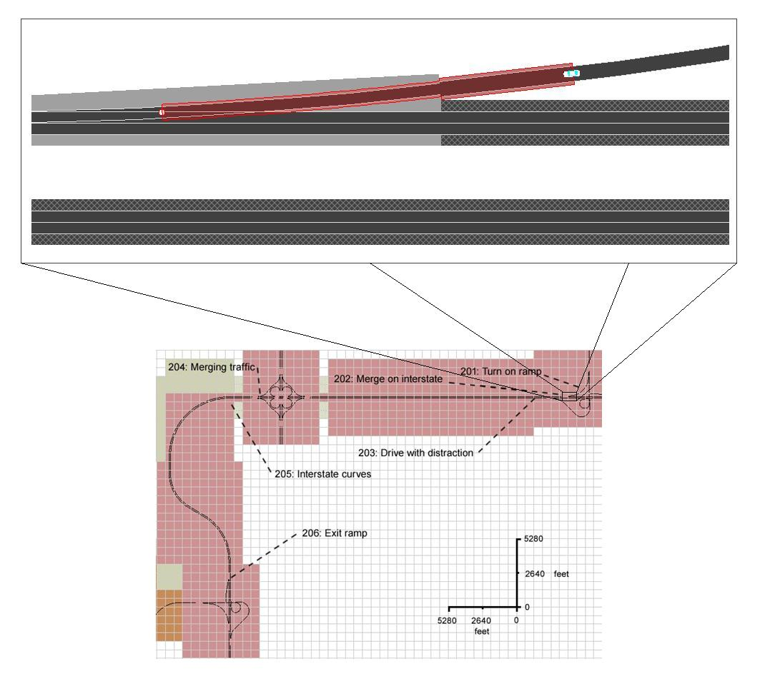
Figure 11 Merging onto highway
- Look for oncoming traffic
- Jerk of accelerator position
- Velocity of accelerator position
- Smoothness of merge on
- Max overshoot
- SDLP on ramp
- SD of acceleration to highway speed
The major variables to take into consideration when comparing an alcohol-impaired driver and an unimpaired driver when merging onto a highway are: time from last glance until merging on, the smoothness of changing lanes, max overshoot, and jerk and velocity of accelerator position. As a person merges onto a highway, looking for other traffic is essential to safe driving and is something that alcohol-impaired drivers tend to ignore**. The smoothness of lane change and max overshoot go hand in hand in the way a person pulls out of the parking space, as unimpaired drivers will get into the lane fairly quickly and impaired drivers will have to adjust their position before settling on an adequate location (Stuster, 1997). Jerk and velocity of accelerator position look at how smoothly the participant pulled out of the parking space in a longitudinal perspective. Alcohol-impaired drivers have trouble slowing and speeding up in a smooth manner (Stuster, 1997).

Interstate Event 203: Drive with Distraction
The participant drives on a straight section of interstate with two slow-moving trucks in the driving lane and a relatively slow-moving passenger car in the passing lane. The driver will also be instructed to interact with the CD player during this event.
Interstate Event 203: Drive with Distraction
Rationale | Once the participant has merged onto the interstate, there will be a slow moving truck ahead of the driver that will maintain 45 mph. The posted speed limit of the interstate is 70 mph but with a posted truck speed limit of 65 mph. At three times during this section the driver will be instructed to interact with the CD player by turning it on and switching tracks. There is no specific FARS rationale for this event; however, it could involve a number of cues from NHTSA’s DWI Detection Guide: e.g., following too close, unsafe lane change, weaving and failure to signal intentions. Some risk taking could take place when the drivers are impaired.
Road Network Requirements | Overall length/distance needed to support event (in feet): 19712  Road type (lanes, surface): 2-lane interstate  Speed limit (in mph): 70 mph for passenger vehicles, 65 mph for trucks  Curvature: none  Intersection type: none  Time of Day/Date: night lit
Preparation | A pair of tractor-trailers are created in the previous event ahead of the participant traveling 10 miles per hour slower than the participant with a minimum speed of 35 mph. Once the driver has finished merging onto the freeway the tractor-trailers will change their speed to 45 miles per hour.  When the participant is at 6500, 10000, and 15000 they will be instructed to interact with the CD player.  Before the participant reaches the first off ramp, a passenger vehicle will be created 1200 feet ahead of the driver in the passing lane. In drives 1 and 2, the vehicle will be created when the driver is 500 feet from the start of the exit-ramp; in drive 3, the vehicle will be created when the participant is 2850 feet from the exit ramp. The passenger vehicle will be traveling at 66% of the participant’s speed; this will encourage the participant change lanes into the right lane to pass the passenger vehicle.
Start Conditions | 200 feet past the on ramp.
Actual Event | The participant has merged onto the interstate. Logstream 1 is incremented, logstream 2 is set to 203, and Logstream 4 is set to 1.  When the participant is within 5.0 seconds headway to the first heavy truck or no later than approximately 6500 ft from the end of the on-ramp. SCC_Audio_Trigger is set to 313, playing the instructions for the 1st CD interaction task: “At this time – please turn on the CD player - select track 13 - then press off.”  When the participant is approximately 10000 ft from the end of the on-ramp. SCC_Audio_Trigger is set to 314, playing the instructions for the 2nd CD interaction task: “At this time – please turn on the CD player - select track 8 - then press off.”  When the participant is approximately 15000 ft from the end of the on-ramp. SCC_Audio_Trigger is set to 315, playing the instructions for the 3rd CD interaction task: “At this time – please turn on the CD player - select track 3 - then press off.”  When the participant is 500 feet from the end of the off-ramp in driver 1&2, and 2850 for drive 3, a car is created in the passing lane 1200 feet ahead of the participant. It will be traveling 66% of t the participants speed. Logstream 4 will be set to 3
End Conditions | The participant is 100 ft before the overpass.
Cleanup | none
Event Contingency  (Variables that define dependence of the current event on the interpretation of the previous event) | Description | Identifier | Units
Scenario Performance  (Measures that indicate if the event is operating as expected) | Description | Identifier | Units
 | Trucks and passenger vehicle maintain speed
 | Trucks and passenger vehicle maintain lane
 | Trucks turn off exit ramp | E203_exit_X (X is truck number, 1 to 2) | binary  1=yes, 0 = no
Assumed Driver Behavior  (Measures that indicate whether the participant behaves according to the assumptions) | Description | Identifier | Units
 | Driver passes first truck |  | binary  1=yes, 0=no
 | Driver passes second truck |  | binary  1=yes, 0=no
 | Driver passes car |  | binary  1=yes, 0=no
 | Driver performs CD task as instructed | By observation
Alcohol Impairment Indicators  (Measures that assess whether the event is sensitive to alcohol impairment) | Description | Identifier | Units
 | Average distance from SV to truck | E203_hdwy_avg_d | ft
 | Number of lane changes during following | E203_lane_change_ct | count
 | Lane position | E203_lp_avg | ft
 | Head movement (during lane change if any) |  | binary  1=yes, 0=no
 | SD of lane position from mean | E203_lp_sd | ft
 | SD of lane position from center | E203_lpn_sd | ft
 | Turn signal use | E203_turn_signal_ct | binary  1=yes, 0 = no
 | Time to collision | E203_ttc_min  E203_ttc_obj | sec  name of obj
 | Smoothness of lane changes
 | SD of steering wheel position | E203_steer_sd
 | Velocity of steering wheel | E203_steer_vel
 | Jerk of steering wheel | E203_steer_jerk
 | Steering error | E203_steer_error
 | Highway turn signal use | E203_highwayturn_sig
 | Proportion of time TLC>2s | E203_tlc_2 | proportion
 | 95% TLC | E203_tlc_95
 | Lateral Acceleration | E203_lat_acc | ft/sec^2
 | Accelerator holds | E203_accel_holds
 | Number of center line crossings | E203_center_cross | count
 | Number of right light crossings | E203_right_cross | count
 | Frequency of lane changes | E203_freq_lane | count
 | Velocity of accelerator position | E203_accel_vel
 | Jerk of accelerator position | E203_accel_jerk
 | SD of accelerator position | E203_accel_sd
 | Mean brake force | E203_brake_avg
 | SD of brake force | E203_brake_sd
 | Speed | E203_sp_avg | mph
 | Speed (relative to posted or assumed speed limit) | E203_spn_avg | mph
 | Timing of participant looking at rear view mirror | E203_rear_look
 | Glance frequency at particular object | E203_freq_glance
 | Pressure output(global and local) | E203_out_pres
 | Pressure and force over time | E203_force_pres
 | Pressure point mapping | E203_map_pres
 | PERCLOS | E203_perclos
 | Eye blink frequency | E203_blink_freq
 | Eye blink duration | E203_blink_dur
 | Percent in center based on median location of gaze | E203_cent_base
 | Correlation between road curvature and eye movements | E203_eye_curve
 | Correlation between steering and road curvature | E203_steer_curve
 | Correlation between eye movements and SDLP | E203_eye_sdlp
 | Correlation between eye movements and steering | E203_eye_steer
 | Correlation between head turn and steering wheel movement | E203_headturn_wheel
 | Number of collisions | E203_num_col
 | Near misses | E203_num_miss
 | Degree of conflict | E203_deg_conflict
 | Delay time | E203_delay_time
 | Rise time | E203_rise_time
 | Peak time | E203_peak_time
 | Max overshoot | E203_over_max
 | Settling time | E203_set_time
 | How well it fits the model | E203_model_fit
 | Smooth pursuit velocity | E203_smpur_vel
 | Smooth pursuit duration | E203_smpur_dur
 | Smooth pursuit frequency | E203_smpur_freq
 | Smooth pursuit maximum velocity | E203_smpur_maxvel
 | Smooth pursuit gain | E203_smpur_gain
 | SD of gaze | E203_gaze_sd
 | Gaze kurtosis | E203_gaze_kurt
 | Dwell duration | E203_dwell_time
 | Frequency of side mirror glances | E203_glance_freq_side
 | Frequency of speedometer glances | E203_glance_freq_speed
 | Glance direction | E203_glance_dir
 | Head movement | E203_head_mov
Algorithm Input  (Measures that is input to the algorithm) | Timing of participant looking at side mirror | E203_side_time
 | Description | Identifier | Units
 | SD of lane position relative to mean
 | Headway
 | Variation in headway
- SD of lane position from mean
- Smoothness of lane changes
- Time headway (if participant actually follows the trucks for any length of time, which is fairly unlikely because of the speed of the trucks)
- Max overshoot
- SD of speed (during “steady state”) relative to mean speed
The major variables to take into consideration when comparing an alcohol-impaired driver and an unimpaired driver when driving on a highway with other traffic are: SDLP, SD speed, and smoothness of lane changes, as well as maximum overshoot and time headway. SDLP has been shown to increase significantly when drivers are under the influence of alcohol (Calhoun et al., 2005; Gawron & Ranney, 1988; Reed & Green, 1999). The same has been shown for variation in speed, which can be measured by SD speed (Arnedt et al., 2001; Gawron & Ranney, 1988). The smoothness of lane change and max overshoot go hand in hand in the way a person pulls out of the parking space, as unimpaired drivers will get into the lane fairly quickly and impaired drivers will have to adjust their position before settling on an adequate location (Stuster, 1997). When drivers are alcohol-impaired, they tend to follow more closely behind a lead vehicle than if they weren’t impaired (Strayer et al., 2006).

Interstate Event 204: Merging Traffic
The participant will approach a second interchange. A passenger vehicle will start to merge onto the interstate; the merge onto the interstate is timed to cause a conflict in the driving lane with the participant. This means the participant will have to either change speed or lane in order to allow the other car to merge if they are in the driving lane. The passenger car will merge onto the interstate, but shortly thereafter will pull of onto the shoulder.
Interstate Event 204: Merging Traffic
Rationale | This scenario will involve the driver approaching an interchange with a vehicle merging about 500 feet ahead of the on-ramp. The driver should keep a relatively constant speed. The FARS rationale is the over-representation of impaired drivers in fatal crashes being the striking vehicles on high speed roads. DWI detection cues that could be observed include the driver’s reaction to the merge: swerving, varying speed, unsafe lane change.
Road Network Requirements | Overall length/distance needed to support event (in feet): 5720  Road type (lanes, surface): 2-lane interstate  Speed limit (in mph): 70 mph for passenger vehicles, 60 mph for trucks  Curvature: none  Intersection type: Highway Interchange  Time of Day/Date: Night
Preparation | The participant approaches a “clover leaf” interchange. A slow-moving vehicle in the passing lane from the previous event encourages the participant to pass on the right and places the participant in the driving lane.  A vehicle merges onto the highway so as to create a conflict situation with the participant if they are in the driving lane.  (The participant is in the driving lane)  After the merging vehicle has driven in the driving lane for a short distance, it brakes and pulls off to the side of the road.
Start Conditions | The participant is 1070 feet before center of clover leaf interchange (merging car will come on first ramp) or between the two over passes (merging car will come on second ramp).
Actual Event | The participant approaches a “clover leaf” interchange.  (The participant is in the driving lane after passing the slow moving vehicle).  The vehicle merging onto the highway is created, logstream 1 is incremented, logstream 2 is set to 204,  logstream 4 is set to 1.  The merging vehicle enters the driving the lane of the interstate from the last entrance ramp for scenarios 1&2, for scenario 3 the vehicle enters from the 1st on-ramp. After a short distance the merging vehicle starts to decelerate with brake lights; logstream 4 is set to 2. The merging car pulls off onto the right shoulder and brakes to a stop.  Once the participant has passed the location where the merging vehicle has or will stop, logstream 4 is set to 100.
End Conditions | 500 ft before start of curves
Cleanup | None
Event Contingency  (Variables that define dependence of the current event on the interpretation of the previous event) | Description | Identifier | Units
Scenario Performance  (Measures that indicate if the event is operating as expected) | Description | Identifier | Units
 | Lateral distance between SV and blocker car at time merging car crosses onto interstate | E204_blocker_lat_d | ft
 | Bumper-to-bumper distance between SV and blocker car at time merging car crosses onto interstate | E204_blocker_long_d | ft
 | Time SV passes blocker car relative to merging car crossing onto interstate (negative = prior) | E204_blocker_pass_t | sec
 | Scenario vehicles do not drive through one another | E204_DO_col_ct  E204_DO_col_tx | count of DOs that collide with each other during event  names of DOs that collide
Assumed Driver Behavior  (Measures that indicate whether the participant behaves according to the assumptions) | Description | Identifier | Units
 | Which lane the participant is in at start of event | E204_lane_init | binary  1=right, 2=left
 | Accelerator release | E204_accel_release | binary  1=yes, 0 = no
 | Brake press | E204_brake_press | binary  1=yes, 0 = no
 | Lane change (driver moves over for merging car) | E204_lane_change | binary  1=yes, 0 = no
 | Correlation between steering and road curvature | E204_steer_curve
 | Correlation between eye movements and SDLP | E204_eye_sdlp
 | Correlation between eye movements and steering | E204_eye_steer
 | Correlation between head turn and steering wheel movement | E204_headturn_wheel
 | Number of collisions | E204_num_col
 | Near misses | E204_num_miss
 | Degree of conflict | E204_deg_conflict
 | Delay time | E204_delay_time
 | Rise time | E204_rise_time
 | Peak time | E204_peak_time
 | Max overshoot | E204_over_max
 | Settling time | E204_set_time
 | How well it fits the model | E204_model_fit
 | Smooth pursuit velocity | E204_smpur_vel
 | Smooth pursuit duration | E204_smpur_dur
 | Smooth pursuit frequency | E204_smpur_freq
 | Smooth pursuit maximum velocity | E204_smpur_maxvel
 | Smooth pursuit gain | E204_smpur_gain
 | SD of gaze | E204_gaze_sd
 | Gaze kurtosis | E204_gaze_kurt
 | Dwell duration | E204_dwell_time
 | Frequency of side mirror glances | E204_glance_freq_side
 | Frequency of speedometer glances | E204_glance_freq_speed
 | Glance direction | E204_glance_dir
 | Head movement | E204_head_mov
 | Percent in center based on median location of gaze | E204_cent_base
 | Timing of participant looking at side mirror | E204_side_time
Algorithm Input  (Measures that is input to the algorithm) | Description | Identifier | Units
 | Mean brake force
 | Mean accelerator position
Figure 12 Merging Traffic
- Look for oncoming traffic
- Jerk of accelerator position
- Velocity of accelerator position
- Smoothness of lane change
- Max overshoot
The major variables to take into consideration when comparing an alcohol-impaired driver and an unimpaired driver when encountering traffic merging onto a highway are: time from last glance until merging on, the smoothness of pulling changing lanes, max overshoot, and jerk and velocity of accelerator position. As a person merges onto a highway, looking for other traffic is essential to safe driving and is something that alcohol-impaired drivers tend to ignore**. The smoothness of lane change and max overshoot go hand in hand in the way a person pulls out of the parking space, as unimpaired drivers will get into the lane fairly quickly and impaired drivers will have to adjust their position before settling on an adequate location (Stuster, 1997). Jerk and velocity of accelerator position look at how smoothly the participant pulled out of the parking space from a longitudinal perspective. Alcohol-impaired drivers have trouble slowing and speeding up in a smooth manner (Stuster, 1997).

Interstate Event 205: Interstate Curves
The participant will navigate a series of three curves on the interstate.
Interstate Event 205: Interstate Curves
Rationale | This scenario will involve a series of three curves the driver must negotiate on the interstate with light traffic. The FARS rationale is the over-representation of impaired driving fatal crashes on curves on dark but lighted roads. DWI detection cues that could occur include: weaving, drifting out of lane, almost striking an object, varying speed, and straddling a lane line.
Road Network Requirements | Overall length/distance needed to support event (in feet): 20020  Road type (lanes, surface): Asphalt 2-lane interstate  Speed limit (in mph): 70 mph for passenger vehicles, 65 mph for trucks  Curvature: 3 curves (radii of 3350, 2250, and 2925 ft)  Intersection type: none  Time of Day/Date: night lit
Preparation | The participant navigates a series of three curves on the interstate.  Audio instruction #3 plays, instructing the participant to get off at the next exit.  (The participant is able to keep the vehicle on the road)
Start Conditions | 500 feet before the start of the first curve
Actual Event | Logstream 1 is incremented, logstream 2 is set to 205  The participant navigates a series of three curves on the interstate.  Audio instruction number 3 plays, instructing participant to get off at the next exit.  (The participant is able to keep the vehicle on the road.)
End Conditions | 1000 feet before off ramp
Cleanup | None
Event Contingency  (Variables that define dependence of the current event on the interpretation of the previous event) | Description | Identifier | Units
Scenario Performance  (Measures that indicate if the event is operating as expected) | Description | Identifier | Units
 | There are no scenario cars traveling in same direction as participant
Assumed Driver Behavior  (Measures that indicate whether the participant behaves according to the assumptions) | Description | Identifier | Units
 | Road departures | E205_road_depart_ct | count
Alcohol Impairment Indicators  (Measures that assess whether the event is sensitive to alcohol impairment) | Description | Identifier | Units
 | Lane position | E205_lp_avg | ft
 | SD of lane position relative to mean | E205_lp_sd | ft
 | SD of lane position relative to center | E205_lpn_sd | ft
 | Steering wheel reversals
 | SD of speed relative to mean | E205_sp_sd | mph
 | SD of speed relative to posted speed limit | E205_spn_sd | mph
 | Number of center line crossings | E205_center_cross | count
 | Number of right line crossings | E205_right_cross | count
 | Speed | E205_sp_avg | mph
 | Speed (relative to posted or assumed speed limit) | E205_spn_avg | mph
 | Smoothness of lane changes (should they occur) | E205_lat_acc_avg | ft/s²
 | Lateral acceleration | E205_lat_acc | ft/s²
 | Head movement (during lane change if any) |  | binary  1=yes,0=no
 | Turn Signal Use | E205_turn_signal | binary  1=yes, 0 = no
 | SD of steering wheel position | E205_steer_sd
 | Velocity of steering wheel | E205_steer_vel
 | Jerk of steering wheel | E205_steer_jerk
 | Steering error | E205_steer_error
 | Steering wheel reversals | E205_steer_rev
 | Highway turn signal use | E205_highwayturn_sig
 | Time to line crossing (TLC) | E205_tlc
 | Proportion of time TLC>2s | E205_tlc_2 | proportion
 | 95% TLC | E205_tlc_95
 | Accelerator holds | E205_accel_holds
 | Frequency of lane changes | E205_freq_lane | count
 | Velocity of accelerator position | E205_accel_vel
 | Jerk of accelerator position | E205_accel_jerk
 | SD of accelerator position | E205_accel_sd
 | Mean brake force | E205_brake_avg
 | SD of brake force | E205_brake_sd
 | Timing of participant looking at rear view mirror | E205_rear_look
 | Glance frequency at particular object | E205_freq_glance
 | Pressure output(global and local) | E205_out_pres
 | Pressure and force over time | E205_force_pres
 | Pressure point mapping | E205_map_pres
 | PERCLOS | E205_perclos
 | Eye blink frequency | E205_blink_freq
 | Eye blink duration | E205_blink_dur
 | Percent in center based on median location of gaze | E205_cent_base
 | Correlation between road curvature and eye movements | E205_eye_curve
 | Correlation between steering and road curvature | E205_steer_curve
 | Correlation between eye movements and SDLP | E205_eye_sdlp
 | Correlation between eye movements and steering | E205_eye_steer
 | Correlation between head turn and steering wheel movement | E205_headturn_wheel
 | Number of collisions | E205_num_col
 | Near misses | E205_num_miss
 | Delay time | E205_delay_time
 | Rise time | E205_rise_time
 | Peak time | E205_peak_time
 | Max overshoot | E205_over_max
 | Settling time | E205_set_time
 | How well it fits the model | E205_model_fit
 | Smooth pursuit velocity | E205_smpur_vel
 | Smooth pursuit duration | E205_smpur_dur
 | Smooth pursuit frequency | E205_smpur_freq
 | Smooth pursuit maximum velocity | E205_smpur_maxvel
 | Smooth pursuit gain | E205_smpur_gain
 | SD of gaze | E205_gaze_sd
 | Gaze kurtosis | E205_gaze_kurt
 | Dwell duration | E205_dwell_time
 | Frequency of side mirror glances | E205_glance_freq_side
 | Frequency of speedometer glances | E205_glance_freq_speed
 | Glance direction | E205_glance_dir
 | Head movement | E205_head_mov
Algorithm Input  (Measures that is input to the algorithm) | Description | Identifier | Units
 | SD of lane position relative to mean
 | SD of speed relative to mean
 | Steering wheel reversals
 | Lateral acceleration
- SD of lane position (relative to mean lane position)
- Speed (relative to posted or assumed speed limit)
- SD of speed (during “steady state”) relative to mean speed
The major variables to take into consideration when comparing an alcohol-impaired driver and an unimpaired driver when driving down a road are: SDLP, SD speed, and speed relative to the posted or assumed speed limit. One of the most widely thought of behaviors of alcohol-impaired drivers is weaving around the lane. This can be represented by the variable SDLP, which has been shown to be sensitive to alcohol (Calhoun et al., 2005; Gawron & Ranney, 1988; Reed & Green, 1999). The same has been shown for variation in speed, which can be measured by SD Speed (Arnedt et al., 2001; Gawron & Ranney, 1988). A standard set of qualitative behaviors for police to follow mentions that alcohol-impaired drivers tend to drive slower than the speed limit by more than 10 mph (Stuster, 1997).

Interstate Event 206: Exit Ramp
The participant will take the next exit ramp off the interstate.
Interstate Event 206: Exit Ramp
Rationale | The participant will get off at the exit. This will involve going from two lanes to one lane, slowing from 70 mph to about 35 mph on a gentle curve. The FARS rationale is the over-representation of impaired participant crashes on curves. The DWI detection cues to observe could be: decelerating or braking in a jerky manner, drifting out of the proper lane, and failure to signal intentions.
Road Network Requirements | Overall length/distance needed to support event (in feet): 1540  Road type (lanes, surface): 2-lane interstate to single lane exit ramp  Speed limit (in mph): 70 to 35 (assumed) mph  Curvature: 3600 ft radius, 2816 ft radius s-curve off ramp  Intersection type: exit ramp  Time of Day/Date: lit night  Elevation: 0 ft at beginning of ramp to 30 ft at end of ramp
Preparation | The participant pulls off interstate onto the off-ramp  As the participant approaches the intersection, some cross traffic passes from both directions in the oncoming intersection  The participant takes the exit ramp  (The participant may or may not actually stop fully at the turn)
Start Conditions | 1000 feet from start of off ramp
Actual Event | When the participant is 500 feet from the start of the off ramp, Logstream 1 is incremented, Logstream 2 is set to 206, Logstream 4 is set to 1.  The participant pulls off onto the off ramp, Logstream 5 is set to 23, Logstream 4 is set to 100  (The participant remembers the audio instructions to pull off at the given exit )  When the participant is 21 seconds from the stop line at the end of the ramp, two cars are created to pass through the intersection of the off ramp with the perpendicular rural roadway. A cargo truck crosses from the left and a car from the right. Logstream 3 is set to 1.  3 seconds later, another car is created to pass through the intersection from the right. Logstream 3 is set to 2.
End Conditions | Participant is at the stop line.
Cleanup | None
Event Contingency  (Variables that define dependence of the current event on the interpretation of the previous event) | Description | Identifier | Units
Scenario Performance  (Measures that indicate if the event is operating as expected) | Description | Identifier | Units
Assumed Driver Behavior  (Measures that indicate whether the participant behaves according to the assumptions) | Description | Identifier | Units
 | Driver does not take the ramp | E206_nav_error | binary  1=yes, 0 = no
 | Accelerator release | E206_accel_release | binary  1=yes, 0 = no
 | Brake press | E206_brake_press | binary  1=yes, 0 = no
Alcohol Impairment Indicators  (Measures that assess whether the event is sensitive to alcohol impairment) | Description | Identifier | Units
 | Speed | E206_sp_avg | mph
 | Speed (relative to posted or assumed speed limit) | E206_spn_avg | mph
 | Mean acceleration | E206_acc_avg | ft/s²
 | Number of center line crossings | E206_center_cross | count
 | Number of right line crossings | E206_right_cross | count
 | Turn signal use | E206_turn_signal | binary  1=yes, 0 = no
 | Smoothness of transition onto the exit ramp (lateral) | E206_smooth_lat
 | Smoothness of transition onto the exit ramp (longitudinal) | E206_smooth_long
 | Head movement |  | binary  1=yes, 0 = no
 | Lateral acceleration | E204_lat_acc | ft/s²
 | SD of steering wheel position | E206_steer_sd
 | Velocity of steering wheel | E206_steer_vel
 | Jerk of steering wheel | E206_steer_jerk
 | Steering error | E206_steer_error
 | Velocity of accelerator position | E206_accel_vel
 | Jerk of accelerator position | E206_accel_jerk
 | SD of accelerator position | E206_accel_sd
 | Mean brake force | E206_brake_avg
 | SD of brake force | E206_brake_sd
 | Glance frequency at particular object | E206_freq_glance
 | Pressure output(global and local) | E206_out_pres
 | Pressure and force over time | E206_force_pres
 | Pressure point mapping | E206_map_pres
 | PERCLOS | E206_perclos
 | Eye blink frequency | E206_blink_freq
 | Eye blink duration | E206_blink_dur
 | Percent in center based on median location of gaze | E206_cent_base
 | Correlation between head turn and steering wheel movement | E206_headturn_wheel
 | Number of collisions | E206_num_col
 | Near misses | E206_num_miss
 | Delay time | E206_delay_time
 | Rise time | E206_rise_time
 | Peak time | E206_peak_time
 | Max overshoot | E206_over_max
 | Settling time | E206_set_time
 | How well it fits the model | E206_model_fit
 | Smooth pursuit velocity | E206_smpur_vel
 | Smooth pursuit duration | E206_smpur_dur
 | Smooth pursuit frequency | E206_smpur_freq
 | Smooth pursuit maximum velocity | E206_smpur_maxvel
 | Smooth pursuit gain | E206_smpur_gain
 | SD of gaze | E206_gaze_sd
 | Gaze kurtosis | E206_gaze_kurt
 | Dwell duration | E206_dwell_time
 | Frequency of side mirror glances | E206_glance_freq_side
 | Frequency of speedometer glances | E206_glance_freq_speed
 | Glance direction | E206_glance_dir
 | Head movement | E206_head_mov
Algorithm Input  (Measures that is input to the algorithm) | Description | Identifier | Units
 | Lateral acceleration
 | Mean brake force
 | Number of center line crossings
 | Number of right line crossings
Figure 13 Interstate off-ramp includes an elevation change. The beginning of the ramp starts at zero feet and increases to thirty feet by the end of the ramp. The elevation then decreases back to zero feet after the participant turns right.
- Jerk of accelerator position
- Velocity of accelerator position
- Velocity of steering wheel
- Jerk of steering wheel
The major variables to take into consideration when comparing an alcohol-impaired driver and an unimpaired driver when turning onto a ramp are: jerk and velocity of accelerator position and jerk and velocity of steering wheel position. Jerk and velocity of accelerator position look at how smoothly the participant pulled out of the parking space from a longitudinal perspective. Alcohol-impaired drivers have trouble slowing and speeding up in a smooth manner (Stuster, 1997). The jerk and velocity of the steering wheel position look at how smoothly the participant turned onto the ramp. Research has shown that alcohol impairs a person’s ability to maintain lateral control (Calhoun et al., 2005).

Rural Event 301: Turn Off Ramp (Transitional)
The driver is at a stop sign at the end of an exit ramp. They will have been given an instruction to turn right at the intersection. The participant will make a right turn onto a rural highway and accelerate up to speed.
Rural Event 301: Turn Off Ramp (Transitional)
Rationale | The driver is required to make a right turn from the off-ramp onto a rural two-lane undivided road with a speed limit of 55 mph. There is no traffic for this transition scenario. The FARS rationale is the over-representation of impaired driving fatal crashes on dark, but lighted, undivided two-lane roads, involving a slight curve. DWI detection cues that could emerge include: turning with a wide radius, weaving across lanes, speed variation problems, and driving in the opposing lane.
Road Network Requirements | Overall length/distance needed to support event (in feet): 1500  Road type (lanes, surface): 1-lane asphalt to 2-lane asphalt  Speed limit (in mph): 35 mph (assumed) exit ramp to 55 mph highway  Curvature: Approximate radius is 1900 ft  Intersection type: Exit ramp to 2-lane rural road  Time of Day/Date: Night, lighted  Elevation: 30 ft to 0 ft
Preparation | The participant nears the stop line  (The participant may or may not come to a complete stop)  The participant turns right onto the 2-lane lit rural highway  (The participant makes the correct turn)  When the participant has driven 400 feet after making the turn, an audio instruction informing them of their next turn plays.  (The participant makes the correct turn)  The participant speeds up and matches the speed limit  (The participant accelerates after the turn)
Start Conditions | The participant is 12 feet in front of the stop line
Actual Event | The participant slows to a very low speed or come to a complete stop near the stop line. Logstream 1 is set to incremented, Logstream 2 is set to 301.  (The participant may or may not come to a complete stop)  The participant turns right onto the 2-lane lit rural highway. As the participant crosses the stop line logstream 4 is set to 1. As the participant finishes the turn and is on the rural highway, logstream 5 is set to 31  (The participant makes the correct turn)  When the participant has driven 400 feet after making the turn, an audio instruction plays informing them of their next turn.  (The participant makes the correct turn)  The participant speeds up and matches the speed limit  (The participant accelerates after the turn)
End Conditions | The participant has traveled 1500 feet from the turn
Cleanup | None
Event Contingency  (Variables that define dependence of the current event on the interpretation of the previous event)hn thought to CC me on that email this time | Description | Identifier | Units
Scenario Performance  (Measures that indicate if the event is operating as expected) | Description | Identifier | Units
 | Crossing vehicles pass through intersection | Observation variable
Assumed Driver Behavior  (Measures that indicate whether the participant behaves according to the assumptions) | Description | Identifier | Units
 | Acceleration rate at beginning of task | E301_acc_init | ft/s²
 | Complete stop | E301_complete_stop | binary  1=yes, 0 = no
 | Minimum speed | E301_sp_min | mph
 | Driver does not turn right at end of the ramp | E301_nav_error | binary  1=yes, 0 = no
 | Acceleration rate at end of event | E301_acc_end | ft/s²
 | Done accelerating | E301_acc_done | binary  1=yes, 0 = no
 | Average acceleration rate on ramp | E301_acc_avg_ramp | ft/s²
 | Average acceleration rate on rural road | E301_acc_avg_rural | ft/s²
 | Acceleration distance on rural road | E301_acc_done_d | ft
 | Speed at the end of event | E301_sp_mavgnd | mph
Alcohol Impairment Indicators  (Measures that assess whether the event is sensitive to alcohol impairment) | Description | Identifier | Units
 | Smooth pursuit duration |  | sec
 | Smooth pursuit frequency |  | pursuits/sec
 | Smooth pursuit maximum velocity |  | deg/sec
 | Smooth pursuit gain
 | S.D. of accelerations | E301_acc_sd | ft/s²
 | Turn signal use | E301_turn_signal | binary  1=yes, 0 = no
 | Head movement |  | binary  1=yes, 0 = no
 | Deviation around the Line of Best fit for speed during acceleration (Robertson, 1996)
 | Number of center line crossings | E301_center_cross | count
 | Number of right line crossings | E301_right_cross | count
 | Smoothness of transition (longitudinal) | E301_smooth_long
 | Smoothness of transition (lateral) | E301_smooth_lat
 | Complete stop | E301_complete_stop | binary  1=yes, 0 = no
 | Location of stop (relative to stop line) | E301_stop_pos | ft
 | Heading at stop | E301_stop_hdng | deg
 | Frequency of glances to traffic on left | E301_glance_freq_left | glances/sec
 | Mean brake force
 | Intersection turn signal use | E301_turn_sig
 | Velocity of accelerator position | E301_accel_vel
 | Jerk of accelerator position | E301_accel_jerk
 | SD of accelerator position | E301_accel_sd
 | Mean brake force | E301_brake_avg
 | SD of brake force | E301_brake_sd
 | Speed | E301_sp_avg | mph
 | Speed (relative to posted or assumed speed limit) | E301_spn_avg | mph
 | Glance frequency at particular object | E301_freq_glance
 | Pressure output(global and local) | E301_out_pres
 | Pressure and force over time | E301_force_pres
 | Pressure point mapping | E301_map_pres
 | PERCLOS | E301_perclos
 | Eye blink frequency | E301_blink_freq
 | Eye blink duration | E301_blink_dur
 | Percent in center based on median location of gaze | E301_cent_base
 | Correlation between road curvature and eye movements | E301_eye_curve
 | Correlation between steering and road curvature | E301_steer_curve
 | Correlation between eye movements and SDLP | E301_eye_sdlp
 | Correlation between eye movements and steering | E301_eye_steer
 | Number of collisions | E301_num_col
 | Near misses | E301_num_miss
 | Delay time | E301_delay_time
 | Rise time | E301_rise_time
 | Peak time | E301_peak_time
 | Max overshoot | E301_over_max
 | Settling time | E301_set_time
 | How well it fits the model | E301_model_fit
 | Smooth pursuit velocity | E301_smpur_vel
 | Smooth pursuit duration | E301_smpur_dur
 | Smooth pursuit frequency | E301_smpur_freq
 | Smooth pursuit maximum velocity | E301_smpur_maxvel
 | Smooth pursuit gain | E301_smpur_gain
 | SD of gaze | E301_gaze_sd
 | Gaze kurtosis | E301_gaze_kurt
 | Dwell duration | E301_dwell_time
 | Frequency of side mirror glances | E301_glance_freq_side
 | Frequency of speedometer glances | E301_glance_freq_speed
 | Glance direction | E301_glance_dir
 | Head movement | E301_head_mov
Algorithm Input  (Measures that is input to the algorithm) | Description | Identifier | Units
 | Mean accelerator position
 | Lateral acceleration
 | Smoothness of acceleration
 | Mean speed
 | Smooth pursuit eye movements
- Jerk of accelerator position
- Velocity of accelerator position
- Smoothness of lane change
- Max overshoot
- Velocity of steering wheel
- Jerk of steering wheel
The major variables to take into consideration when comparing an alcohol-impaired driver and an unimpaired driver when turning left are: the smoothness of pulling out, max overshoot, and jerk and velocity of accelerator position. The smoothness of lane change and max overshoot go hand in hand in the way a person pulls out of the parking space, as unimpaired drivers will get into the lane fairly quickly and impaired drivers will have to adjust their position before settling on an adequate location (Stuster, 1997). Jerk and velocity of accelerator position look at how smoothly the participant pulled out of the parking space from a longitudinal perspective. Alcohol-impaired drivers have trouble slowing and speeding up in a smooth manner (Stuster, 1997).

Rural Event 302: Lighted Rural
The participant will follow a lighted two-lane road with a speed limit of 55 mph.
Rural Event 302: Lighted Rural
Rationale | The driver is required to drive for a few minutes on a lighted two-lane rural road with a speed limit of 55 mph with oncoming traffic about once every 60 seconds. The FARS rationale includes the over-representation on rural two-lane undivided roads with a speed limit of 55 mph. DWI detection cues could be: weaving, drifting, lane maintenance problems, accelerating or decelerating for no good reason, varying speed, and driving in opposing lanes
Road Network Requirements | Overall length/distance needed to support event (in feet): 750  Road type (lanes, surface): 2-lane asphalt  Speed limit (in mph): 55 mph  Curvature: None  Intersection type: None  Time of Day/Date: Night, lighted
Preparation | The participant follows this lighted two-lane road with a speed limit of 55 mph.  (The participant has finished accelerating and is traveling 55 mph)  The participant sees oncoming traffic on average once per 60 seconds
Start Conditions | The participant has traveled 1500 feet after turning onto the rural highway
Actual Event | Logstream 1 is incremented, logstream 2 is set to 302, logstream 3 is set to 0, logstream 4 is set to 100.  The participant follows this lighted two-lane road with a speed limit of 55 mph.  (The participant is traveling 55 mph)  The participant sees oncoming traffic on average once per 60 seconds
End Conditions | The participant has passed the last lamp post
Cleanup
Event Contingency  (Variables that define dependence of the current event on the interpretation of the previous event) | Description | Identifier | Units
 | Done accelerating | E301_acc_done | binary  1=yes, 0 = no
Scenario Performance  (Measures that indicate if the event is operating as expected) | Description | Identifier | Units
 | Oncoming traffic present on average every 60 seconds | E302_oncoming_freq | avg. sec between cars
 | Lighting present on road | observation
Assumed Driver Behavior  (Measures that indicate whether the participant behaves according to the assumptions) | Description | Identifier | Units
 | Average speed during event | E302_sp_avg | mph
 | Average speed relative to speed limit | E302_spn_avg | mph
 | SD speed during event relative to mean | E302_sp_sd | mph
 | SD speed during event relative to speed limit | E302_spn_sd | mph
Alcohol Impairment Indicators  (Measures that assess whether the event is sensitive to alcohol impairment) | Description | Identifier | Units
 | Average lane position | E302_lp_avg | ft
 | SD of lane position relative to mean | E302_lp_sd | ft
 | SD of lane position relative to center of lane | E302_lpn_sd | ft
 | Speed | E302_sp_avg | mph
 | Speed (relative to posted or assumed speed limit) | E302_spn_avg | mph
 | SD speed during event relative to mean | E302_sp_sd | mph
 | SD speed during event relative to speed limit | E302_spn_sd | mph
 | Number of center line crossings | E302_center_cross | count
 | Number of right line crossings | E302_right_cross | count
 | Frequency of glances to rear view mirror | E302_glance_freq_rear | glances/sec
 | Steering wheel reversals | E302_steer_rev
 | SD of steering wheel position | E302_steer_sd
 | Velocity of steering wheel | E302_steer_vel
 | Jerk of steering wheel | E302_steer_jerk
 | Steering error | E302_steer_error
 | Time to line crossing (TLC) | E302_tlc
 | Proportion of time TLC>2s | E302_tlc_2 | proportion
 | 95% TLC | E302_tlc_95
 | Accelerator holds | E302_accel_holds
 | Velocity of accelerator position | E302_accel_vel
 | Jerk of accelerator position | E302_accel_jerk
 | SD of accelerator position | E302_accel_sd
 | Glance frequency at particular object | E302_freq_glance
 | Pressure output(global and local) | E302_out_pres
 | Pressure and force over time | E302_force_pres
 | Pressure point mapping | E302_map_pres
 | PERCLOS | E302_perclos
 | Eye blink frequency | E302_blink_freq
 | Eye blink duration | E302_blink_dur
 | Percent in center based on median location of gaze | E302_cent_base
 | Correlation between road curvature and eye movements | E302_eye_curve
 | Correlation between steering and road curvature | E302_steer_curve
 | Correlation between eye movements and SDLP | E302_eye_sdlp
 | Correlation between eye movements and steering | E302_eye_steer
 | Number of collisions | E302_num_col
 | Near misses | E302_num_miss
 | Smooth pursuit velocity | E302_smpur_vel
 | Smooth pursuit duration | E302_smpur_dur
 | Smooth pursuit frequency | E302_smpur_freq
 | Smooth pursuit maximum velocity | E302_smpur_maxvel
 | Smooth pursuit gain | E302_smpur_gain
 | SD of gaze | E302_gaze_sd
 | Gaze kurtosis | E302_gaze_kurt
 | Dwell duration | E302_dwell_time
 | Frequency of side mirror glances | E302_glance_freq_side
 | Frequency of speedometer glances | E302_glance_freq_speed
 | Glance direction | E302_glance_dir
Algorithm Input  (Measures that is input to the algorithm) | Description | Identifier | Units
 | Lane position
 | Speed
 | SD of lane position relative to mean
 | SD of speed relative to mean
 | Steering wheel reversals
 | Number of center line crossings
 | Number of right line crossings
- SD of lane position (relative to mean lane position)
- Speed (relative to posted or assumed speed limit)
- SD of speed (during “steady state”) relative to mean speed
The major variables to take into consideration when comparing an alcohol-impaired driver and an unimpaired driver are driving down a road are: SDLP, SD speed, and speed relative to the posted or assumed speed limit. One of the most widely thought of behaviors of alcohol-impaired drivers is weaving around the lane. This can be represented by the variable SDLP, which has been shown to be sensitive to alcohol (Calhoun et al., 2005; Gawron & Ranney, 1988; Reed & Green, 1999). The same has been shown for variation in speed which can be measured by SD speed (Arnedt et al., 2001; Gawron & Ranney, 1988). A standard set of qualitative behaviors for police to follow mentions that alcohol-impaired drivers tend to drive slower than the speed limit by more than 10 mph (Stuster, 1997).

Rural Event 303: Transition to Dark Rural
The road will transition to an unlighted two-lane road. The center and road edge markings are faded, and the road will have a grayish surface.
Rural Event 303: Transition to Dark Rural
Rationale | The driver is required to transition to a segment of the rural road that is unlighted. The center and edge lines are faded and the road will have a grayish surface. There is no specific FARS rationale, but this transition is typical and could involve some challenging visual problems. DWI detection cues that could occur include: swerving, drifting, varying speed, and straddling the lane lines.
Road Network Requirements | Overall length/distance needed to support event (in feet):1500 ft  Road type (lanes, surface): 2-lane asphalt  Speed limit (in mph): 55 mph  Curvature: None  Intersection type: None  Time of Day/Date: Night, transition from lit to dark
Preparation | The participant is driving on the lighted two-lane road with a speed limit of 55 mph.  (The participant is traveling 55 mph)
Start Conditions | Event starts at the last lamp post
Actual Event | The participant enters the unlighted portion of the rural road. Logstream 1 is incremented, logstream 2 is set to 303, logstream 4 is set to 32.  (The participant maintains speed or slows slightly.)
End Conditions | Event ends 1500 feet past the last lamp post.
Cleanup | None
Event Contingency  (Variables that define dependence of the current event on the interpretation of the previous event) | Description | Identifier | Units
Scenario Performance  (Measures that indicate if the event is operating as expected) | Description | Identifier | Units
 | Lighted road ends—dark begins
 | Oncoming traffic every 60 seconds | E303_oncoming_freq | avg. sec between cars
Assumed Driver Behavior  (Measures that indicate whether the participant behaves according to the assumptions) | Description | Identifier | Units
 | Beginning speed | E303_sp_init | mph
 | Ending speed | E303_sp_mavgnd | mph
 | Average speed | E303_sp_avg | mph
 | Average speed relative to speed limit | E303_spn_avg | mph
 | SD speed relative to mean speed | E303_sp_sd | mph
 | SD speed relative to speed limit | E303_spn_sd | mph
Alcohol Impairment Indicators  (Measures that assess whether the event is sensitive to alcohol impairment) | Description | Identifier | Units
 | Average lane position | E303_lp_avg | ft
 | SD of lane position relative to mean lane position | E303_lp_sd | ft
 | SD of lane position relative to center of lane | E303_lpn_sd | ft
 | SD speed relative to mean speed | E303_sp_sd | mph
 | SD speed relative to speed limit | E303_spn_sd | mph
 | Number of center line crossings | E303_center_cross | count
 | Number of right line crossings | E303_right_cross | count
 | Frequency of glances to rear view mirror | E303_glance_freq_rear | glances/sec
 | Steering wheel reversals | E303_steer_rev
 | SD of steering wheel position | E303_steer_sd
 | Velocity of steering wheel | E303_steer_vel
 | Jerk of steering wheel | E303_steer_jerk
 | Steering error | E303_steer_error
 | Time to line crossing (TLC) | E303_tlc
 | Proportion of time TLC>2s | E303_tlc_2 | proportion
 | 95% TLC | E303_tlc_95
 | Accelerator holds | E303_accel_holds
 | Velocity of accelerator position | E303_accel_vel
 | Jerk of accelerator position | E303_accel_jerk
 | SD of accelerator position | E303_accel_sd
 | Speed | E303_sp_avg | mph
 | Speed (relative to posted or assumed speed limit) | E303_spn_avg | mph
 | Glance frequency at particular object | E303_freq_glance
 | Pressure output(global and local) | E303_out_pres
 | Pressure and force over time | E303_force_pres
 | Pressure point mapping | E303_map_pres
 | PERCLOS | E303_perclos
 | Eye blink frequency | E303_blink_freq
 | Eye blink duration | E303_blink_dur
 | Percent in center based on median location of gaze | E303_cent_base
 | Correlation between road curvature and eye movements | E303_eye_curve
 | Correlation between steering and road curvature | E303_steer_curve
 | Correlation between eye movements and SDLP | E303_eye_sdlp
 | Correlation between eye movements and steering | E303_eye_steer
 | Number of collisions | E303_num_col
 | Near misses | E303_num_miss
 | Smooth pursuit velocity | E303_smpur_vel
 | Smooth pursuit duration | E303_smpur_dur
 | Smooth pursuit frequency | E303_smpur_freq
 | Smooth pursuit maximum velocity | E303_smpur_maxvel
 | Smooth pursuit gain | E303_smpur_gain
 | SD of gaze | E303_gaze_sd
 | Gaze kurtosis | E303_gaze_kurt
 | Dwell duration | E303_dwell_time
 | Frequency of side mirror glances | E303_glance_freq_side
 | Frequency of speedometer glances | E303_glance_freq_speed
 | Glance direction | E303_glance_dir
Algorithm Input  (Measures that is input to the algorithm) | Description | Identifier | Units
 | Lane position
 | Speed
 | SD lane position relative to mean
 | SD speed relative to mean
 | Steering wheel reversals
 | Number of center line crossings
 | Number of right line crossings
- Change in speed (from beginning of the event to the end)
- SDLP
- Maximum brake pressure
The major variables to take into consideration when comparing an alcohol-impaired driver and an unimpaired driver with a lit to unlit roadway transition are: SDLP, the change in speed from the beginning of the event to the end, and the maximum brake pressure. One of the most widely thought of behaviors of alcohol-impaired drivers is weaving around the lane. This can be represented by the variable SDLP, which has been shown to be sensitive to alcohol (Calhoun et al., 2005; Gawron & Ranney, 1988; Reed & Green, 1999). Maximum brake pressure and change in speed both look at a participant’s ability to control velocity in a changing environment. It is known that alcohol-impaired drivers have trouble slowing and speeding up in a smooth manner (Stuster, 1997).

Rural Event 304: Dark Rural
The road has transitioned to an unlighted two-lane road. The center and road edge markings are faded, and the road has a grayish surface.
Rural Event 304: Dark Rural
Rationale | This segment involves a few minutes of driving on this rural, two-lane, unlighted 55 mph road with faded lane lines involving some curves. Curve radii range from 456 ft to 5500 ft. The FARS rationale includes the over-representation of impaired driving fatal crashes occurring under just these conditions. DWI cues that could emerge include: weaving across lanes, drifting, varying speed, driving in opposing lane, and running off the road.
Road Network Requirements | Overall length/distance needed to support event (in feet): 14510  Road type (lanes, surface): 2-lane asphalt with faded pavement markings  Speed limit (in mph): 55 mph initially, 45 mph on curves, 55 mph at end of event  Curvature: Varying straight and curved sections including approximately 45 deg left turn with radius of 1525 ft and hairpin curve, approximately 135 deg, radius of 456 ft.  Intersection type: None  Time of Day/Date: Night, dark  Elevation: Event contains a hill approximately 55 ft high
Preparation | The participant follows an unlighted two-lane road with a speed limit of 55 mph.  (The participant is traveling 55 mph)  The participant experiences oncoming traffic on average every 60 seconds.  The participant experiences a series of curves.  (The participant is traveling 45 mph)  The participant experiences an oncoming car timed such that it meets the participant near the apex of one of the curves
Start Conditions | The participant has passed the geometric point defining the end of the transition to the dark rural road segment (1500 ft after lighted rural roadway segment ends).
Actual Event | Logstream 1 is incremented, logstream 2 is set to 304. The participant follows an unlighted two-lane road with a speed limit of 55 mph.  (The participant is traveling 55 mph)  The participant navigates through a series of curves.  (The participant is traveling 45 mph, maintains lane position, and does not crash.)  Traffic frequency in oncoming lane is 1 vehicle/60 sec.  The participant encounters an oncoming vehicle on a curve. When the oncoming vehicle is 800 feet from the participant, logstream 3 is set to 1  (The participant does not crash)  When the oncoming vehicle is has passed the participant, logstream 3 is set to 0  (The participant does not crash)
End Conditions | 500 ft before Y-intersection with transition to gravel road
Cleanup | None
Event Contingency  (Variables that define dependence of the current event on the interpretation of the previous event) | Description | Identifier | Units
Scenario Performance  (Measures that indicate if the event is operating as expected) | Description | Identifier | Units
 | No lights | Observation
 | Oncoming traffic (1 car/60 sec) | E304_oncoming_freq | avg. sec between cars
 | Meet conflict car on apex of curve
Assumed Driver Behavior  (Measures that indicate whether the participant behaves according to the assumptions) | Description | Identifier | Units
 | Speed (average, min, and max) | E304_sp_avg  E304_sp_min  E304_sp_max | mph
Alcohol Impairment Indicators  (Measures that assess whether the event is sensitive to alcohol impairment) | Description | Identifier | Units
 | Lane position | E304_lp_avg | ft
 | SD of lane position (relative to mean lane position) | E304_lp_sd | ft
 | SD of lane position (relative to center of lane) | E304_lpn_sd | ft
 | Speed | E304_sp_avg | mph
 | Speed (relative to posted or assumed speed limit) | E304_spn_avg | mph
 | SD of speed (relative to mean speed) | E304_sp_sd | mph
 | SD of speed (relative to posted or assumed speed limit) | E304_spn_sd | mph
 | Number of center line crossings | E304_center_cross | count
 | Number of right line crossings | E304_right_cross | count
 | Frequency of glances to rear view mirror | E304_glance_freq_rear | glances/sec
 | Mean speed during hairpin turn | E302_spn_avg_hp | mph
 | Steering wheel reversals | E304_steer_rev
 | SD of steering wheel position | E304_steer_sd
 | Velocity of steering wheel | E304_steer_vel
 | Jerk of steering wheel | E304_steer_jerk
 | Steering error | E304_steer_error
 | Time to line crossing (TLC) | E304_tlc
 | Proportion of time TLC>2s | E304_tlc_2 | proportion
 | 95% TLC | E304_tlc_95
 | Accelerator holds | E304_accel_holds
 | Velocity of accelerator position | E304_accel_vel
 | Jerk of accelerator position | E304_accel_jerk
 | SD of accelerator position | E304_accel_sd
 | Glance frequency at particular object | E304_freq_glance
 | Pressure output(global and local) | E304_out_pres
 | Pressure and force over time | E304_force_pres
 | Pressure point mapping | E304_map_pres
 | PERCLOS | E304_perclos
 | Eye blink frequency | E304_blink_freq
 | Eye blink duration | E304_blink_dur
 | Percent in center based on median location of gaze | E304_cent_base
 | Correlation between road curvature and eye movements | E304_eye_curve
 | Correlation between steering and road curvature | E304_steer_curve
 | Correlation between eye movements and SDLP | E304_eye_sdlp
 | Correlation between eye movements and steering | E304_eye_steer
 | Number of collisions | E304_num_col
 | Near misses | E304_num_miss
 | Degree of conflict | E304_deg_conflict
 | Smooth pursuit velocity | E304_smpur_vel
 | Smooth pursuit duration | E304_smpur_dur
 | Smooth pursuit frequency | E304_smpur_freq
 | Smooth pursuit maximum velocity | E304_smpur_maxvel
 | Smooth pursuit gain | E304_smpur_gain
 | SD of gaze | E304_gaze_sd
 | Gaze kurtosis | E304_gaze_kurt
 | Dwell duration | E304_dwell_time
 | Frequency of side mirror glances | E304_glance_freq_side
 | Frequency of speedometer glances | E304_glance_freq_speed
 | Glance direction | E304_glance_dir
Algorithm Input  (Measures that is input to the algorithm) | Description | Identifier | Units
 | Lane position
 | Speed
 | SD of lane position relative to mean
 | SD of speed relative to mean
 | Number of center line crossings
 | Number of right line crossings
 | Steering wheel reversals

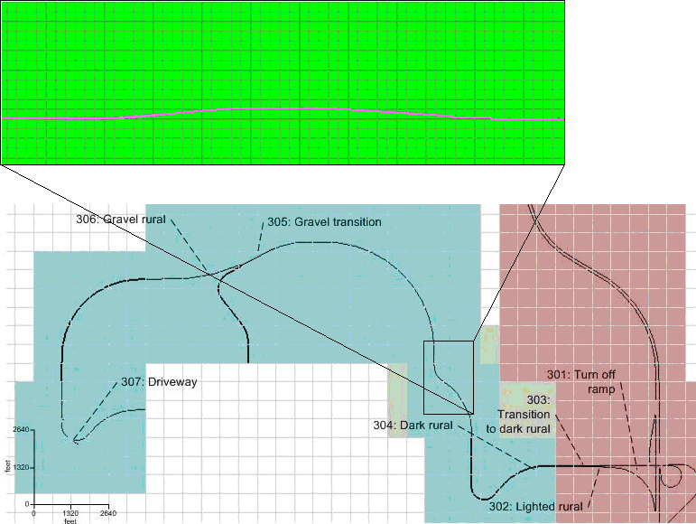
Figure 14 Elevation change for rural curves increases from zero feet to fifty, then decreases back to zero feet.
- SD of lane position (relative to mean lane position)
- Speed (relative to posted or assumed speed limit)
- SD of speed (during “steady state”) relative to mean speed
The major variables to take into consideration when comparing an alcohol-impaired driver and an unimpaired driver driving down a road are: SDLP, SD speed, and speed relative to the posted or assumed speed limit. One of the most widely thought of behaviors of alcohol-impaired drivers is weaving around the lane. This can be represented by the variable SDLP, which has been shown to be sensitive to alcohol (Calhoun et al., 2005; Gawron & Ranney, 1988; Reed & Green, 1999). The same has been shown for variation in speed, which can be measured by SD speed (Arnedt et al., 2001; Gawron & Ranney, 1988). A standard set of qualitative behaviors for police to follow mentions that alcohol-impaired drivers tend to drive slower than the speed limit by more than 10 mph (Stuster, 1997).

Rural Event 305: Gravel Transition
The participant will come upon a fork in the road. The main road will curve to the left, and a gravel road will veer to the right. Participants will veer to the right, continuing straight (see Figure 15). The participant is instructed through an audio queue to continue onto the gravel road.
Rural Event 305: Gravel Transition
Rationale | In this segment, the driver will come to a fork in the road, turn slightly to the right on a gravel road, and continue straight. The FARS rationale is the over-representation of high BAC crashes on gravel roads. DWI cues could be driving too fast for conditions, swerving, running off the road edge, and stopping for no apparent reason.
Road Network Requirements | Overall length/distance needed to support event (in feet): 2420  Road type (lanes, surface): Transition from faded asphalt to 2-lane gravel  Speed limit (in mph): 55 mph to an assumed speed of 45 mph  Curvature: None  Intersection type: Y, gravel road straight ahead, asphalt road curving away  Time of Day/Date: Night, dark
Preparation | The participant approaches a Y intersection (gravel road going straight ahead, asphalt road curving away to the left)  (The participant is driving on the road and in the correct lane )  The following vehicles(approximately 500 feet behind) veer left at the intersection and not follow the onto the gravel road
Start Conditions | 500 ft before the Y-intersection
Actual Event | Logstream 1 is incremented, logstream 2 is set to 305, logstream 4 is set to 1  Once the participant has crossed into the gravel road, logstream 4 is set to 100, and logstream 5 is set to 33  The participant continues straight onto the gravel road section  (The participant veers off the paved road onto the gravel road.)  (The participant adjusts their speed appropriately for the gravel road surface (no posted speed limit).  The following vehicles veer left at the intersection and not follow the participant onto the gravel road
End Conditions | The participant has traveled 1500 ft past the start of the gravel road.
Cleanup | None
Event Contingency  (Variables that define dependence of the current event on the interpretation of the previous event) | Description | Identifier | Units
Scenario Performance  (Measures that indicate if the event is operating as expected) | Description | Identifier | Units
Assumed Driver Behavior  (Measures that indicate whether the participant behaves according to the assumptions) | Description | Identifier | Units
 | Participant does not take turn | E305_nav_error | binary  1=yes, 0 = no
 | Initial speed (speed at beginning of event) | E305_sp_init | mph
 | End speed (speed at end of event) | E305_sp_mavgnd | mph
 | Accelerator release | E305_accel_release | binary  1=yes, 0 = no
 | Brake press | E305_brake_press | binary  1=yes, 0 = no
Alcohol Impairment Indicators  (Measures that assess whether the event is sensitive to alcohol impairment) | Description | Identifier | Units
 | SD of speed relative to mean | E305_sp_sd | mph
 | SD of speed relative to posted or assumed speed limit | E305_spn_sd | mph
 | Speed | E305_sp_avg | mph
 | Speed (relative to posted or assumed speed limit) | E305_spn_avg | mph
 | S.D. of steering wheel angle | E305_steer_sd | deg
 | Smoothness of transition onto gravel (longitudinal) | E305_smooth_long
 | Smoothness of transition onto gravel (lateral) | E305_smooth_lat
 | Turn signal use | E305_turn_signal | binary  1=yes, 0 = no
 | Steering wheel reversals | E305_steer_rev
 | SD of steering wheel position | E305_steer_sd
 | Velocity of steering wheel | E305_steer_vel
 | Jerk of steering wheel | E305_steer_jerk
 | Steering error | E305_steer_error
 | Frequency of glances to rear view mirror | E305_glance_freq_rear | glances/sec
 | Accelerator holds | E305_accel_holds
 | Number of left line crossings | E305_left_cross | count
 | Number of right line crossings | E305_right_cross | count
 | Velocity of accelerator position | E305_accel_vel
 | Jerk of accelerator position | E305_accel_jerk
 | SD of accelerator position | E305_accel_sd
 | Mean brake force | E305_brake_avg
 | SD of brake force | E305_brake_sd
 | Glance frequency at particular object | E305_freq_glance
 | Pressure output(global and local) | E305_out_pres
 | Pressure and force over time | E305_force_pres
 | Pressure point mapping | E305_map_pres
 | PERCLOS | E305_perclos
 | Eye blink frequency | E305_blink_freq
 | Eye blink duration | E305_blink_dur
 | Percent in center based on median location of gaze | E305_cent_base
 | Correlation between road curvature and eye movements | E305_eye_curve
 | Correlation between steering and road curvature | E305_steer_curve
 | Correlation between eye movements and SDLP | E305_eye_sdlp
 | Correlation between eye movements and steering | E305_eye_steer
 | Number of collisions | E305_num_col
 | Near misses | E305_num_miss
 | Delay time | E305_delay_time
 | Rise time | E305_rise_time
 | Peak time | E305_peak_time
 | Max overshoot | E305_over_max
 | Settling time | E305_set_time
 | How well it fits the model | E305_model_fit
 | Smooth pursuit velocity | E305_smpur_vel
 | Smooth pursuit duration | E305_smpur_dur
 | Smooth pursuit frequency | E305_smpur_freq
 | Smooth pursuit maximum velocity | E305_smpur_maxvel
 | Smooth pursuit gain | E305_smpur_gain
 | SD of gaze | E305_gaze_sd
 | Gaze kurtosis | E305_gaze_kurt
 | Dwell duration | E305_dwell_time
 | Frequency of side mirror glances | E305_glanceglance_freq_side_side
 | Frequency of speedometer glances | E305_glance_freq_speed
 | Glance direction | E305_glance_dir
Algorithm Input  (Measures that is input to the algorithm) | Description | Identifier | Units
 | Mean brake force
 | Mean accelerator position
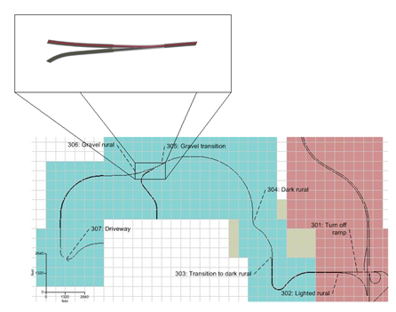
Figure 15 Rural Event 3: Entering gravel road
- Change in speed (from beginning of the event to the end)
- Maximum brake pressure
- SDLP
The major variables to take into consideration when comparing an alcohol-impaired driver and an unimpaired driver with a pavement to gravel road transition are: SDLP, the change in speed from the beginning of the event to the end, and the maximum brake pressure. One of the most widely thought of behaviors of alcohol-impaired drivers is weaving around the lane. This can be represented by the variable SDLP, which has been shown to be sensitive to alcohol (Calhoun et al., 2005; Gawron & Ranney, 1988; Reed & Green, 1999). Maximum brake pressure and change in speed both look at a participant’s ability to control velocity in a changing environment. It is known that alcohol-impaired drivers have trouble slowing and speeding up in a smooth manner (Stuster, 1997).

Rural Event 306: Gravel Rural
At distance of 1500 ft. after the transition to the gravel road, the participant will experience a series of curves and straight-aways.
Rural Event 306: Gravel Rural
Rationale | In this segment, the driver will navigate on an unlighted gravel rural road that contains a series of curves and has no posted speed limit. The FARS rationale includes an over-representation of impaired driving fatal crashes on curves and unlighted rural gravel roads. The DWI cues that could be observed include: running off the road, almost striking objects, varying speed, and driving in the opposing lane.
Road Network Requirements | Overall length/distance needed to support event (in feet): 11880  Road type (lanes, surface): 2-lane gravel with little or no shoulder  Speed limit (in mph): Not posted (assumed 45 mph)  Curvature: Varying straight and curved sections  Intersection type: None  Time of Day/Date: Night, dark
Preparation | At the start of the event, instruction #5 is played, informing them to pull into the first driveway on the right.  The participant navigates an unlighted two-lane rural gravel road that contains a series of curves and has no posted speed limit.  (The participant is assumed to travel at approximately 45 mph.)
Start Conditions | The participant has traveled 1670 ft past the transition to gravel at the Y-intersection.
Actual Event | Logstream 1 is incremented; logstream 2 is set to 306. Instruction #5 is played.  The participant continues along the gravel road section.  The participant navigates a series of curves.  (The participant adjusts their speed appropriately for the gravel road surface and curves.)
End Conditions | The participant is 550 feet before driveway
Cleanup | None
Event Contingency  (Variables that define dependence of the current event on the interpretation of the previous event) | Description | Identifier | Units
Scenario Performance  (Measures that indicate if the event is operating as expected) | Description | Identifier | Units
 | No cars in either direction
 | Dark gravel road
 | No oncoming traffic | E306_oncoming_freq | avg. sec between cars
Assumed Driver Behavior  (Measures that indicate whether the participant behaves according to the assumptions) | Description | Identifier | Units
 | Initial speed (speed at beginning of event) | E306_sp_init | mph
 | End speed (speed at end of event) | E306_sp_mavgnd | mph
Alcohol Impairment Indicators  (Measures that assess whether the event is sensitive to alcohol impairment) | Description | Identifier | Units
 | SD of lane position relative to mean lane position | E306_lp_sd | ft
 | SD of lane position relative to center of lane | E306_lpn_sd | ft
 | Lane position | E306_lp_avg | ft
 | SD of speed (relative to mean speed) | E306_sp_sd | mph
 | SD of speed (relative to assumed or posted speed limit) | E306_spn_sd | mph
 | Speed | E306_sp_avg | mph
 | Speed relative to assumed speed | E306_spn_avg | mph
 | Frequency of glances to rear view mirror | E306_glance_freq_rear | glances/sec
 | Steering wheel reversals | E303_steer_rev
 | SD of steering wheel position | E306_steer_sd
 | Velocity of steering wheel | E306_steer_vel
 | Jerk of steering wheel | E306_steer_jerk
 | Steering error | E306_steer_error
 | Time to line crossing (TLC) | E306_tlc
 | Proportion of time TLC>2s | E306_tlc_2 | proportion
 | 95% TLC | E306_tlc_95
 | Accelerator holds | E306_accel_holds
 | Number of left line crossings | E306_left_cross | count
 | Number of right linet crossings | E306_right_cross | count
 | Velocity of accelerator position | E306_accel_vel
 | Jerk of accelerator position | E306_accel_jerk
 | SD of accelerator position | E306_accel_sd
 | Glance frequency at particular object | E306_freq_glance
 | Pressure output(global and local) | E306_out_pres
 | Pressure and force over time | E306_force_pres
 | Pressure point mapping | E306_map_pres
 | PERCLOS | E306_perclos
 | Eye blink frequency | E306_blink_freq
 | Eye blink duration | E306_blink_dur
 | Percent in center based on median location of gaze | E306_cent_base
 | Correlation between road curvature and eye movements | E306_eye_curve
 | Correlation between steering and road curvature | E306_steer_curve
 | Correlation between eye movements and SDLP | E306_eye_sdlp
 | Correlation between eye movements and steering | E306_eye_steer
 | Number of collisions | E306_num_col
 | Near misses | E306_num_miss
 | Smooth pursuit velocity | E306_smpur_vel
 | Smooth pursuit duration | E306_smpur_dur
 | Smooth pursuit frequency | E306_smpur_freq
 | Smooth pursuit maximum velocity | E306_smpur_maxvel
 | Smooth pursuit gain | E306_smpur_gain
 | SD of gaze | E306_gaze_sd
 | Gaze kurtosis | E306_gaze_kurt
 | Dwell duration | E306_dwell_time
 | Frequency of side mirror glances | E306_glance_freq_side
 | Frequency of speedometer glances | E306_glance_freq_speed
 | Glance direction | E306_glance_dir
Algorithm Input  (Measures that is input to the algorithm) | Description | Identifier | Units
 | Mean lane position
 | Mean speed
 | SD of lane position relative to mean
 | SD of speed relative to mean
 | Steering wheel reversals
- SD of speed (during “steady state”) relative to mean speed
- Speed
- SDLP (relative to mean lane position)
The major variables to take into consideration when comparing an alcohol-impaired driver and an unimpaired driver when driving on a gravel road are: SDLP, SD of speed relative to the mean speed, and mean speed. One of the most widely thought of behaviors of alcohol-impaired drivers is weaving around the lane. This can be represented by the variable SDLP, which has been shown to be sensitive to alcohol (Calhoun et al., 2005; Gawron & Ranney, 1988; Reed & Green, 1999). The same has been shown for variation in speed, which can be measured by SD speed (Arnedt et al., 2001; Gawron & Ranney, 1988). A standard set of qualitative behaviors for police to follow mentions that alcohol-impaired drivers tend to drive slower than the speed limit by more than 10 mph (Stuster, 1997).

Rural Event 307: Driveway
The drive will end with the participant pulling into a gravel driveway. The participant is instructed through an audio queue to pull off on the gravel driveway. The turn is gradual.
Rural Event 307: Driveway
Rationale | The drive will end with the driver pulling into a gravel driveway. The turn is gradual. This is the typical end of a trip from the bar. No FARS rationale, but could involve DWI cues such as: turning with a wide radius, almost striking an object, and stopping problems (too far, too short, etc.).
Road Network Requirements | Overall length/distance needed to support event (in feet): 660  Road type (lanes, surface): 2-lane gravel to 1-lane gravel  Speed limit (in mph): Assumed 45 mph to a stop  Curvature: 1800ft radius intersection corridor to 510ft radius driveway  Intersection type: None  Time of Day/Date: Night, dark
Preparation | The participant slows and turns into the drive way  (The participant turns into the driveway)  The participant is instructed to stop the car, ending the drive  (The participant stops the car)
Start Conditions | The participant is 550 ft before driveway.
Actual Event | The participant makes the turn onto the drive way, logstream 5 changes to 34.  (The participant makes the turn)  When the participant has pulled onto the driveway an audio message instructs them to stop  (The participant stops)
End Conditions | The participant brakes to a complete stop.
Cleanup | None
Event Contingency  (Variables that define dependence of the current event on the interpretation of the previous event) | Description | Identifier | Units
Scenario Performance  (Measures that indicate if the event is operating as expected) | Description | Identifier | Units
Assumed Driver Behavior  (Measures that indicate whether the participant behaves according to the assumptions) | Description | Identifier | Units
 | Initial speed | E307_sp_init | mph
 | End speed | E307_sp_mavgnd | mph
 | Deceleration rate | E307_acc_avg | ft/s²
 | Maximum steering angle (assuming positive indicates right turn) | E307_steer_max | deg
Alcohol Impairment Indicators  (Measures that assess whether the event is sensitive to alcohol impairment) | Description | Identifier | Units
 | Turn signal use | E307_turn_signal | binary  1=yes, 0 = no
 | Speed variance | E307_sp_sd | mph
 | Mean brake force | E104_brake_avg
 | Smoothness of deceleration
 | Frequency of glances to rear view mirror | E307_glance_freq_rear | glances/sec
 | Glance frequency at particular object | E307_freq_glance
 | Pressure output(global and local) | E307_out_pres
 | Pressure and force over time | E307_force_pres
 | Pressure point mapping | E307_map_pres
 | PERCLOS | E307_perclos
 | Eye blink frequency | E307_blink_freq
 | Eye blink duration | E307_blink_dur
 | Percent in center based on median location of gaze | E307_cent_base
 | Correlation between head turn and steering wheel movement | E307_headturn_wheel
 | Number of collisions | E307_num_col
 | Near misses | E307_num_miss
 | Delay time | E307_delay_time
 | Rise time | E307_rise_time
 | Peak time | E307_peak_time
 | Max overshoot | E307_over_max
 | Settling time | E307_set_time
 | How well it fits the model | E307_model_fit
 | Smooth pursuit velocity | E307_smpur_vel
 | Smooth pursuit duration | E307_smpur_dur
 | Smooth pursuit frequency | E307_smpur_freq
 | Smooth pursuit maximum velocity | E307_smpur_maxvel
 | Smooth pursuit gain | E307_smpur_gain
 | SD of gaze | E307_gaze_sd
 | Gaze kurtosis | E307_gaze_kurt
 | Dwell duration | E307_dwell_time
 | Frequency of side mirror glances | E307_glance_freq_side
 | Frequency of speedometer glances | E307_glance_freq_speed
 | Glance direction | E307_glance_dir
Algorithm Input  (Measures that is input to the algorithm) | Description | Identifier | Units
 | Mean brake force
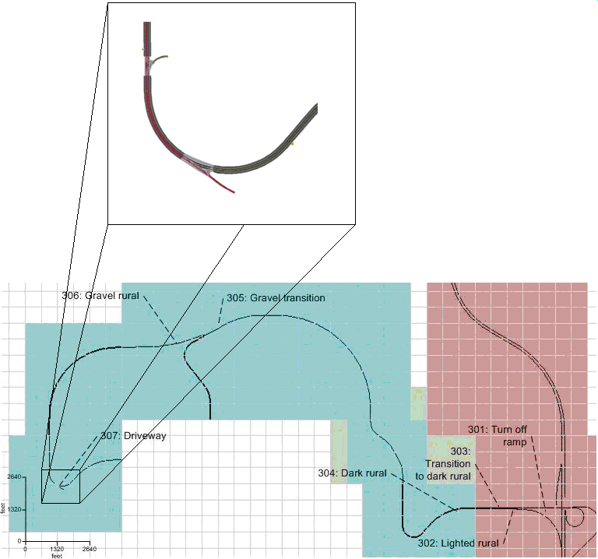
Figure 16 Driveway
- Max brake pressure
- Variation in brake pressure
Maximum brake pressure and variation in brake pressure look at a participant’s ability to control velocity in a changing environment. It is known that alcohol impaired drivers have trouble slowing and speeding up in a smooth manner (Stuster, 1997).

Potential Hazards in Urban Scenario Events
The urban scenario events contain a number of potential hazards in the form of pedestrians and vehicles whose behavior might give the participants the impression that they need to react to the hazard in order to avoid collision. The location and timing of these potential hazards is catalogued so that the participants’ responses may be evaluated. Each of the three scenarios contains equal numbers of each kind of hazard and to the extent possible the environment near the hazard is equivalent.

Hazard number | Name | Description
1 | Walker3DRR1_01 | Three dimensional pedestrian on the right in the parking lane walking in same direction as the driver.
2 | Walker3DLR5_02 | Two dimensional pedestrian on the left in the parking lane walking towards the driver.
3 | Walker2DRS7_03 | Two dimensional pedestrian on the right on the sidewalk walking toward the road.
4 | Walker3DLR1_04 | Three dimensional pedestrian on the left in the parking lane walking in the same direction as the driver.
5 | Walker3DRS1_05 | Three dimensional pedestrian on the right on the sidewalk walking in the same direction as the driver.
6 | Walker3DLS5_06 | Three dimensional pedestrian on the left on the sidewalk walking towards the driver.
7 | Walker2DRS8_07 | Two dimensional pedestrian on the right on the sidewalk walking towards the road and in the same direction as the driver.
8 | Walker3DRS5_08 | Three dimensional pedestrian on the right on the sidewalk walking towards the driver.
9 | Walker3DRR1_09 | Three dimensional pedestrian on the right in the parking lane walking away from the driver.
10 | Walker3DLS5_10 | Three dimensional pedestrian on the left on the sidewalk walking towards the driver.
11 | Walker2DLS2_11 | Two dimensional pedestrian on the left on the sidewalk walking towards the road in the same direction as the driver.
12 | Walker3DLR5_12 | Three dimensional pedestrian on the left on the parking lane walking away from the driver.
13 | PullOutVespaRight | Vespa moped coming from an alley on the right pulls out into the parking lane approximately 75 ft in front of the driver and parks after traveling a short distance.
14 | PullOutVespaLeft | Vespa moped coming from an ally on the left pulls out onto the parking lane approximately 18 ft in front of the driver and parks after traveling a short distance.
15 | AllyTaxi | Taxi coming from an alley on the left created approximately 650 ft in front of the driver pulls through the parking lane as if it is going to turn and join the roadway but does not enter the oncoming traffic lane.
16 | TaxiPullOut | Taxi parked in the opposite parking lane pulling out into the roadway and joining oncoming traffic approximately 100 ft in front of the driver.
17 | PullOutCar1 | Parked car in the oncoming lane pulling out into oncoming traffic 8 seconds in front of the driver.
18 | FakeCrosser | Three dimensional pedestrian in parking lane on the left waiting for a car to pass before walking onto oncoming lane towards driver and then walking around a parked car.
19 | StreetCrosser | As driver approaches intersection for E105: Left Turn, a pedestrian walks across the perpendicular street from the far corner on the right toward the driver in the crosswalk.

Motion Pre-positions and Washouts
Each scenario specifies pre-position points for the motion base. Whenever one is encountered, the motion slowly ramps to the new position so that it is favorably positioned for an upcoming event. Similarly, the washout parameters are dynamically changed from one set to another when requested by the scenario. There is a washout set for turns, one for highways, and another for curves.
The three figures that follow have each pre-position and washout trigger called out on the figure. The pre-position call-out consists of three position numbers corresponding to X, Y, and turntable angle respectively. The washout call-outs will show the text ‘Turn’,’Hwy’, or ‘Curve’ to denote which washout file is loaded at that point.
Finally, each scenario has an initial position that controls where the simulator motion base starts at the beginning of the scenario. These positions are given in text boxes inset into each figure. The practice drive is based on scenario 1, and therefore the practice drive initial position is given in the Scenario 1 figure.
Preposition | Crossbeam X | Carriage Y | Turntable Angle
A | 150 in | 150 in | 45 deg
B | 0 in | 0 in | 45 deg
C | 200 in | 0 in | 90 deg
D | 200 in | 0 in | 90 deg
E | 0 in | 0 in | 90 deg
F | 250 in | 0 in | 90 deg
G | 100 in | 0 in | 90 deg
H | 100 in | 0 in | 90 deg
Table 7 - List of motion pre-position points with markers
Washout | Name
1 | Turn.mda
2 | Hwy.mda
3 | Curve.mda
Table 8 - List of motion washout files with markers
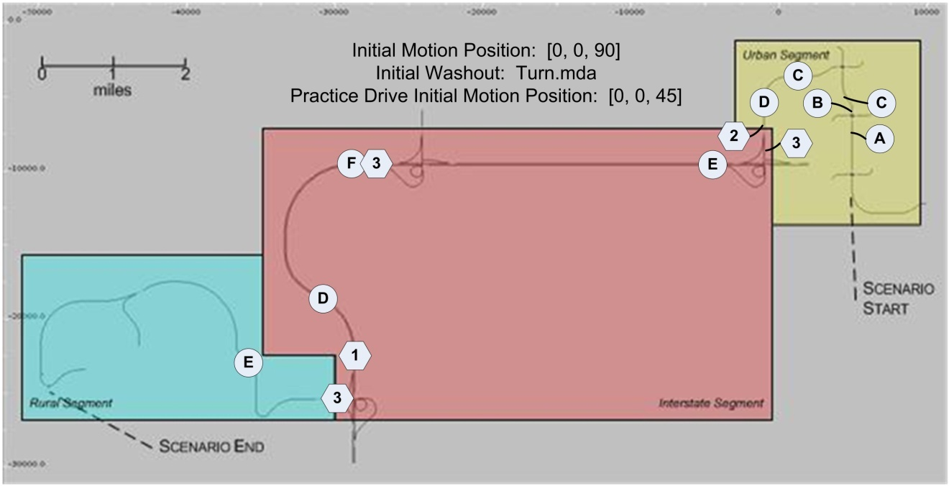
Figure 17 - Scenario 1 Pre-positions and Washouts

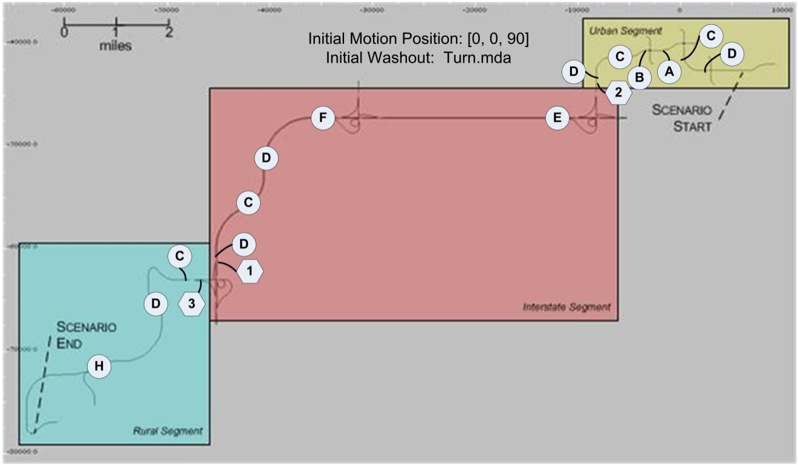
Figure 18 - Scenario 2 Pre-positions and Washouts

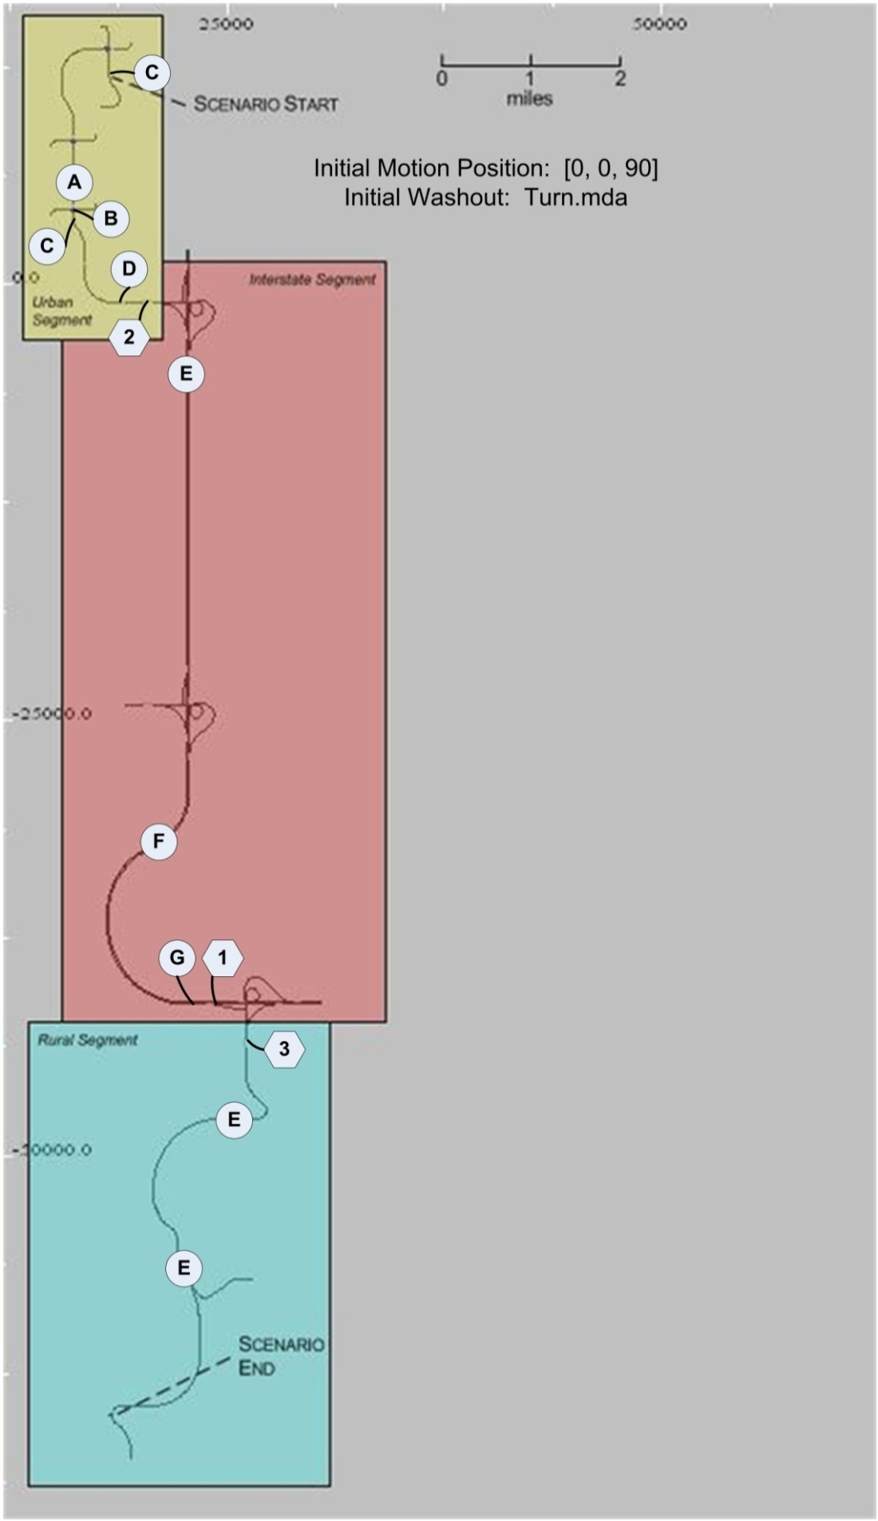
Figure 19 - Scenario 3 Pre-positions and Washouts

Data Reduction Routine
The data from the NADS is saved in DAQ files. When each of these files is written from temporary storage to long-term storage, a report is generated. This report contains the name and size of the DAQ file. Names of valid DAQ files are copied from the report and appended to an Excel spreadsheet. The first few rows of this Excel spreadsheet for Task 1 Pilot 3 are shown below. An “X” is placed in the Analyze column for the DAQ files that need to be reduced. Each time the reduction scripts are run, this Excel spreadsheet is read in and only the DAQ files specified in the Analyze column are reduced. If the eye data collected during the drives are too poor to be used for analysis, an “X” is placed in the Bad Eye column. When these DAQ files with poor eye data are reduced, a null value of 99 is given to any eye movement dependent measures. In addition, the spreadsheet contains the Run Name (which identifies the directory on the data storage server where the DAQ file is saved), the name of the DAQ file (timestamp when file was created), the date the data was collected (extracted from timestamp), the participant number, the name of the drive, the participant’s age group (Y=young, M=middle, O=old), gender, and which combination of dose order and scenario order the participant was assigned to (18 possible combinations counterbalanced across age and gender).
Analyze | Ignore | Reduced | Eye (Place 'X' in column if eye data is bad) | Run Name | DAQ File | Date | Part Num | Drive | Age | Gender | Order
 | X |  |  | P304YF01_1PRACT | 20080919184353 | 09/19/2008 | P304YF01 | 1PRACT | Y | F | 01
X |  |  |  | P304YF01_1S1RNA | 20080919185511 | 09/19/2008 | P304YF01 | 1S1RNA | Y | F | 01
 | X |  |  | P303OM01_1PRACT | 20080919193422 | 09/19/2008 | P303OM01 | 1PRACT | O | M | 01
X |  |  |  | P303OM01_1S1RNA | 20080919194410 | 09/19/2008 | P303OM01 | 1S1RNA | O | M | 01
X |  |  |  | P303OM01_1S1RS5 | 20080919201433 | 09/19/2008 | P303OM01 | 1S1RS5 | O | M | 01

DAQ files will be reduced as frequently as possible during main data collection (ideally, daily, but no less than three times a week).

MATLAB is used to perform the data reduction. During data reduction, each DAQ file indicated in the spreadsheet is individually opened and the required variables are read into the MATLAB workspace. Some raw values, e.g., lane deviation, need to be cleaned in order to calculate the specified dependent measures. Once the raw data is cleaned for the entire file, dependent measures are calculated for each of the scenario events.

Data Reduction Output File Layout
The data reduction procedure creates two output data files. The first file contains all of the dependent measures specified in Section 3, including scenario performance measures, measures of assumed driver behavior, and measures of alcohol impairment. Each row in this file contains the reduced data from one scenario event. Not all dependent measures are applicable to all events. Thus, this output file is very sparse with only a few columns containing values for a given event. Columns that are not applicable to a given event contain “NaN”. A portion of this file is shown in Table 9.
The second file contains all of the dependent measures that are thought to be indicative of driver impairment due to alcohol. Each row in this file contains the reduced data from one experimental drive. Thus, each dependent measure is identified by the number of the scenario event they are associated with. For example, all dependent measures associated with the pullout event begin with “E101.” Cells without data are left blank. A portion of this file is shown in Table 10.

Table 9 Data reduction output file sample – first 13 columns
Subject | RunName | Drive | Event | acc_avg | acc_end | acc_end_d | acc_end_t | acc_init | accel_release | accel_sd | accelerate | brake_press
001 | 20080528131249 | 1 | E101 | NaN | NaN | 425.6597667 | 7.933333333 | NaN | NaN | NaN | NaN | NaN
001 | 20080528131249 | 1 | E102 | NaN | NaN | NaN | NaN | NaN | NaN | NaN | NaN | NaN
001 | 20080528131249 | 1 | E103 | NaN | NaN | NaN | NaN | NaN | NaN | NaN | NaN | 0
001 | 20080528131249 | 1 | E104 | NaN | NaN | NaN | NaN | NaN | 1 | NaN | -1 | 0
001 | 20080528131249 | 1 | E105 | NaN | NaN | NaN | NaN | NaN | 1 | NaN | NaN | 1
001 | 20080528131249 | 1 | E106 | NaN | NaN | NaN | NaN | NaN | NaN | NaN | NaN | NaN
001 | 20080528131249 | 1 | E201 | -1 | NaN | NaN | NaN | NaN | 0 | NaN | NaN | 0
001 | 20080528131249 | 1 | E202 | -1 | NaN | NaN | NaN | NaN | 0 | -1 | NaN | 0
001 | 20080528131249 | 1 | E203 | NaN | NaN | NaN | NaN | NaN | NaN | NaN | NaN | NaN
001 | 20080528131249 | 1 | E204 | NaN | NaN | NaN | NaN | NaN | 0 | NaN | NaN | 0
001 | 20080528131249 | 1 | E205 | NaN | NaN | NaN | NaN | NaN | NaN | NaN | NaN | NaN
001 | 20080528131249 | 1 | E206 | NaN | NaN | NaN | NaN | NaN | 1 | NaN | NaN | 1
001 | 20080528131249 | 1 | E301 | NaN | -1 | -1 | NaN | -1 | NaN | NaN | NaN | NaN
001 | 20080528131249 | 1 | E302 | NaN | NaN | NaN | NaN | NaN | NaN | NaN | NaN | NaN
001 | 20080528131249 | 1 | E303 | NaN | NaN | NaN | NaN | NaN | NaN | NaN | NaN | NaN
001 | 20080528131249 | 1 | E304 | NaN | NaN | NaN | NaN | NaN | NaN | NaN | NaN | NaN
001 | 20080528131249 | 1 | E305 | NaN | NaN | NaN | NaN | NaN | 0 | NaN | NaN | 0
001 | 20080528131249 | 1 | E306 | NaN | NaN | NaN | NaN | NaN | NaN | NaN | NaN | NaN
001 | 20080528131249 | 1 | E307 | NaN | NaN | NaN | NaN | NaN | NaN | NaN | NaN | NaN

Table 10 Sample of second data reduction output file – first 12 columns
Subject | Drive | E101_head_turn | E101_side_mirror | E101_rear_mirror | E101_last_glance | E101_gap | E101_collision | E101_collision_obj | E101_turn_signal | E102_done_acc | E102_done_acc_t
1 | 1 | -2 | -2 | -2 | -2 | -1 | -1 | -1 | -1 | 0 | -2.8
1 | 2 | -2 | -2 | -2 | -2 | -1 | -1 | -1 | -1 | 0 | -2.8
1 | 3 | -2 | -2 | -2 | -2 | -1 | -1 | -1 | -1 | 0 | -2.8
2 | 1 | -2 | -2 | -2 | -2 | -1 | -1 | -1 | -1 | 0 | -2.8
2 | 2 | -2 | -2 | -2 | -2 | -1 | -1 | -1 | -1 | 0 | -2.8
2 | 3 | -2 | -2 | -2 | -2 | -1 | -1 | -1 | -1 | 0 | -2.8

Appendix

Changes to Scenarios
On March 6, 2008, it was decided that the scenario needed to be shortened from its current length of 30 minutes. After taking into account the number of simulator hours budgeted (210) and the number of participants (108), the scenarios were shortened to 24 minutes. The following modifications were made:
- Eliminate two-way stop event from the urban segment
- Increase speed limit on interstate from 65 mph to 70 mph
- Decrease the dark rural event from 3.5 minutes to 2 minutes of driving
- Decrease the gravel rural event from 3 minutes to 1.5 minutes of driving
The original and modified road networks are presented in Figure 20.
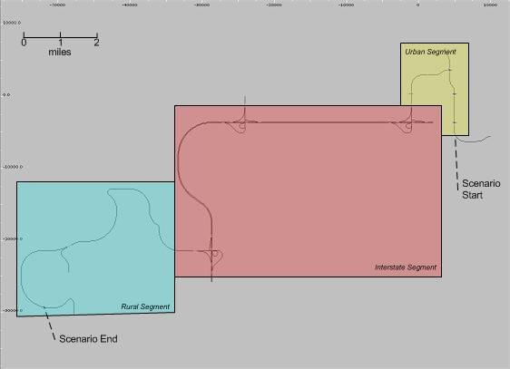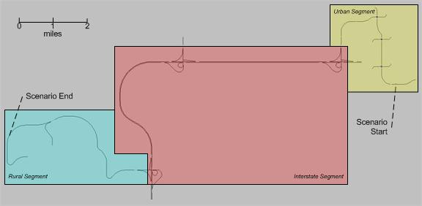
Figure 20 Old road network (left) and modified road network (right)

Appendix C: Recruitment Materials

Advertisement Wording

Main Study

Adults ages 21-34, 38-51, and 55-68 are invited to participate in a driving simulation study to determine how various levels of blood alcohol concentration impacts driving performance. Must be a moderate to heavy drinker. 4 visits total. (3 visits after 4pm, approximately 6 hours each in length). Drug and pregnancy screen completed at each visit. Must live within a 30 minute drive of UI Oakdale Campus. You will be paid for your time and effort. For more information, call 319-335-4719 or www.drivingstudies.com

Adults 55-68 are invited to participate in a driving simulation study to determine how various levels of blood alcohol concentration impacts driving performance. Must be a moderate to heavy drinker. 4 visits total. (3 visits after 4pm, approximately 6 hours each in length). Drug and pregnancy screen completed at each visit. Must live within a 30 minute drive of UI Oakdale Campus. You will be paid for your time and effort. For more information, call 319-335-4719 or www.drivingstudies.com

Adults 38-51 are invited to participate in a driving simulation study to determine how various levels of blood alcohol concentration impacts driving performance. Must be a moderate to heavy drinker. 4 visits total. (3 visits after 4pm, approximately 6 hours each in length). Drug and pregnancy screen completed at each visit. Must live within a 30 minute drive of UI Oakdale Campus. You will be paid for your time and effort. For more information, call 319-335-4719 or www.drivingstudies.com

Women 55-68 are invited to participate in a driving simulation study to determine how various levels of blood alcohol concentration impacts driving performance. Must be a moderate to heavy drinker. 4 visits total. (3 visits after 4pm, approximately 6 hours each in length). Drug and pregnancy screen completed at each visit. Must live within a 30 minute drive of UI Oakdale Campus. You will be paid for your time and effort. For more information, call 319-335-4719 or www.drivingstudies.com

Women 38-51 are invited to participate in a driving simulation study to determine how various levels of blood alcohol concentration impacts driving performance. Must be a moderate to heavy drinker. 4 visits total. (3 visits after 4pm, approximately 6 hours each in length). Drug and pregnancy screen completed at each visit. Must live within a 30 minute drive of UI Oakdale Campus. You will be paid for your time and effort. For more information, call 319-335-4719 or www.drivingstudies.com

Email Script

Email

The National Advanced Driving Simulator at The University of Iowa Oakdale Campus is inviting adults to participate in a driving simulation study to determine how varies levels of blood alcohol concentration impacts driving performance.

Who can be part of this study?

- Adults ages 21-34, 38-51 and 55-68
- Live within 30 minute drive to the University of Iowa Oakdale Campus
- You are a moderate to heavy drinker of alcoholic beverages
- Able to attend 4 study visits, (3 visits take place after 4pm approximately 6 hours each in length
- Drug and pregnancy screen completed at each visit

If you meet the above criteria and are interested in participating, please visit:
www.drivingstudies.com
Email: recruit@nads-sc.uiowa.edu
Call: 319-335-4719

If you do participate in the study, you will be paid for your time and effort.

Even if you don’t qualify to participate in this study, please forward this message to anyone you know who does!

Newspaper Ad

Adults ages 21-34, 38-51, and 55-68 are invited to participate in a driving simulation study
to determine how various levels of blood alcohol concentration impacts driving performance.
Must be moderate to heavy drinker. Four visits total, (3 visits after 4pm, approximately 6 hours each in length). Drug and pregnancy screen completed at each visit. Must live within 30 minute drive of UI Oakdale campus. You will be paid for your time and effort.
For more information:
319 335 4719

www.drivingstudies.com

Website Script
Website script:

Main Study

Adults ages 21-34, 38-51, or 55-68 are invited to participate in a driving simulation study to determine how various levels of blood alcohol concentration impacts driving performance. Must be a moderate to heavy drinker. Four visits, (3 visits will take place after 4pm approximately 6 hours each in length). Must live within a 30 minute drive of UI Oakdale Campus. Drug and pregnancy screen completed at each visit. You will be paid for your time and effort. For more information, call 319-335-4719 or www.drivingstudies.com

Flyer
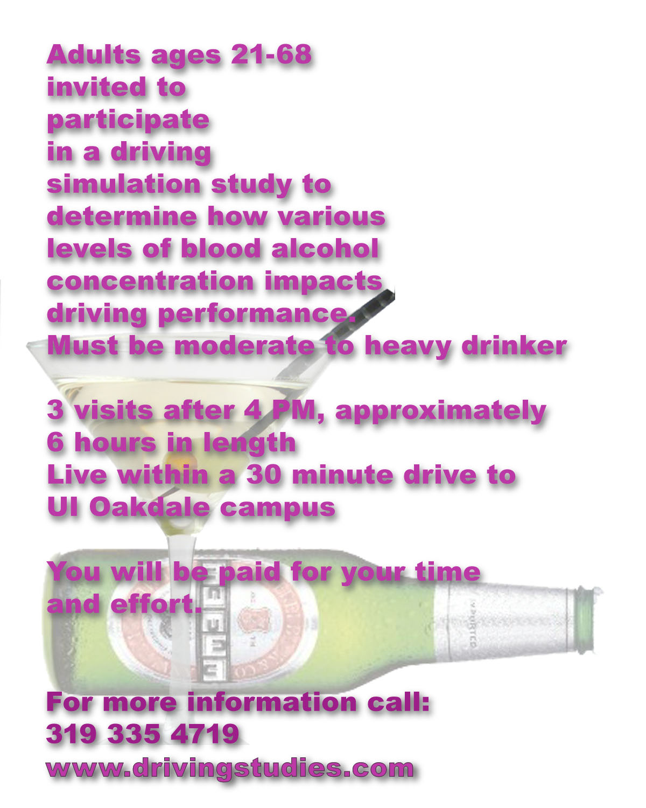

Appendix D: Screening Procedures

Overview of Study
The purpose of this research study is to determine how varying levels of blood alcohol concentration (BAC) impacts driving performance. In order to research how BAC impacts driving performance, we will be asking you to drink alcoholic beverages on three separate visits within a controlled environment before driving in the simulator. Each visit will require you to drink enough alcohol to produce either a BAC of 0.00%, 0.05% or 0.10%.

This study involves 4 study visits, the first visit will be a screening appointment which will last approximately 1 ½ hours in length and will determine if you are eligible to be in the study. If you are eligible, the next 3 visits (dosing visits) will be conducted over a 3 week period of time, one study visit per week. These visits could last approximately 6 hours in length and will begin after 4 pm or later.

If you do enroll into the study, arrangements will be made for your transportation to and from your residence to the National Advanced Driving Simulator for the three dosing study visits as you will not be allowed to drive or be driven to your study visits.

We will ask you to not eat for 4 hours before your dosing visits, not drink alcoholic beverages within 24 hours of these study visits, not drink caffeine 30 minutes prior to your visit, and to refrain from using recreational drugs 30 days of your scheduled visits. Additionally, we will be conducting urine drug screens at each visit and for females; a urine pregnancy test will be completed for each study visit.

If you meet phone screening qualifications your study appointments will be arranged at the end of this conversation.

DETAILS OF STUDY VISITS

If you meet study criteria and are interested in participating in this study this is what will happen during the study visits.

Screening Visit (1): The first visit, staff will review the informed consent document with you and answer any questions you may have about the study, and then obtain your written consent. You will receive a copy of the informed consent document.

Then you will be asked to provide a urine sample and a urine drug screen will be performed.
FEMALES – your urine sample will additionally be screened for pregnancy.
Next you will sit quietly for 5 minutes followed by staff obtaining your blood pressure and heart rate.

If your drug screen test is positive, your blood pressure and/or heart rate doesn’t meet study criteria (FEMALES- your urine screen test positive for pregnancy) your participation in the study will end. Results from these tests will remain confidential and eligibility will be documented as either YES or NO, no additional information will be recorded. If your participation is ended, you will be paid for your time and effort.

If you continue to meet study criteria, you will then complete a breath alcohol test, and fill out a questionnaire about the quantity and frequency you drink wine, beer, and liquor/spirits.

If you continue to meet study criteria, you will then complete questionnaires about your sleep patterns in the last 24 hours, your food intake within the last 4 hours, a questionnaire about your driving record, driving behavior, driving history, and drinking history, and asked to watch an overview presentation of the simulator cab, following which staff will train you on an in-vehicle task involving changing CD tracks. Before you enter the simulator, staff will measure and record your height and weight.

Then you will complete a 5 to 8 minute practice drive in the simulator followed by a questionnaire after which you will be escorted back to the waiting room and staff will confirm your next 3 study visit dates and time.

Dosing Visits (2, 3 and 4):

You will be asked to provide a urine sample and a urine drug screen will be performed.
FEMALES – your urine sample will additionally be screened for pregnancy.
Next you will sit quietly for 5 minutes followed by staff obtaining your blood pressure and heart rate.

If your drug screen test is positive, your blood pressure and/or heart rate doesn’t meet study criteria (FEMALES- your urine screen test positive for pregnancy) your participation in the study will end. Results from these tests will remain confidential and eligibility will be documented as either YES or NO, no additional information will be recorded. If your participation is ended, you will be paid for your time and effort.

If you continue to meet study criteria, you will then complete a breath alcohol test. You will then be served 3 equal sized alcoholic drinks over a period of 30 minutes. Staff will instruct and monitor you during the drinking period. Twenty minutes after you complete your last drink, staff will administer breath alcohol tests using a breath analyzer to determine your BAC until a targeted BAC is reached.

You will be asked to fill out a questionnaire about your current sleepiness level before and after your simulator drive. Before you enter the simulator, temporary stickers will be applied to your face to facilitate our ability to track your eye movements while driving.

Then we will ask you drive approximately 30 minutes and this drive will consist of 3 segments which include urban, freeway, and rural roadways. Following the drive, staff will obtain a BAC measurement using a breath analyzer and ask you to fill out a questionnaire about how you currently feel. You will be escorted out of the simulator and a standardized field sobriety test will be conducted followed by a questionnaire about your experience in the simulator. Transportation will be arranged to take you home.

At the end of the last visit (Visit 4) you will be asked a series of questions about your experience while participating in the study and staff will finalize your payment voucher.

Compensation
If you complete all study visits and procedures you will be paid $250 for your time and effort.

If you withdraw from the study or your participation ends your compensation will be pro-rated:
Visit 1 $10
Visit 2 $70
Visit 3 $80
Visit 4 $90

If you fail to meet study criteria you will be paid only $15 for the visit.

If interested, proceed to Inclusion Criteria Questions.

Inclusion Criteria ~ General Questions

Overview
Before this list of questions is administered, please communicate the following:

There are several criteria that must be met for participation in this study. I will need to ask you several questions to determine your eligibility.

If a subject fails to meet one of the following criteria, (answers must be YES), proceed to Closing.

- Do you possess a valid U.S. Drivers’ License and have been a licensed driver for two years?

- Are the ONLY restrictions on your driver’s license limited to vision correction?
-vision restriction acceptable if vision is corrected to 20/20 with lenses

- Do you drive at least 10,000 miles per year?

- You do not need to use any special equipment to help you drive such as pedal extensions, hand brake or throttle, spinner wheel knobs or other non-standard equipment? (no mechanical aid or use of prosthetic aid)

- Are you between the ages: 21-34, 38-51, or 55-68

- Do you live within a 30 minute drive time to The National Advanced Driving Simulator, located at Oakdale Campus?

- Must be able to come to study visits after 4 pm or later? (Pilot 2,3 and Main only)

General Inclusion Criteria is met – Administer Phone Screening Quantity-Frequency-Variability (QFV) Questionnaire

Because we are conducting a study to determine how varies levels of blood alcohol concentration impact driving performance, the following questions ask you about the quantity, frequency, and regularity of alcohol you consume. Your answers will determine if you continue to meet the study qualifications.

Administer Phone Screening Quantity-Frequency-Variability (QFV) Questionnaire
- If all Inclusion Criteria are met, proceed to General Health Exclusion
- If subject doesn’t meet criteria, proceed to Closing

General Health Exclusion Criteria

Overview

Before administering this list of questions, please communicate the following:

Because of pre-existing health conditions, some people are not eligible for participation in this study.

I need to ask you several health-related questions before you can be scheduled for a study session.

Your responses are voluntary and all answers are confidential.

You can refuse to answer any questions and only a record of your motion sickness susceptibility will be kept as part of this study.

No other responses will be kept.
- If a participant fails to meet one of the following criteria, proceed to the Closing (If unsure about exclusion criteria, consult Principal Investigator )

1) If the subject is female:
  - Are you, or is there any possibility that you are pregnant?
Exclusion criteria:
- If there is ANY possibility of pregnancy

2) Have you been diagnosed with a serious illness?
  - If YES, is the condition still active?
  - Are there any lingering effects?
  - If YES, do you care to describe?
Exclusion criteria:
- Cancer (receiving any radiation and/or chemotherapy treatment within last 6 months)
- Crohn’s disease
- Hodgkin’s disease
- Currently receiving any radiation and/or chemotherapy treatment

3) Do you have Diabetes?
    - Have you been diagnosed with hypoglycemia?
    - If yes, do you take insulin or any other medication for blood sugar?
NOTE: Type II Diabetes accepted if controlled (medicated and under the supervision of physician)
Exclusion criteria:
- Type I Diabetes - insulin dependent
- Type II – Uncontrolled (see above)

4) Do you suffer from a heart condition such as disturbance of the heart rhythm or have you had a heart attack or a pacemaker implanted within the last 6 months?
  - If YES, please describe?
Exclusion criteria:
- History of ventricular flutter or fibrillation
- Systole requiring cardio version (atrial fibrillation may be acceptable if heart rhythm is stable following medical treatment or pacemaker implants)

5) Have you ever suffered brain damage from a stroke, tumor, head injury, or infection?
  - If YES, what are the resulting effects?
  - Do you have an active tumor?
  - Any visual loss, blurring or double vision?
  - Any weakness, numbness, or funny feelings in the arms, legs or face?
  - Any trouble swallowing or slurred speech?
  - Any uncoordination or loss of control?
  - Any trouble walking, thinking, remembering, talking, or understanding?
Exclusion criteria:
- A stroke within the past 6 months
- An active tumor
- Any symptoms still exist

6) Have you ever been diagnosed with seizures or epilepsy?
  - If YES, how frequently and what type?
Exclusion criteria:
- A seizure within the past 12 months

7) Do you have Ménière's Disease or any inner ear, dizziness, vertigo, hearing, or balance problems?
  - Wear hearing aides - full correction with hearing aides acceptable
  - If YES, please describe.
  - Ménière's Disease is a problem in the inner ear that affects hearing and balance. Symptoms can be low- pitched roaring in the ear (tinnitus), hearing loss, which may be permanent or temporary, and vertigo.
  - Vertigo is a feeling that you or your surroundings are moving when there is no actual movement, described as a feeling of spinning or whirling and can be sensations of falling or tilting. It may be difficult to walk or stand and you may lose your balance and fall.

Exclusion criteria:
- Meniere’s Disease
- Any recent history of inner ear, dizziness, vertigo, or balance problems

8) Do you currently have a sleep disorder such as sleep apnea, narcolepsy or
Chronic Fatigue Syndrome?
  - If YES, please describe.
  - Sleep apnea: how long under treatment and was treatment successful
Exclusion criteria:
- Untreated sleep apnea
- Narcolepsy
- Chronic Fatigue Syndrome

9) Do you have migraine or tension headaches that require you to take medication daily?
  - If YES, please describe.
Exclusion criteria:
- Any narcotic medications

10) Do you currently have untreated depression, anxiety disorder, ADHD or claustrophia?
  - If YES, please describe.
Exclusion criteria:
- Untreated depression
- Agoraphobia, hyperventilation, or anxiety attacks
- ADHD (treated and untreated)

11) Are you currently taking any prescription or over the counter medications?
  - If YES, what is the medication?
  - Check PDR for possible interaction with alcohol

  - Are there any warning labels on your medications? Warning about using medication with alcohol or Warning about drowsiness
  - Ask potential subject to check with his/her physician that use of their medication is acceptable while drinking alcoholic beverages.
  - Over the counter medications – ask potential subject to not use medication for 48 hours prior to visit if discontinued use does not compromise them medically and is acceptable to them to not use prior to visit
Exclusion criteria:
- Any sedating medications or drowsiness label on medication
- Drugs that interact with alcohol
- Subject’s physician objects to use of medication while drinking alcoholic beverages
- Warning on label about use of medication with alcohol
- Unable to discontinue use of over the counter medication

12) Do you experience any kind of motion sickness?
  - If YES, what were the conditions you experienced: when occurred (age), what
mode of transportation, (boat, plane, train, car), and what was the intensity of
your motion sickness?
  - On a scale of 0 to 10, how often do you experience motion sickness with 0 = Never and 10 = Always
  - On a scale of 0 to 10, how severe are the symptoms when you experience motion sickness with
0 = Minimal and 10 = Incapacitated
Exclusion criteria:
- One single mode of transportation where intensity is high and present
- More than 2 to 3 episodes for mode of transportation where intensity is
moderate or above
- Severity and susceptibility scores rank high

If qualify:

Make appointment for all three study visits.
Provide a pick-up time.
Have subject bring their driver’s license with them to their first appointment.
Remind subjects to not drink alcoholic beverages for 24 hours prior, refrain from caffeine 30 minutes before all study visits, not eat 4 hours prior to study visit time and refrain from using recreational drugs within 30 days of your scheduled visits.

Appendix E: Audit Survey and Criteria
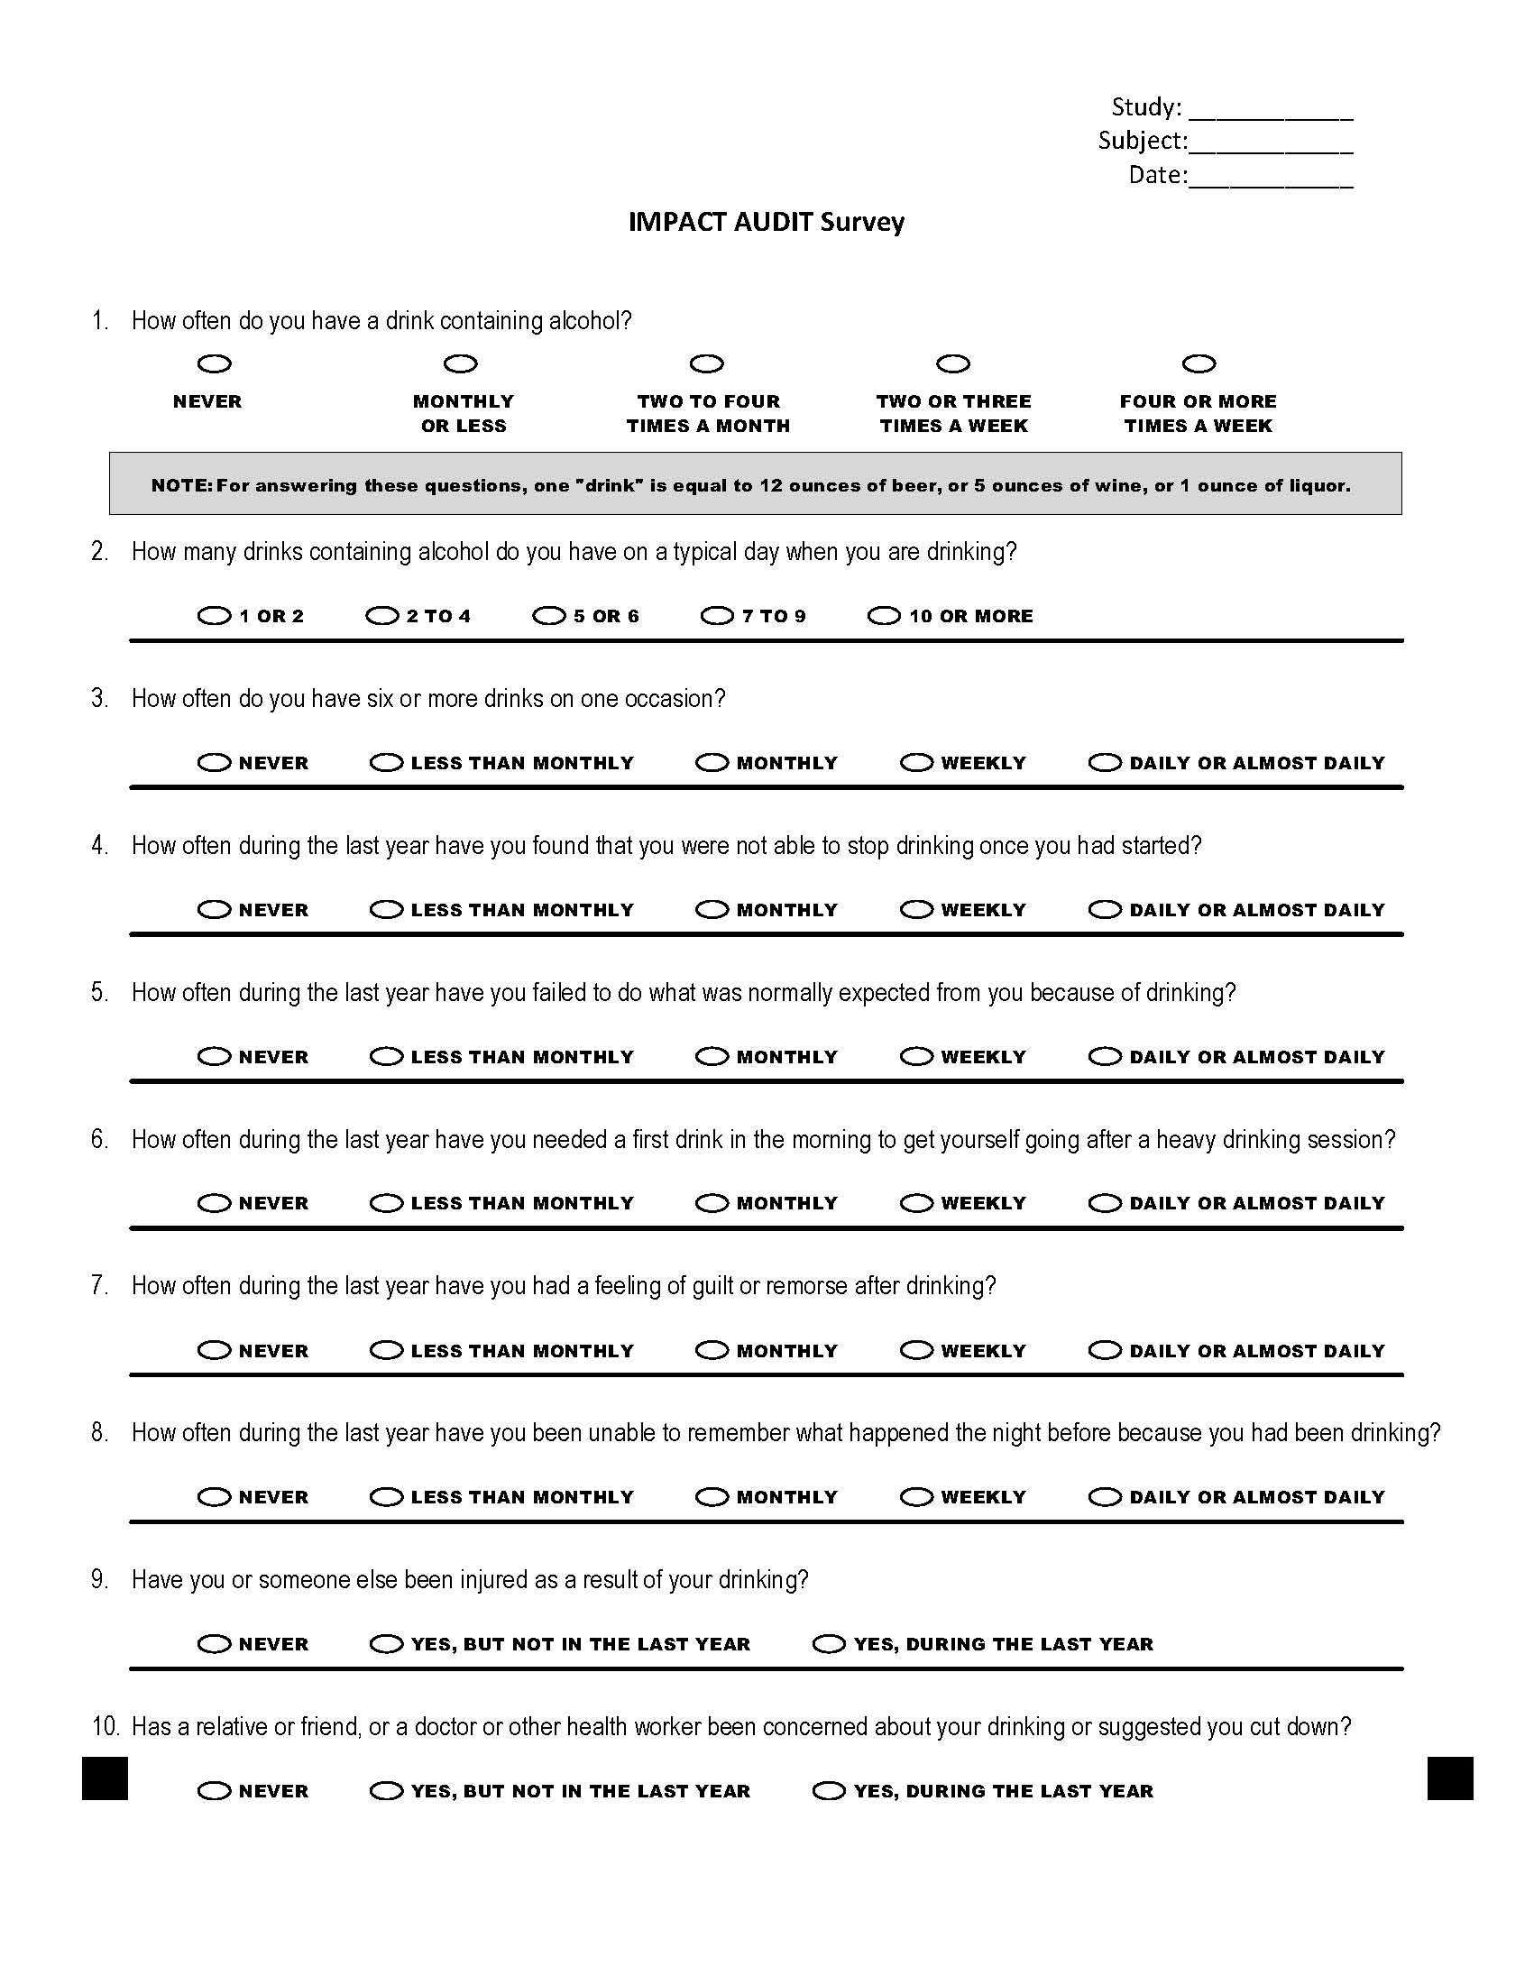

Subjects will be excluded if their responses meet the following criteria.

If a subject provides an answer to AT LEAST ONE of the criteria for either Question 4 or 6
AND if they provide one of the listed answers to TWO or MORE of the criteria listed in Questions 5, 7, 8, 9, or 10 they will be excluded from the study.

4) How often during the last year have you found that you were not able to stop drinking once you had
started?
if subject response is at least one of these:
  - Monthly
  - Weekly
  - Daily or almost daily

6) How often during the last year have you needed a first drink in the morning to get yourself going after
a heavy drinking session?
- Monthly
  - Weekly
  - Daily or almost daily

5) How often during the last year have you failed to do what was normally expected from you because
of drinking?
- Less than monthly
- Monthly
- Weekly
- Daily or almost daily

7) How often during the last year have you had a feeling of guilt or remorse after drinking?
- Less than monthly
- Monthly
- Weekly
- Daily or almost daily

8) How often during the last year have you been unable to remember what happened the night before
because you had been drinking?
- Less than monthly
- Monthly
- Weekly
- Daily or almost daily

9) Have you or someone else been injured as a result of your drinking?
- Yes, during the last year

10) Has a relative or friend, or a doctor or other health worker been concerned about your drinking or
suggested you cut down?
- Yes, during the last year

Appendix F: Experimental Procedures for IMPACT main Study

The flow of the study is presented below.

Phone Screening
- Complete the telephone screening as outlined in Screening Procedures.
- Complete Phone QFV.

Screening (Visit 1)
- Upon arriving at NADS, verify that participant has a valid driver’s license.
- Review elements of informed consent either verbally, encouraging participant to ask questions.
- Have participant sign and date Informed Consent Document. (Visit 1 Only)
- Have participant sign and date Video Release Statement (Visit 1 Only)
- Have the participant fill out the Payment Voucher. (Visit 1 Only)
- Escort participant to restroom so that urine sample can be collected.
- Participant asked to rest for 5 minutes. Urine drug screen and pregnancy test performed on urine sample performed during this time.
- Take participant’s blood pressure and heart rate
- If drug and (females pregnancy screen), blood pressure or heart rate does not meet study requirements, participant will be taken home. If passed, participant will complete a Breath alcohol test.
- Have participant fill out QFV.
- Have participant fill out AUDIT SURVEY.
- If participant remains eligible, continue with IMPACT Driving Survey. If not, participant is released to go home
- Have participant fill out IMPACT Driving Survey. (Visit 1 Only)
- Measure and record Height and Weight of participant
- Watch training video.
- Put eye tracking stickers on before escorting to simulator.
Driving (Visit 1 Only)
- Introduce in-vehicle experimenter, who takes over at this point.
- Escort participant to the vehicle and allow him/her to be seated.
- Ask the participant if he/she has any questions.
- Calibrate Eye Tracker.
- Brief the participant on the practice drive and ask if there are any questions.
- After completing practice drive, advise participant to shift into PARK.

End of Driving (Visit 1 Only)
- After the practice drive is complete and the participant has shifted into PARK, administer the Wellness Survey.
- When the simulator has docked, escort the participant to the participant prep area and make sure that prep area experimenter knows he/she is there. The prep area experimenter will confirm date and time of participant’s next three study visits.

Alcohol Dosing (Visit 2-4)
- Arrangements made to pick up participant at home.
- Escort participant to restroom so that urine sample can be collected.
- Participant asked to rest for 5 minutes. Urine drug screen and pregnancy test performed on urine sample performed during this time.
- Take participant’s blood pressure and heart rate
- If drug and (females pregnancy screen), blood pressure or heart rate does not meet study requirements, participant will be taken home. If passed, participant will complete a Breath alcohol test.
- If participant remains eligible, have participant fill out Sleep/ Food Intake Survey. If not, take home.
- Administer 1st drink and allow participant 10 minutes to drink, instructing participant to pace self to drink for entire 10 minutes. Staff stays in room to monitor.
- Administer 2nd drink and allow participant 10 minutes to drink, instructing participant to pace self to drink for entire 10 minutes , instructing participant to pace self to drink for entire 10 minutes. Staff stays in room to monitor.
- Administer 3rd drink and allow participant 10 minutes to drink, instructing participant to pace self to drink for entire 10 minutes. Staff stays in room to monitor.
- Wait 16 minutes after the end of the last drink.
- Take a BAC measurement with Breathalyzer every 2-5 minutes until peak BAC of +/- 0. 005% is reached.
- When peak BAC is reached, participant is ready for simulator.

Driving (Visit 2-4)
- Introduce in-vehicle experimenter, who takes over at this point.
- Escort participant to the vehicle and allow him/her to be seated.
- Ask the participant if he/she has any questions.
- Calibrate Eye Tracker.
- Brief the participant on the study drive and ask if there are any questions.
- Administer Stanford Sleepiness Scale.
- DriveAfter completing study drive, advise participant to shift into PARK.

End of Driving (Visit 2-4)
- After the study drive is complete and the participant has shifted into PARK, take a BAC Measurement
- Administer the Stanford Sleepiness Scale and Wellness Survey.
- When the simulator has docked, escort the participant to the participant prep area and make sure that prep area experimenter knows he/she is there. The prep area experimenter takes over at this point.

Wrap-Up (Visit 2-4)
- Offer participant snack/beverage.
- Ask if participant has any questions.
- Allow participant to complete Wellness Survey if not finished in vehicle.
- Administer Standardized Field Sobriety Test.
- Administer Realism Survey.
- Administer IMPACT Debrief Statement. (Visit 4 only)
- Administer IMPACT Debrief Interview. (Visit 4 only)
- Participant waits comfortably at NADS facility until BAC level is less than .03.
- Arrange transportation for participant to go home

Assignment to Treatment
Table F-1 BAC sequence and event sequence across participants
 |  | Age
 |  | 21-34 |  | 38-51 |  | 55-68
 |  | Gender |  | Gender |  | Gender
BAC Sequence | Event Sequence | Male | Female | Male | Female | Male | Female
1 | 1 | 2 | 2 | 2 | 2 | 2 | 2
1 | 2 | 2 | 2 | 2 | 2 | 2 | 2
1 | 3 | 2 | 2 | 2 | 2 | 2 | 2
2 | 1 | 2 | 2 | 2 | 2 | 2 | 2
2 | 2 | 2 | 2 | 2 | 2 | 2 | 2
2 | 3 | 2 | 2 | 2 | 2 | 2 | 2
3 | 1 | 2 | 2 | 2 | 2 | 2 | 2
3 | 2 | 2 | 2 | 2 | 2 | 2 | 2
3 | 3 | 2 | 2 | 2 | 2 | 2 | 2
Total |  | 18 | 18 | 18 | 18 | 18 | 18
Note. BAC sequence 1 = 0.10%, 0.05%, 0.00%, 2 = 0.05%, 0.00%, 0.10%, 3 = 0.00%, 0.10%, 0.05%. Total participants must add to multiples of 54. Current number of participants = 108.

Appendix G: In-Cab Protocol
IMPACT MainP1 in-cab protocol (Auto Eye Tracking)
CAB ORIENTATION
[Participant has already viewed an introductory PPT about the study and the Malibu adjustments.]
[open car door]
(RAS): Please be seated and make the adjustments so you are in a comfortable driving position. If you need any help, please let me know. [Show mirror control panel but remind to adjust after eye tracking pix]
[RAS enters back seat at this time] [Resting position reminder]
(RAS): We are going to set the cameras for eye tracking so please look straight ahead at this time.
[Control room should cue that ET is working.]
[after Auto ET is done, during start up of sim, play file] Sim Start: The simulator is moving towards its start position. During this time, you may hear rumbling and feel vibrations. This is perfectly normal. There are microphones in the cab so the Simulator Operator can hear you at all times. If, for any reason, you wish to stop driving, please let us know. The Operator can bring you to a stop in just a few seconds.
[Practice drive is only on first visit. If other than 1st visit, go directly to Main Drive.]

PRACTICE DRIVE [First time visit only]
(play file) Practice Drive: Your first drive will be a practice drive. It is designed to help you get used to the simulator. During this drive you should become familiar with driving at the various posted speed limits and recognizing traffic control devices. When it is time to begin, instructions will tell you to merge into traffic. Onboard navigational instructions will provide directions to the interstate and instruct you when to adjust the CD player. A recording will tell you when it is time to stop. Do you have any questions?
[At End, pre-recorded stop instructions will play]
[Seatbelt reminder]
[Administer first SSQ] [Exit Simulator]
.. .. Control room
.. .. RAS
.. .. Surveys
[Go to Main Drive]

MAIN DRIVE
[First visit]
(RAS): [1st visit] Please look straight ahead so they can check the Eye Tracking.
[Go to SIM START]
[Return Visit]
[open car door]
(RAS): Please be seated and make the adjustments so you are in a comfortable driving position. If you need any help, please let me know. [Show mirror control panel but remind to adjust after eye tracking pix]
[RAS enters back seat at this time] [Resting position reminder]
(RAS): We are going to set the cameras for eye tracking so please look straight ahead at this time.
[Control room should cue that ET is working.]
[SIM START]
[after Auto ET is done, during start up of sim, play file] Sim Start: The simulator is moving towards its start position. During this time, you may hear rumbling and feel vibrations. This is perfectly normal. There are microphones in the cab so the Simulator Operator can hear you at all times. If, for any reason, you wish to stop driving, please let us know. The Operator can bring you to a stop in just a few seconds.
[Sleep Scale before Main Drive]
[RAS: cue driver to upcoming drive instructions]
(play file): MAIN: The Main drive will start shortly. Remember to listen to the on-board instructions carefully. If you have any uncertainty about navigating during the drive, please ask. Do you have any questions at this time?
[If No...] (RAS) Are you ready? [if YES, Operator cues going to RUN] (RAS)Standby for scenery and instructions.
[RAS stays quiet but can give concise directions if asked, intervene for well being and study continuity or provide segue during restarts]
[RAS works with Operator to identify correct restart if needed]
END MAIN DRIVE
[Seatbelt fastened reminder. [Administer SSQ and Sleep Scale] [Exit Simulator]

Appendix H: Control Room Logs

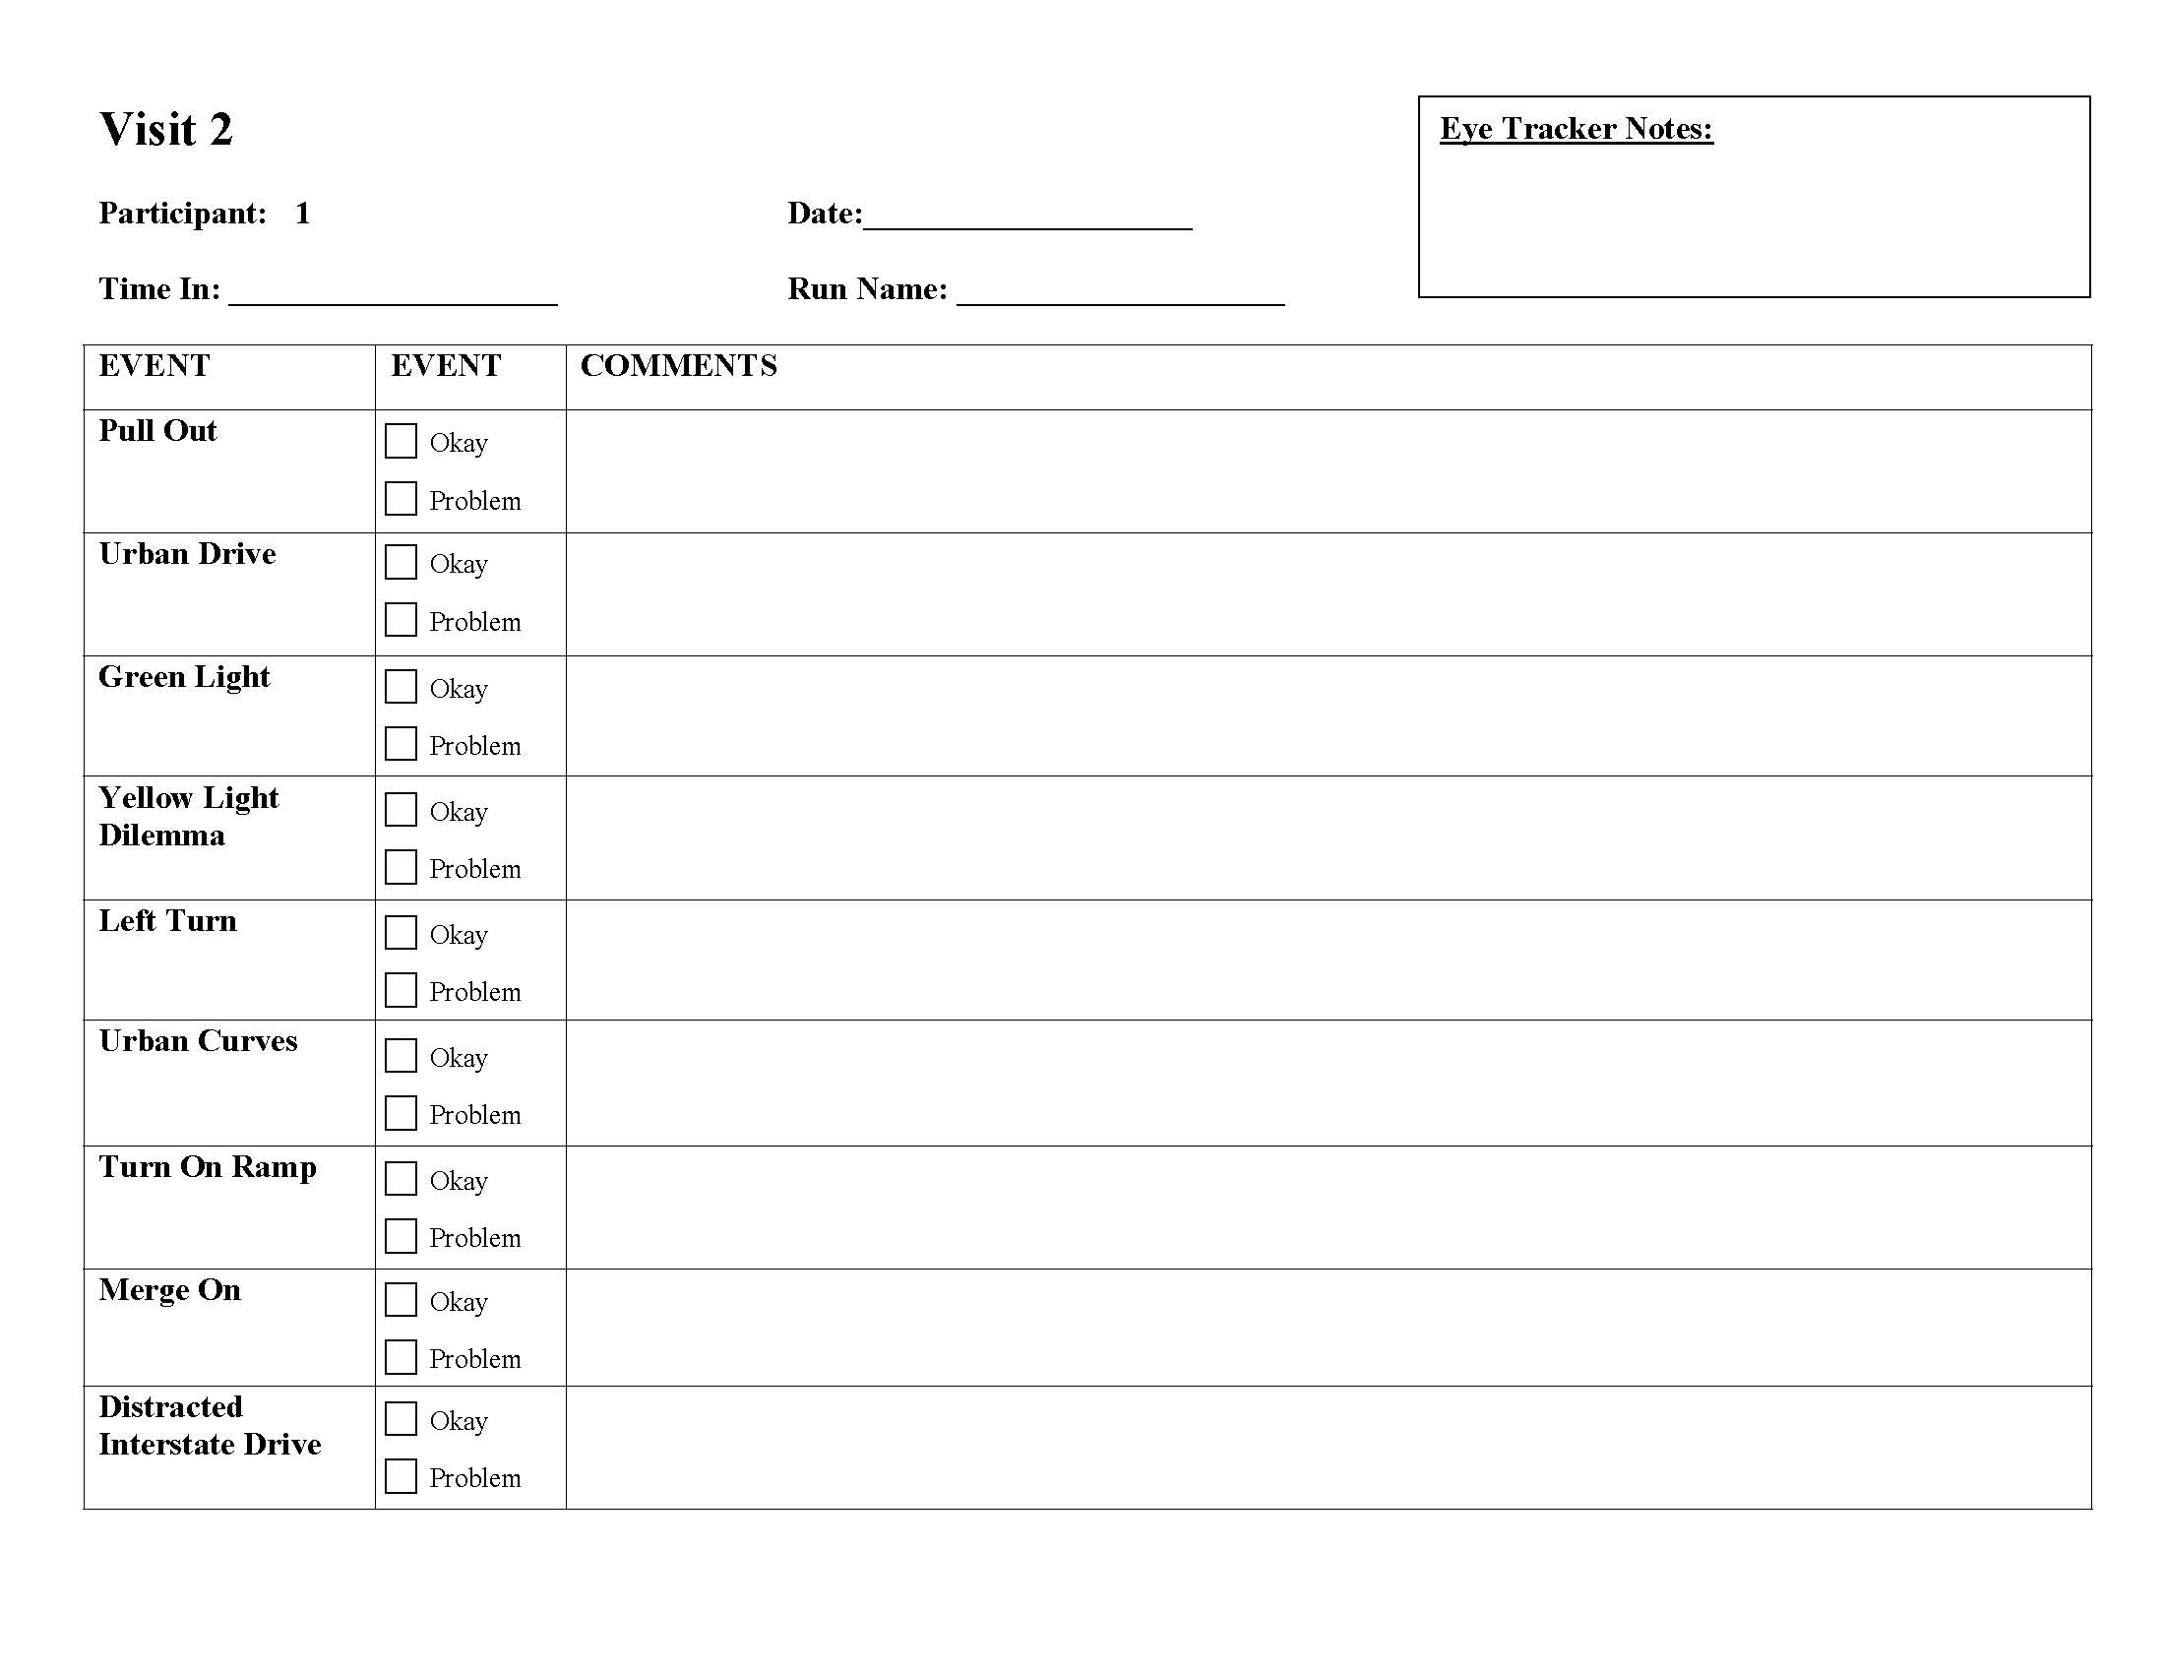
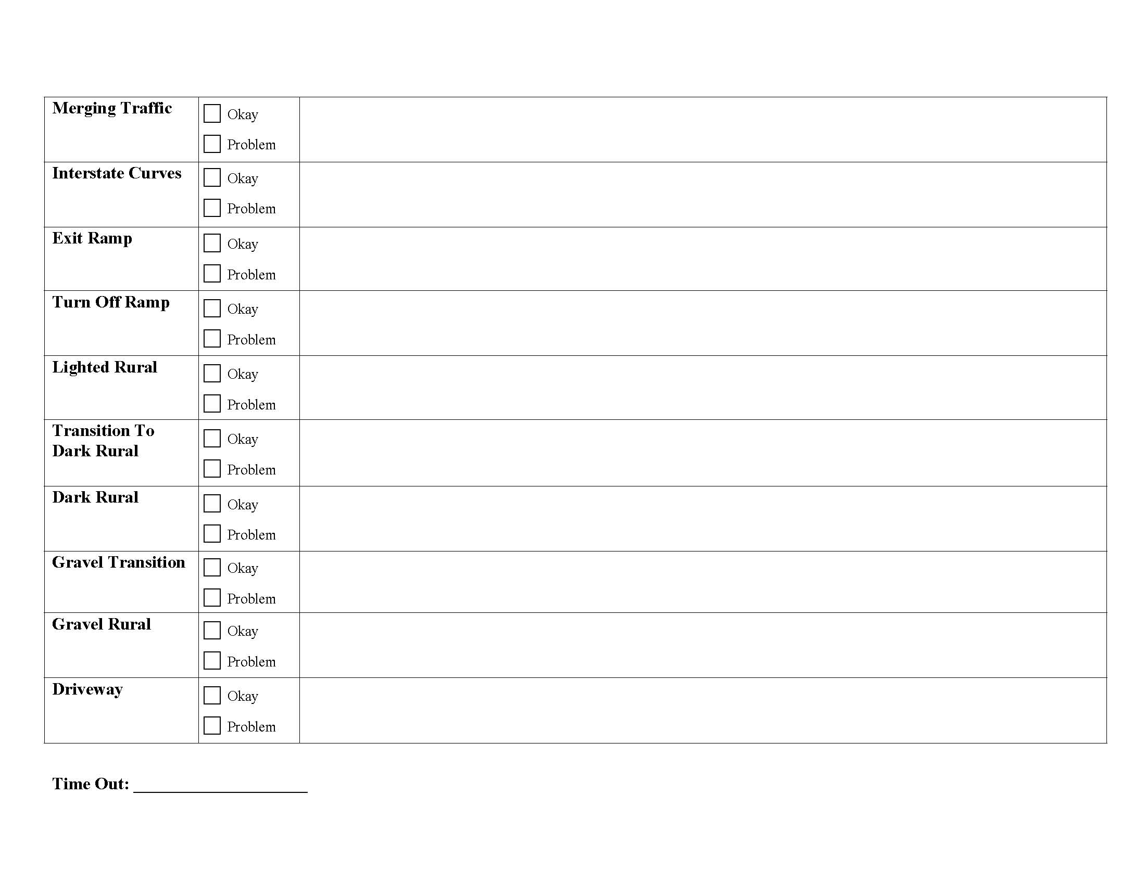
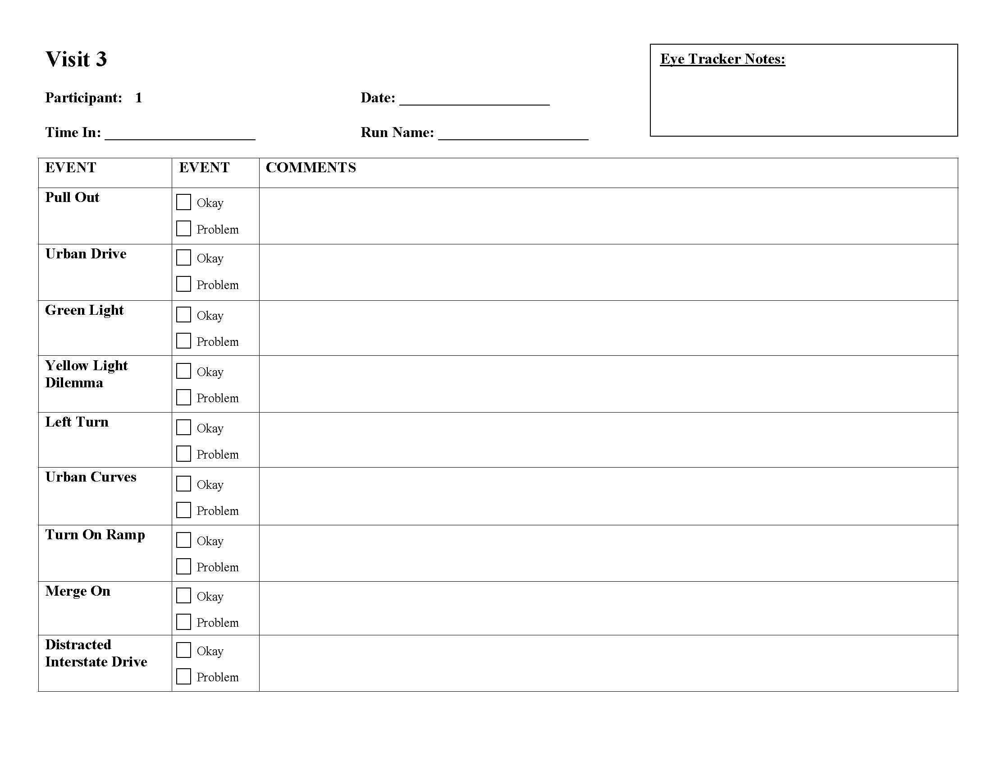
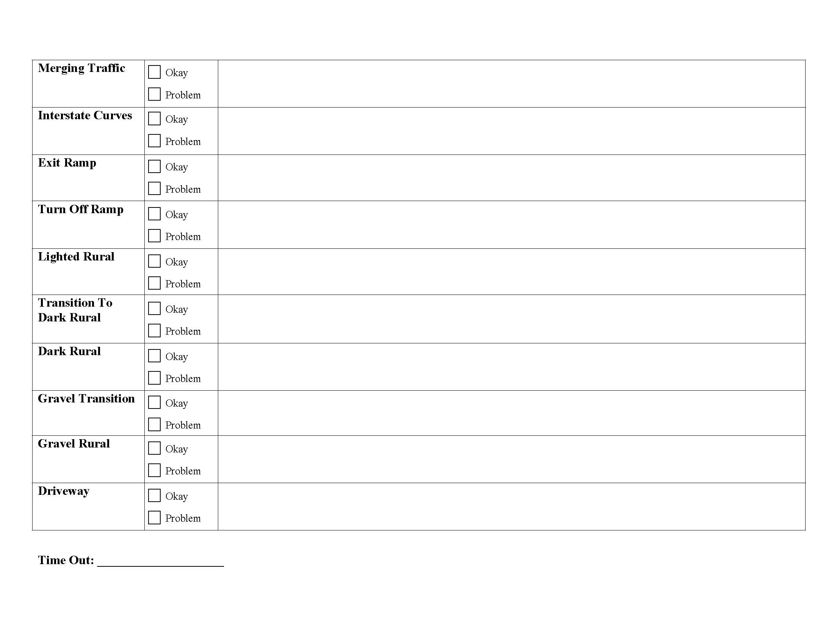
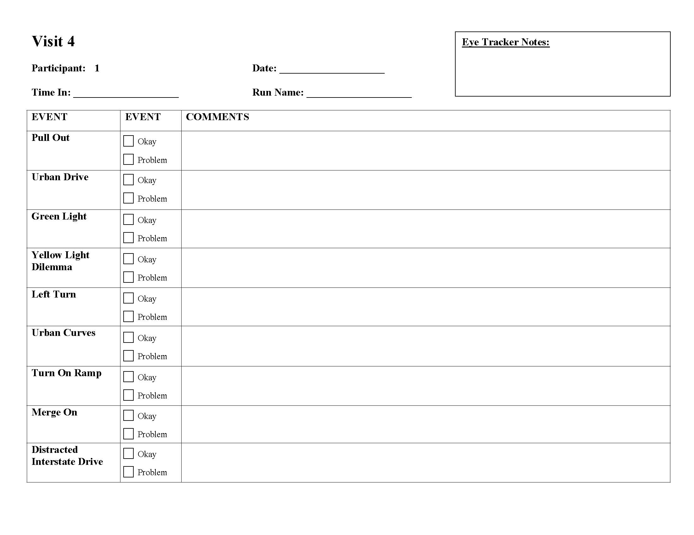
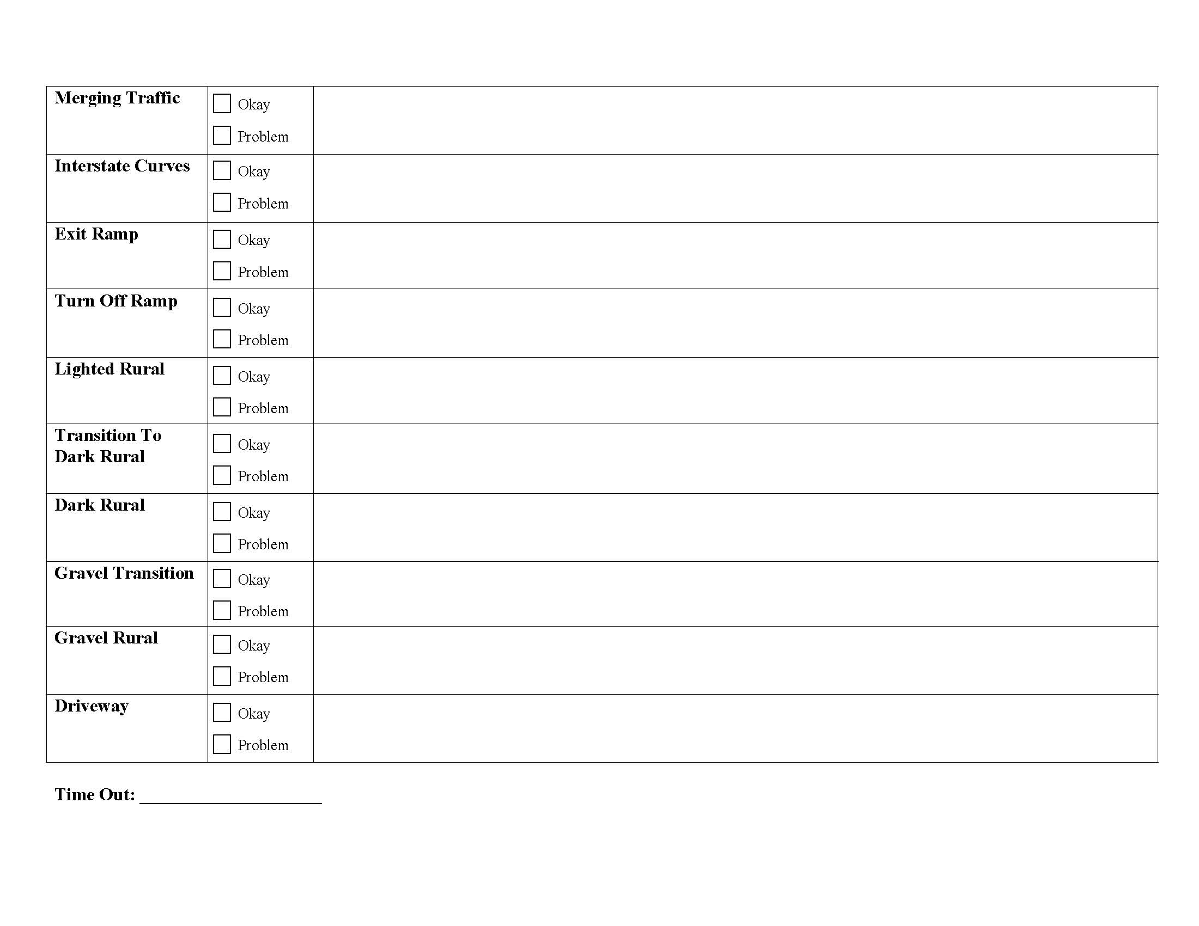

Appendix I: Informed Consent Document (Main IFC)
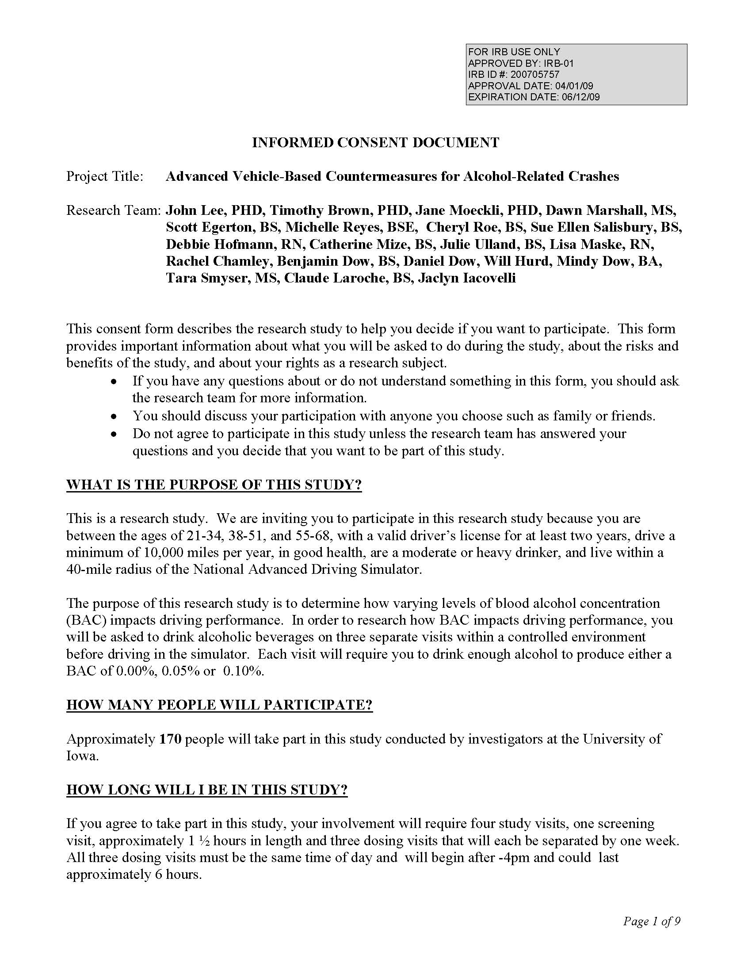
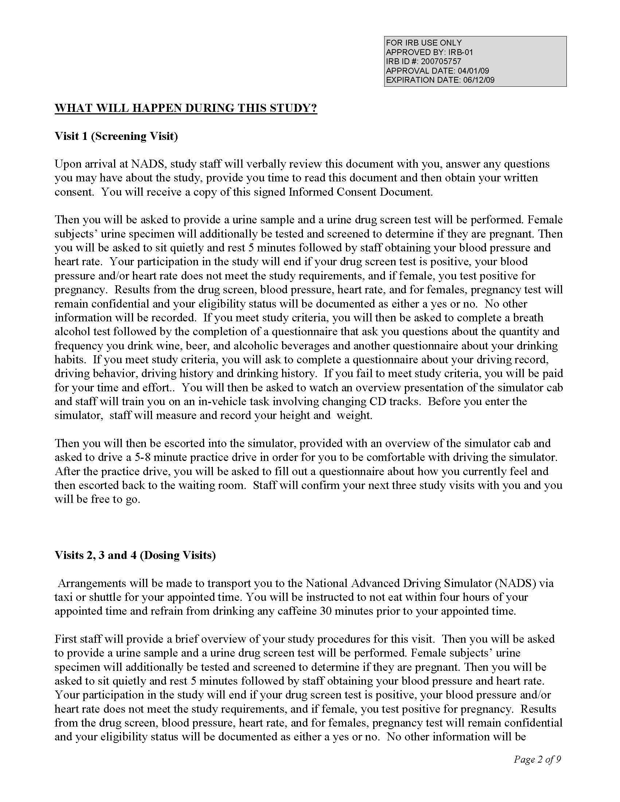
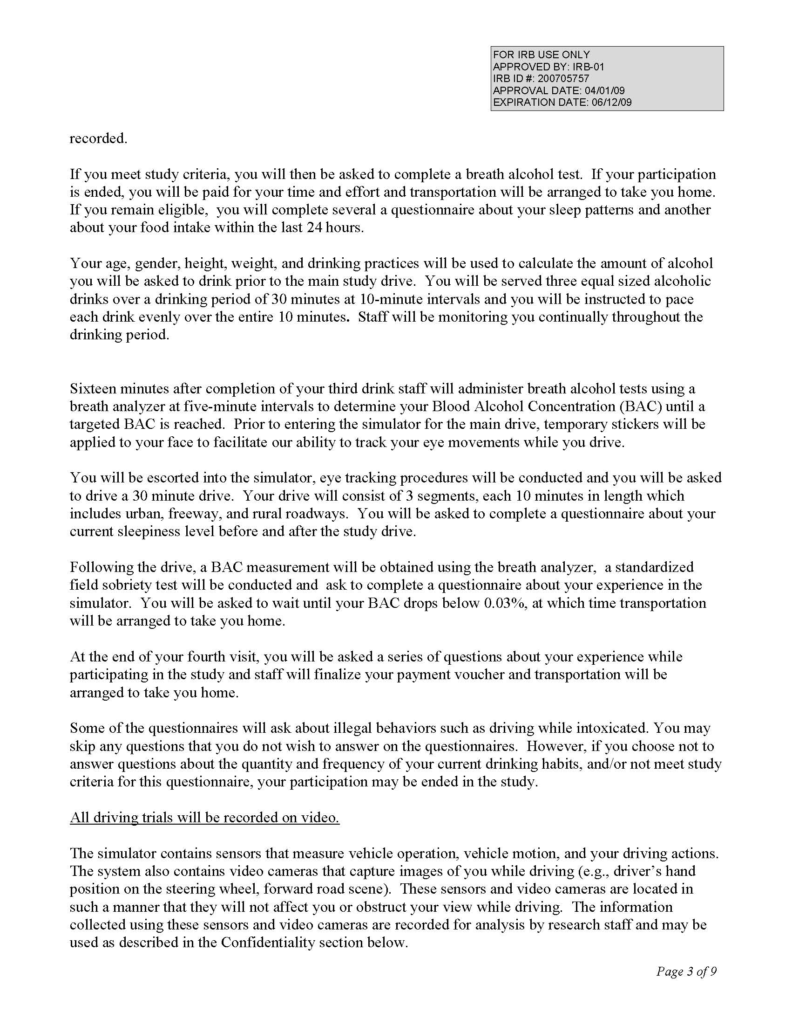
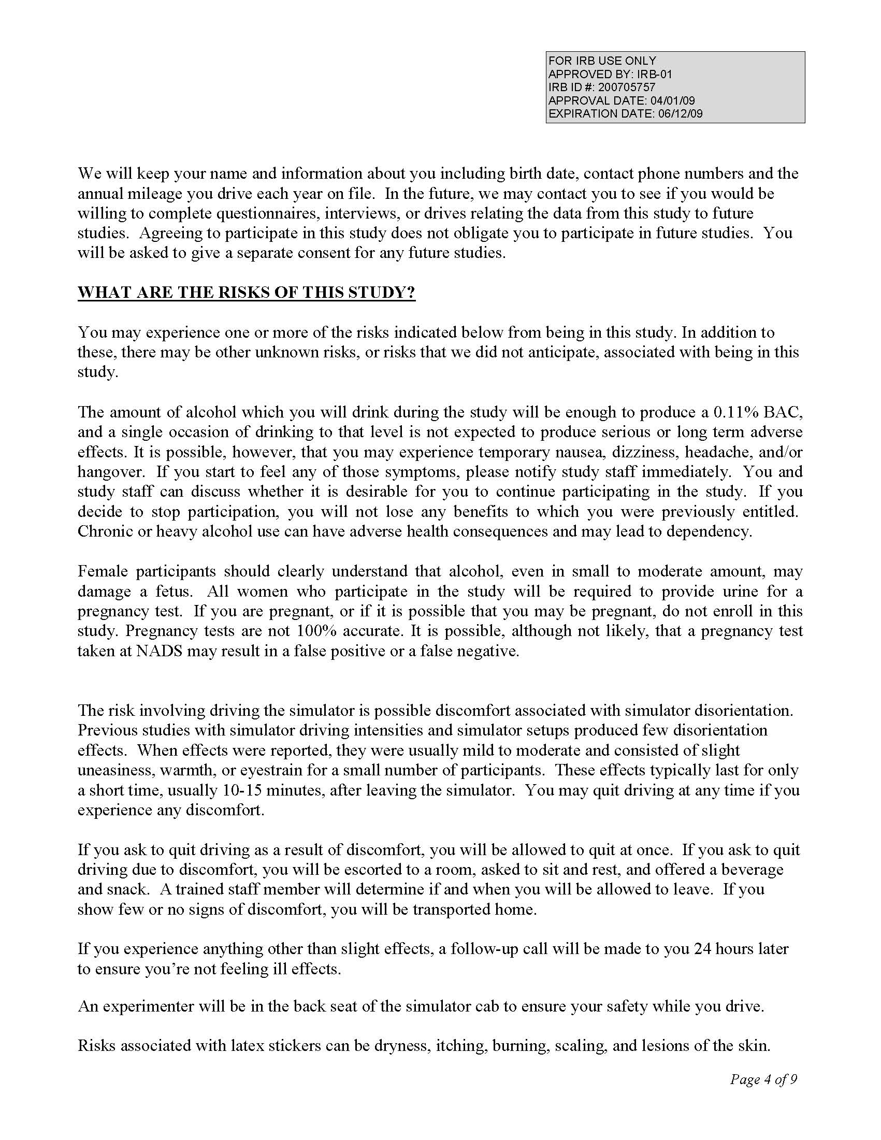
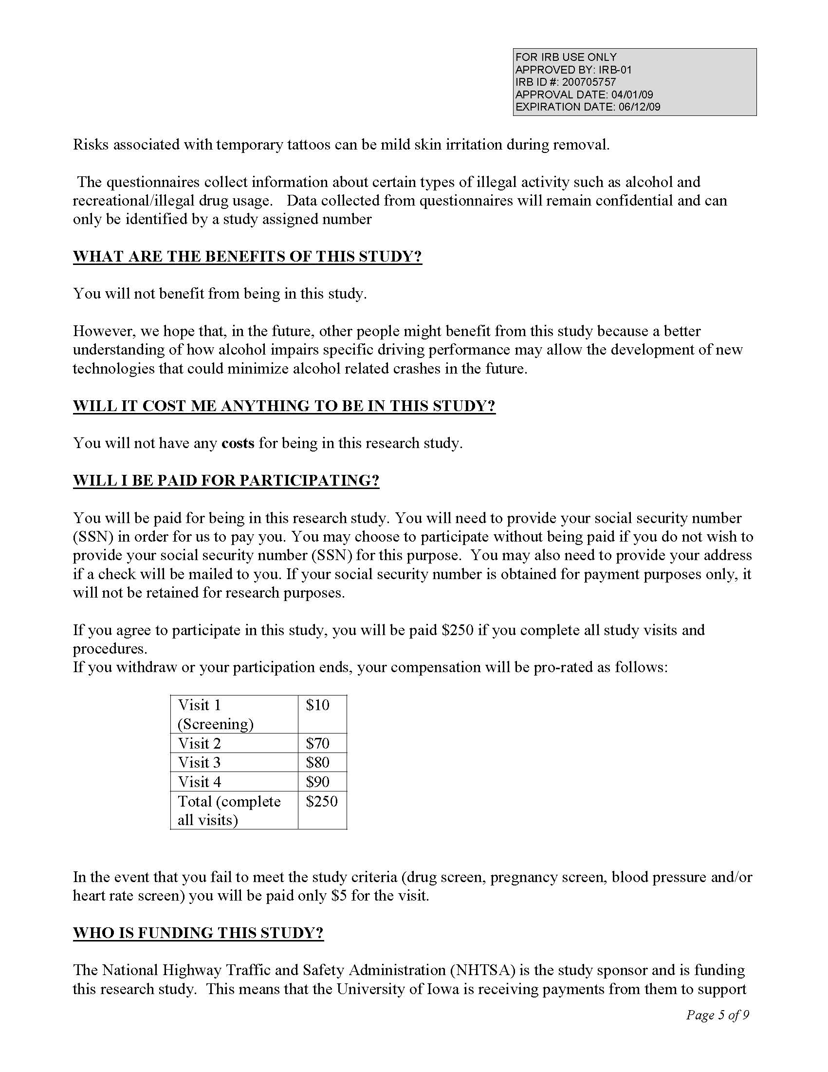
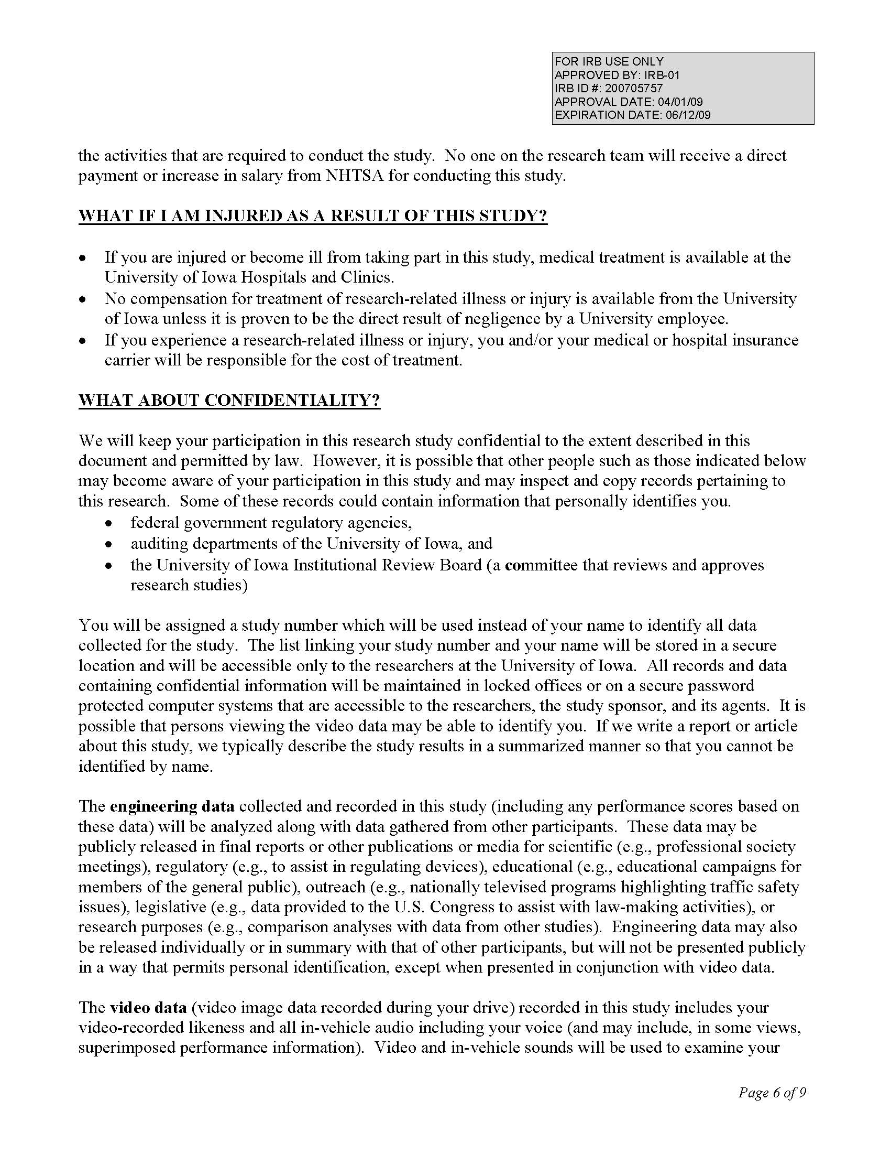
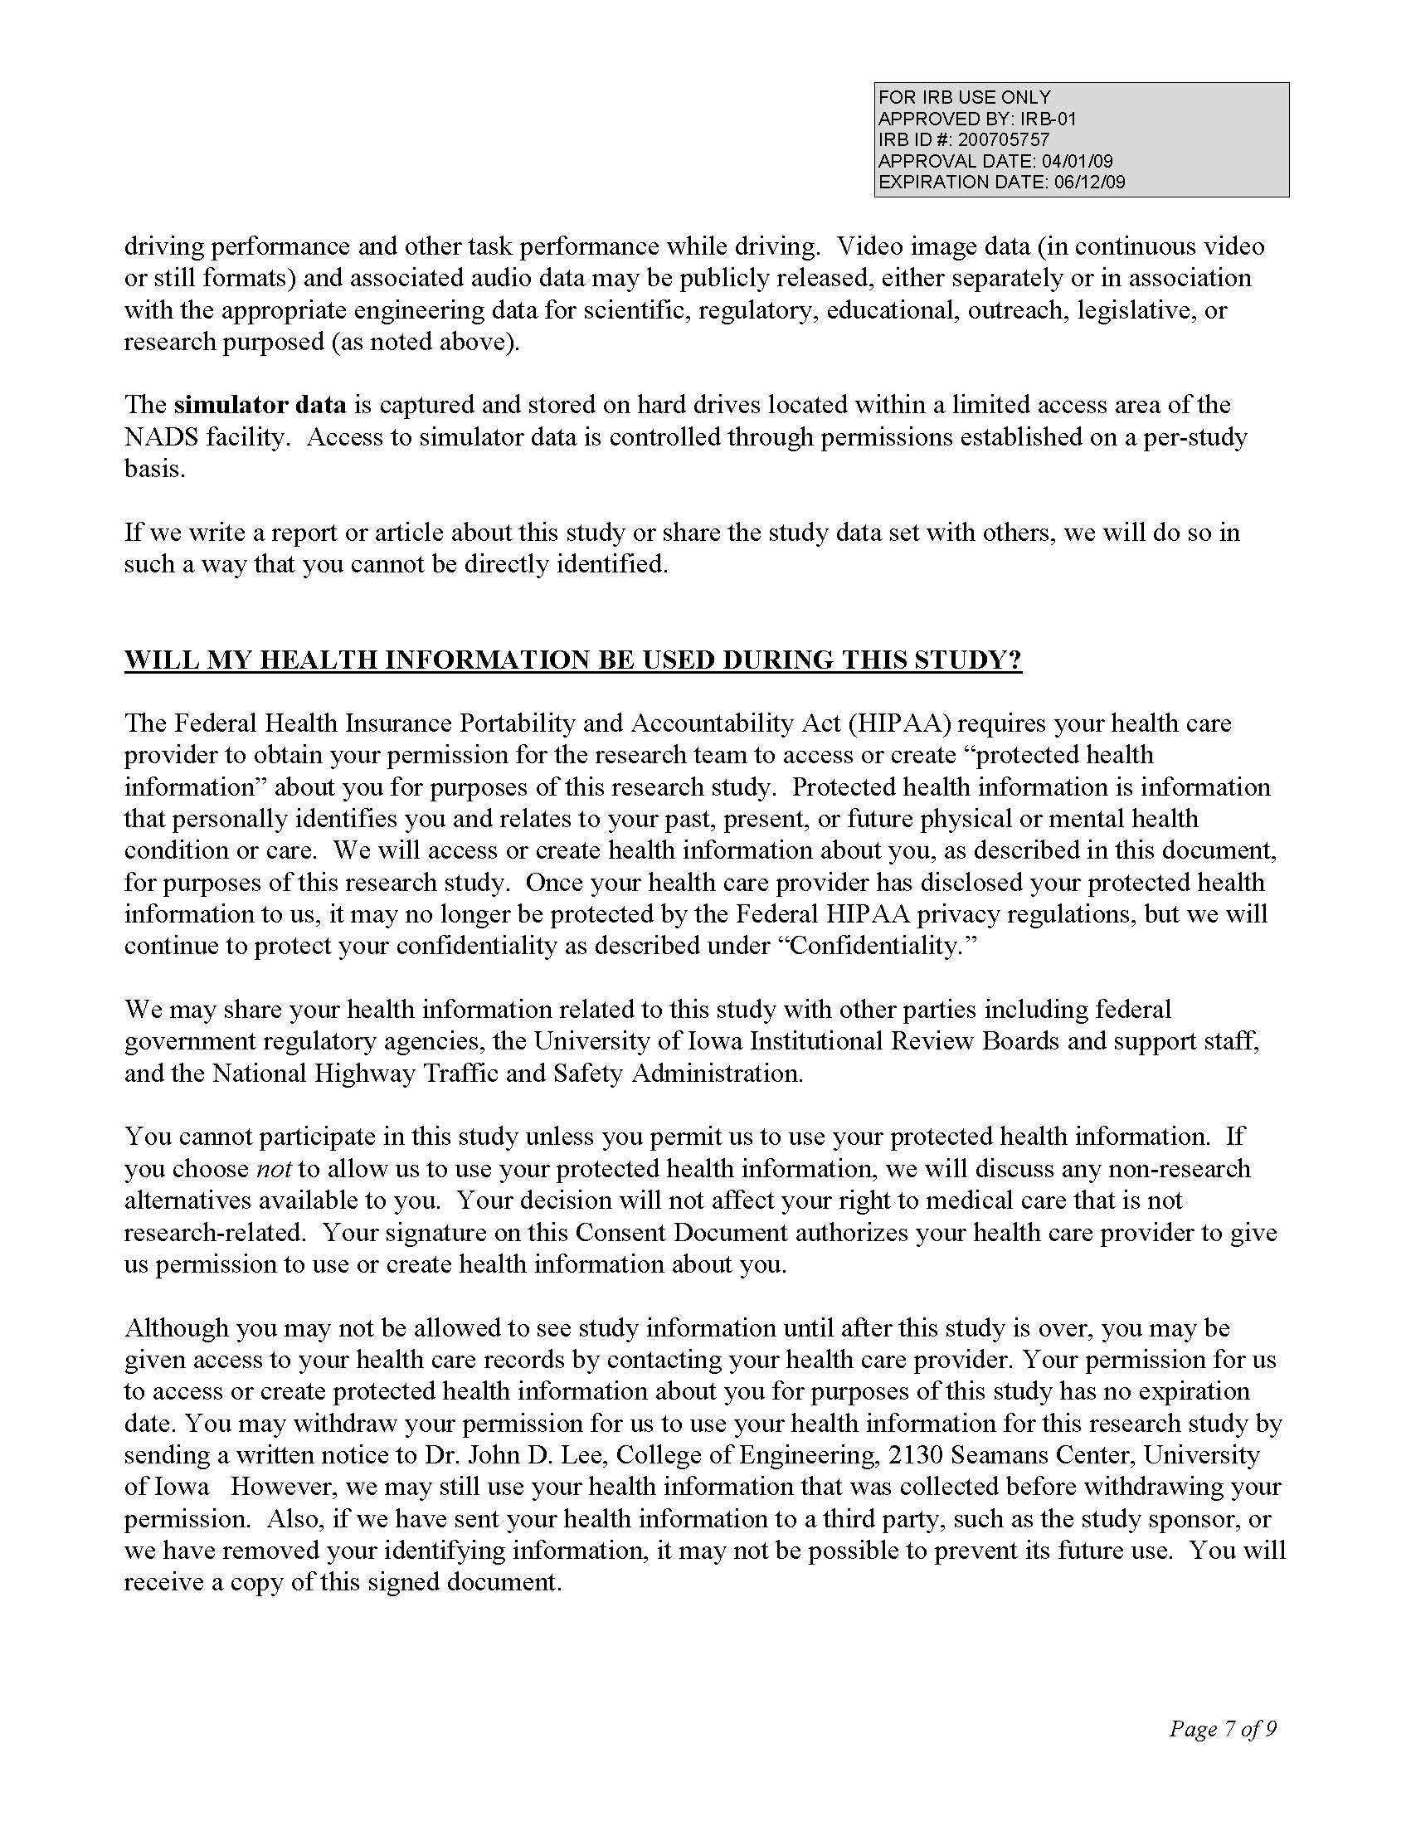
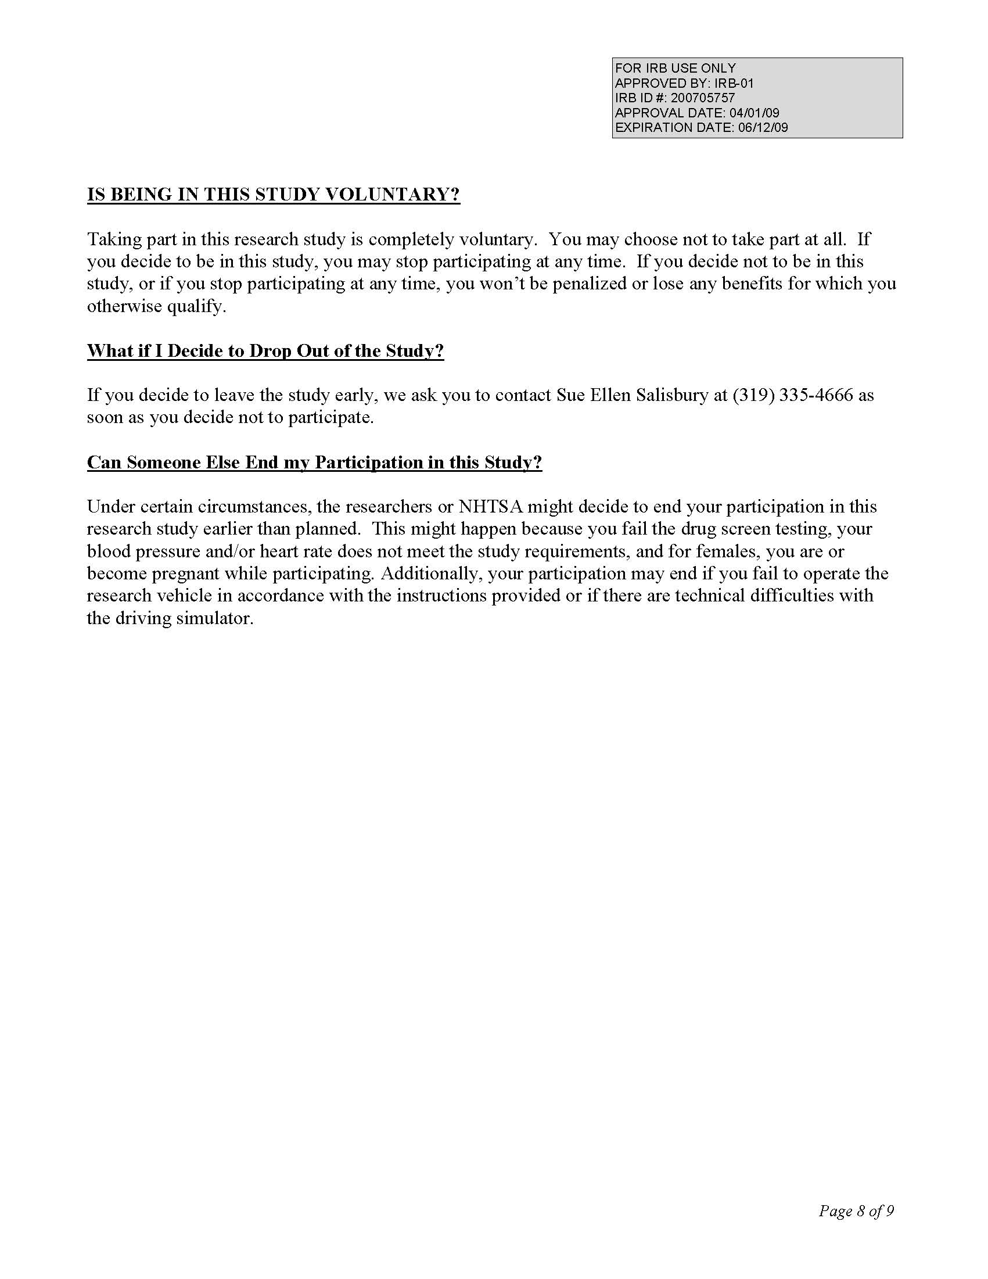

Appendix J: Quantity, Frequency, Variability (QFV) Scale

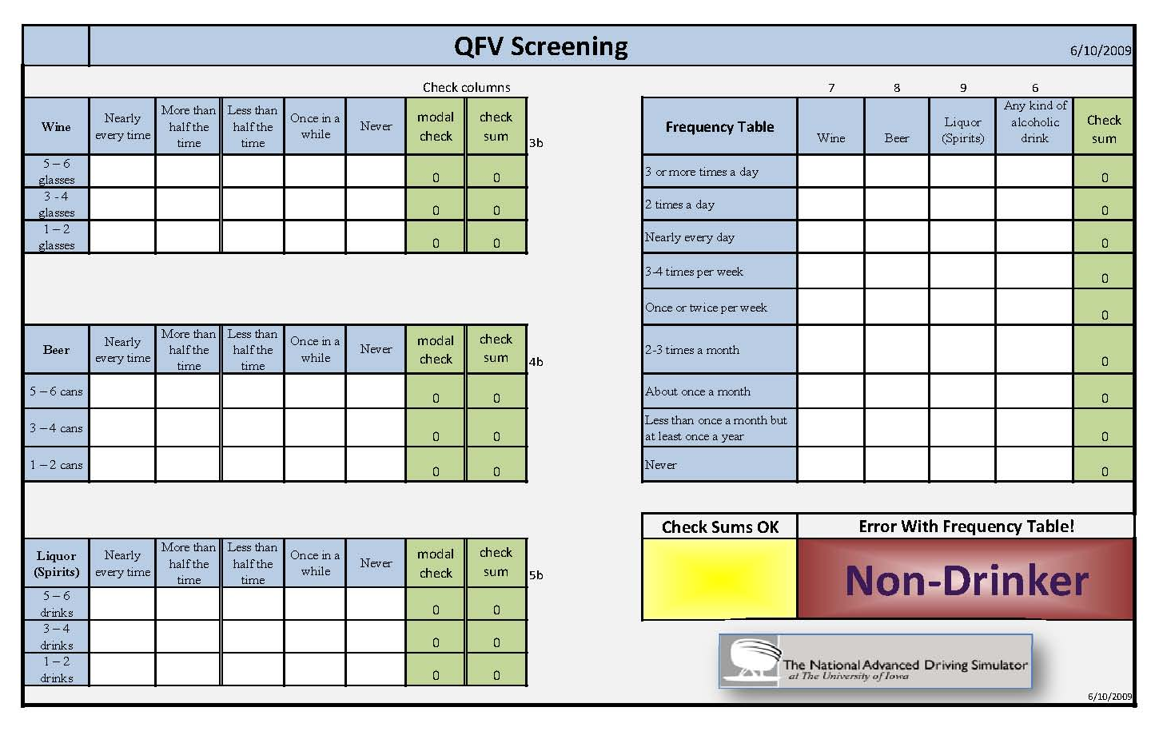

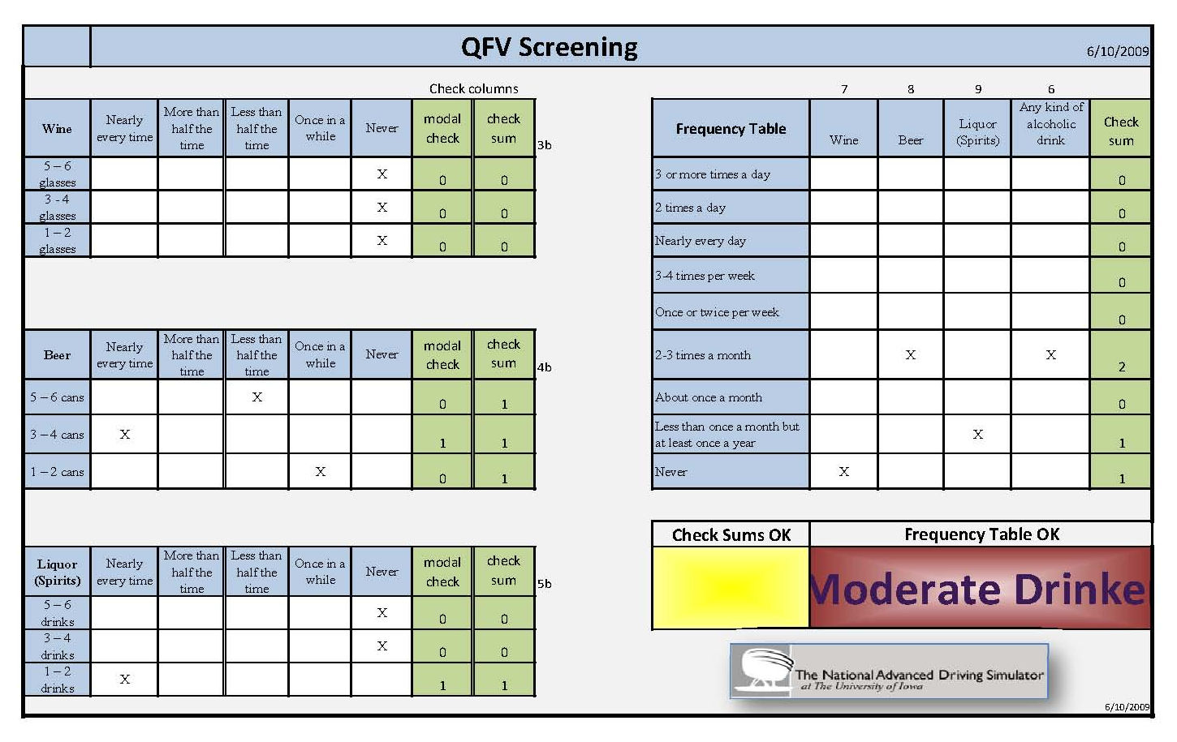

Appendix K: Driving Survey T2
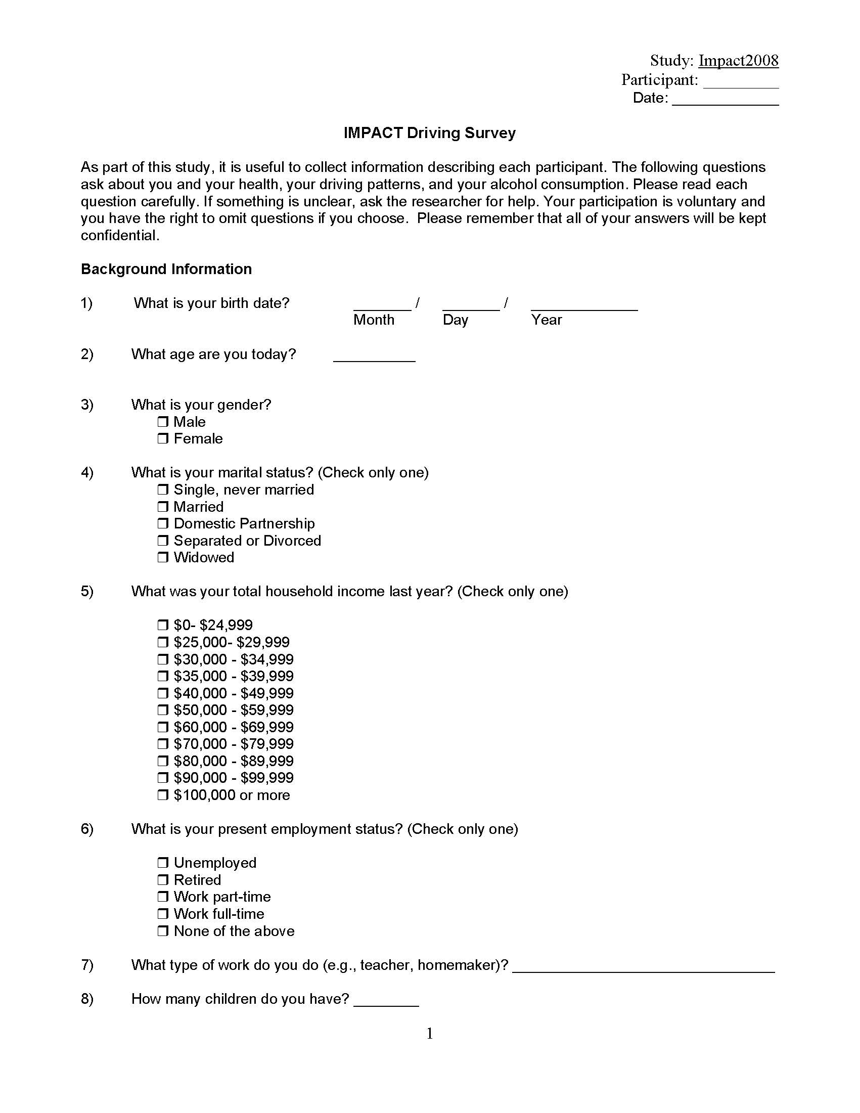
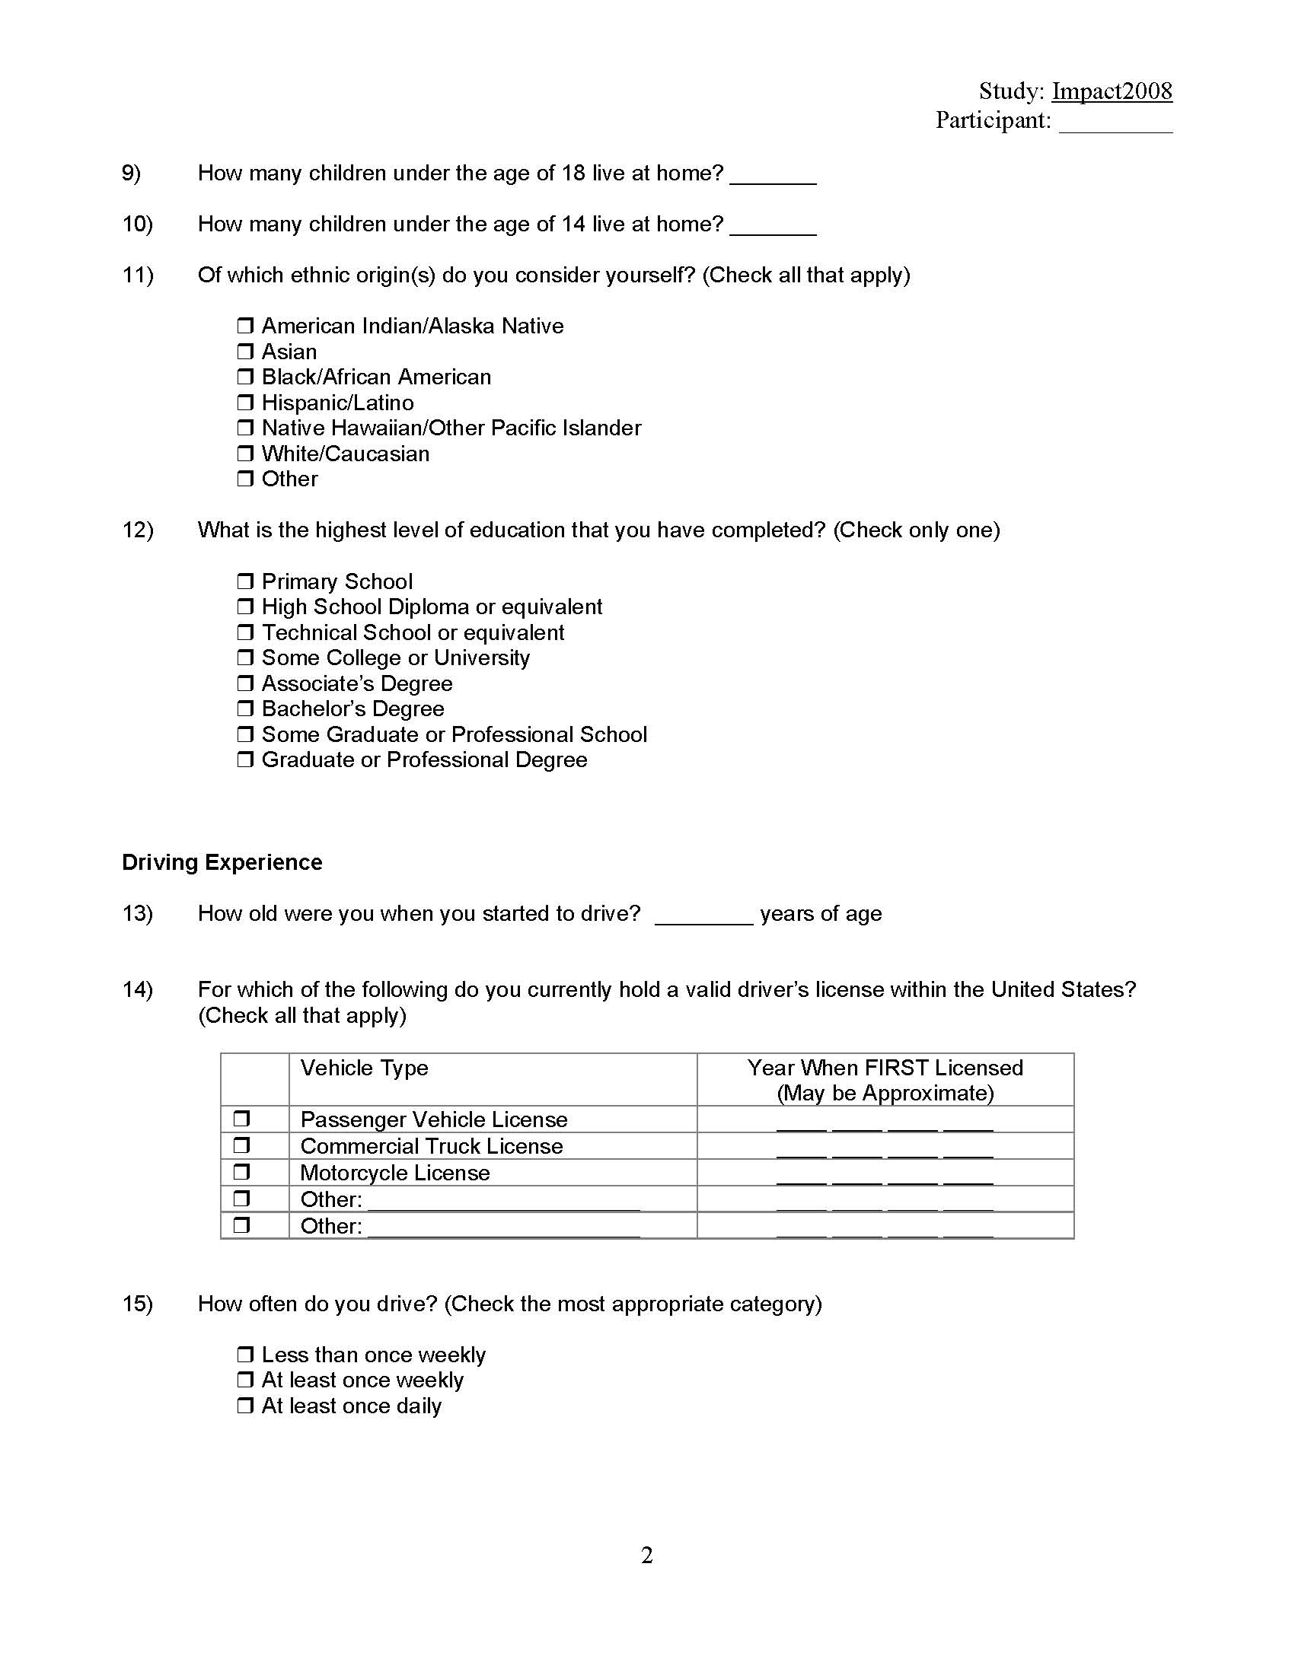
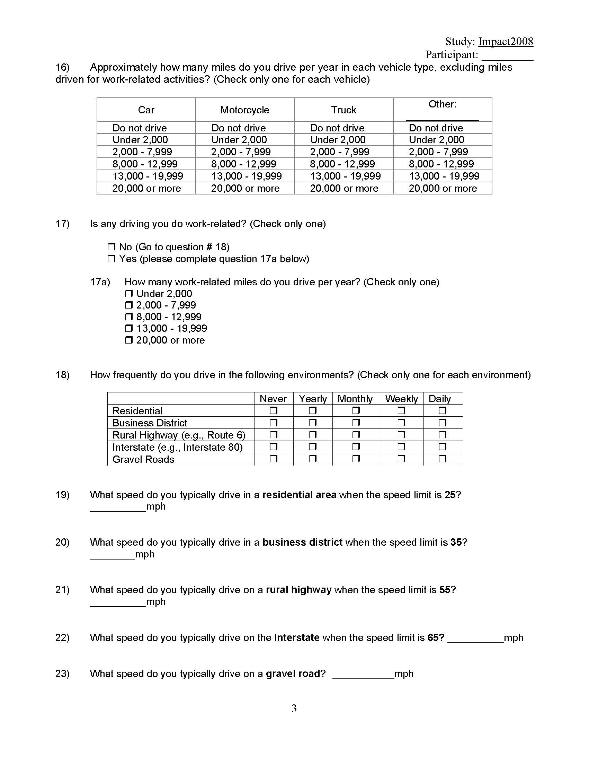
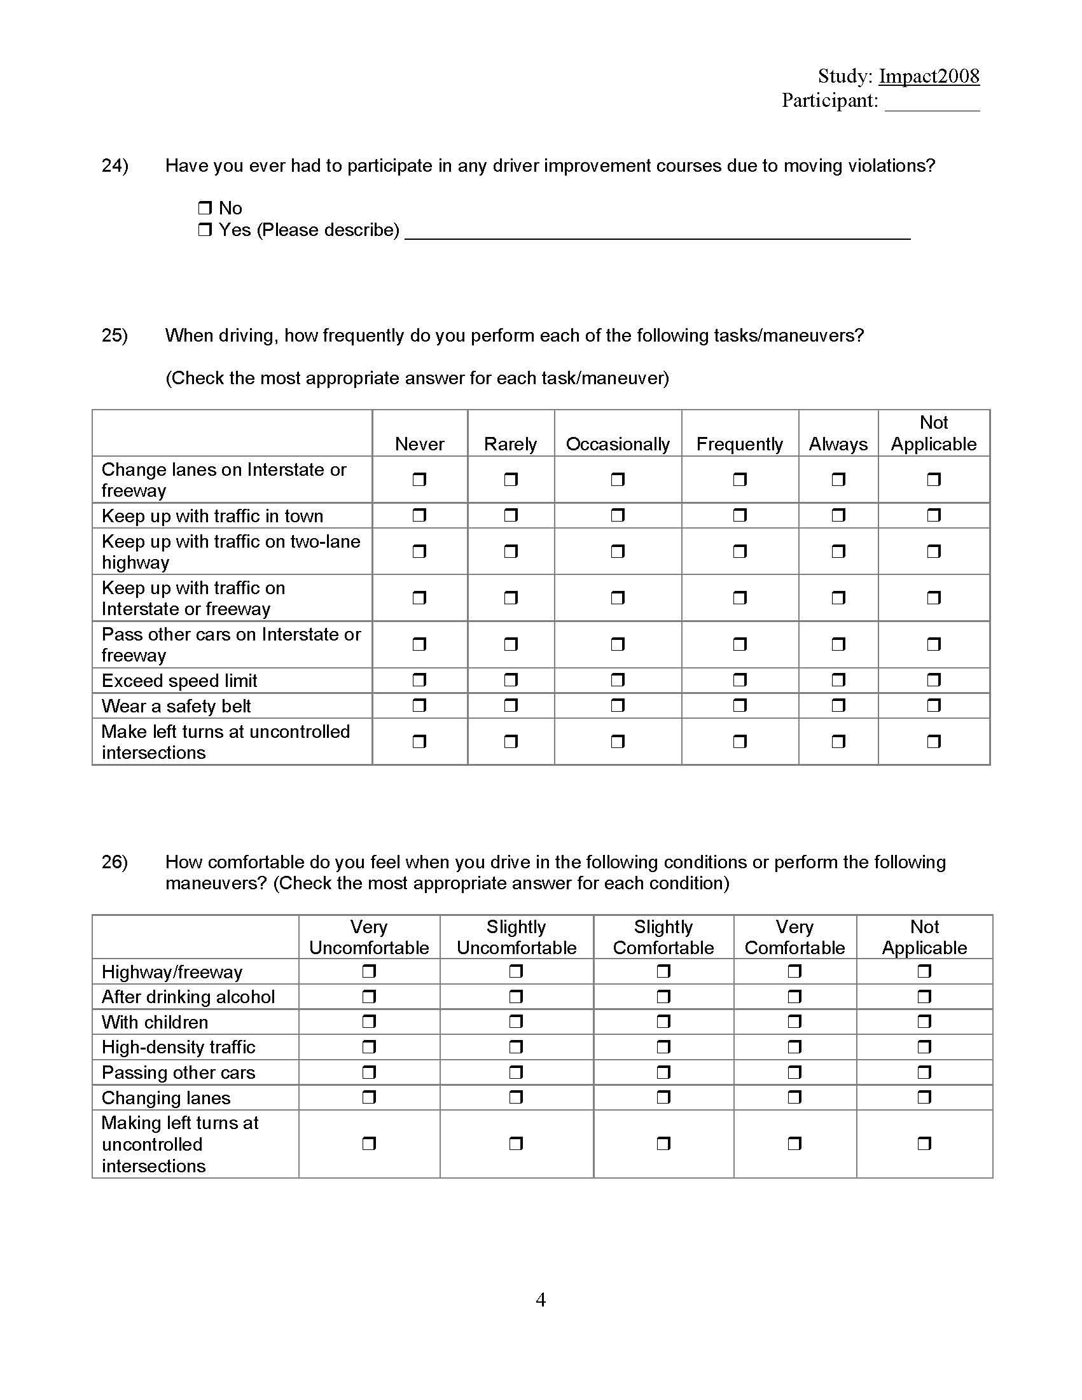
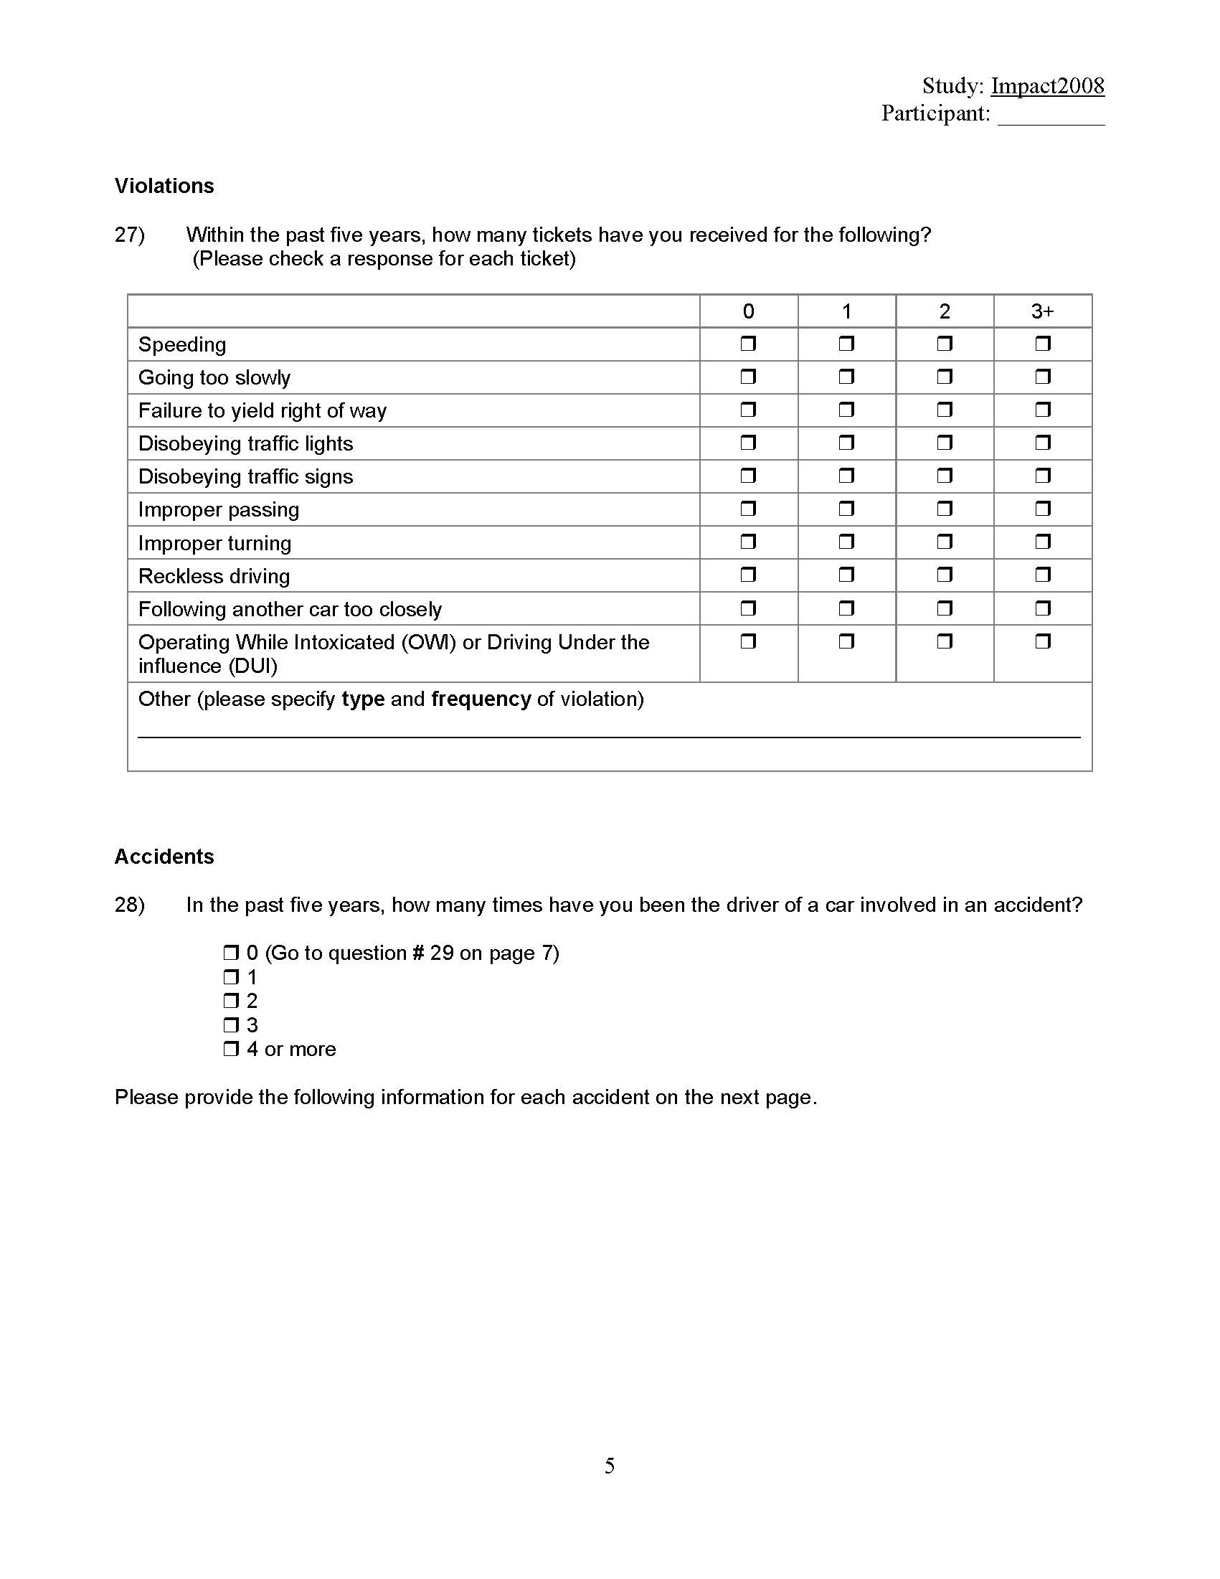
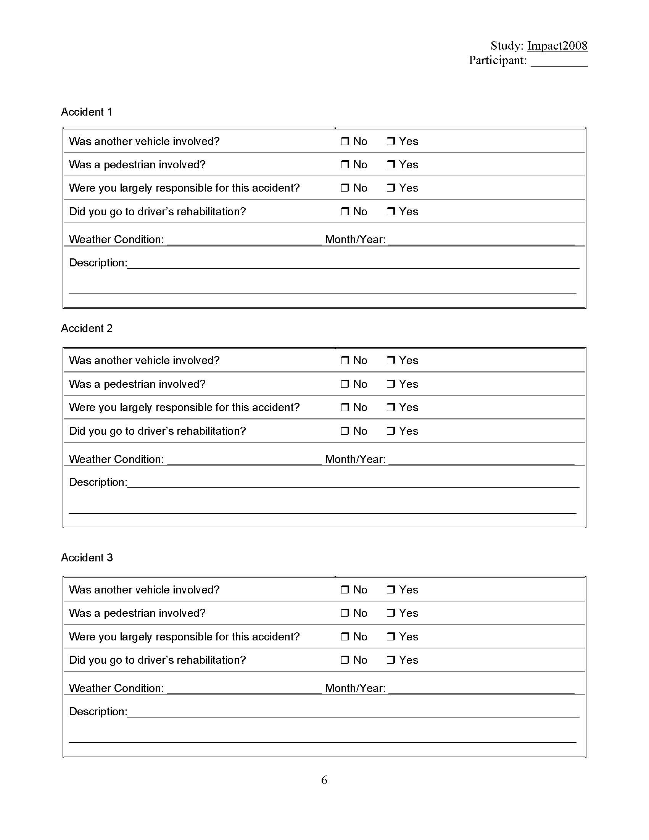
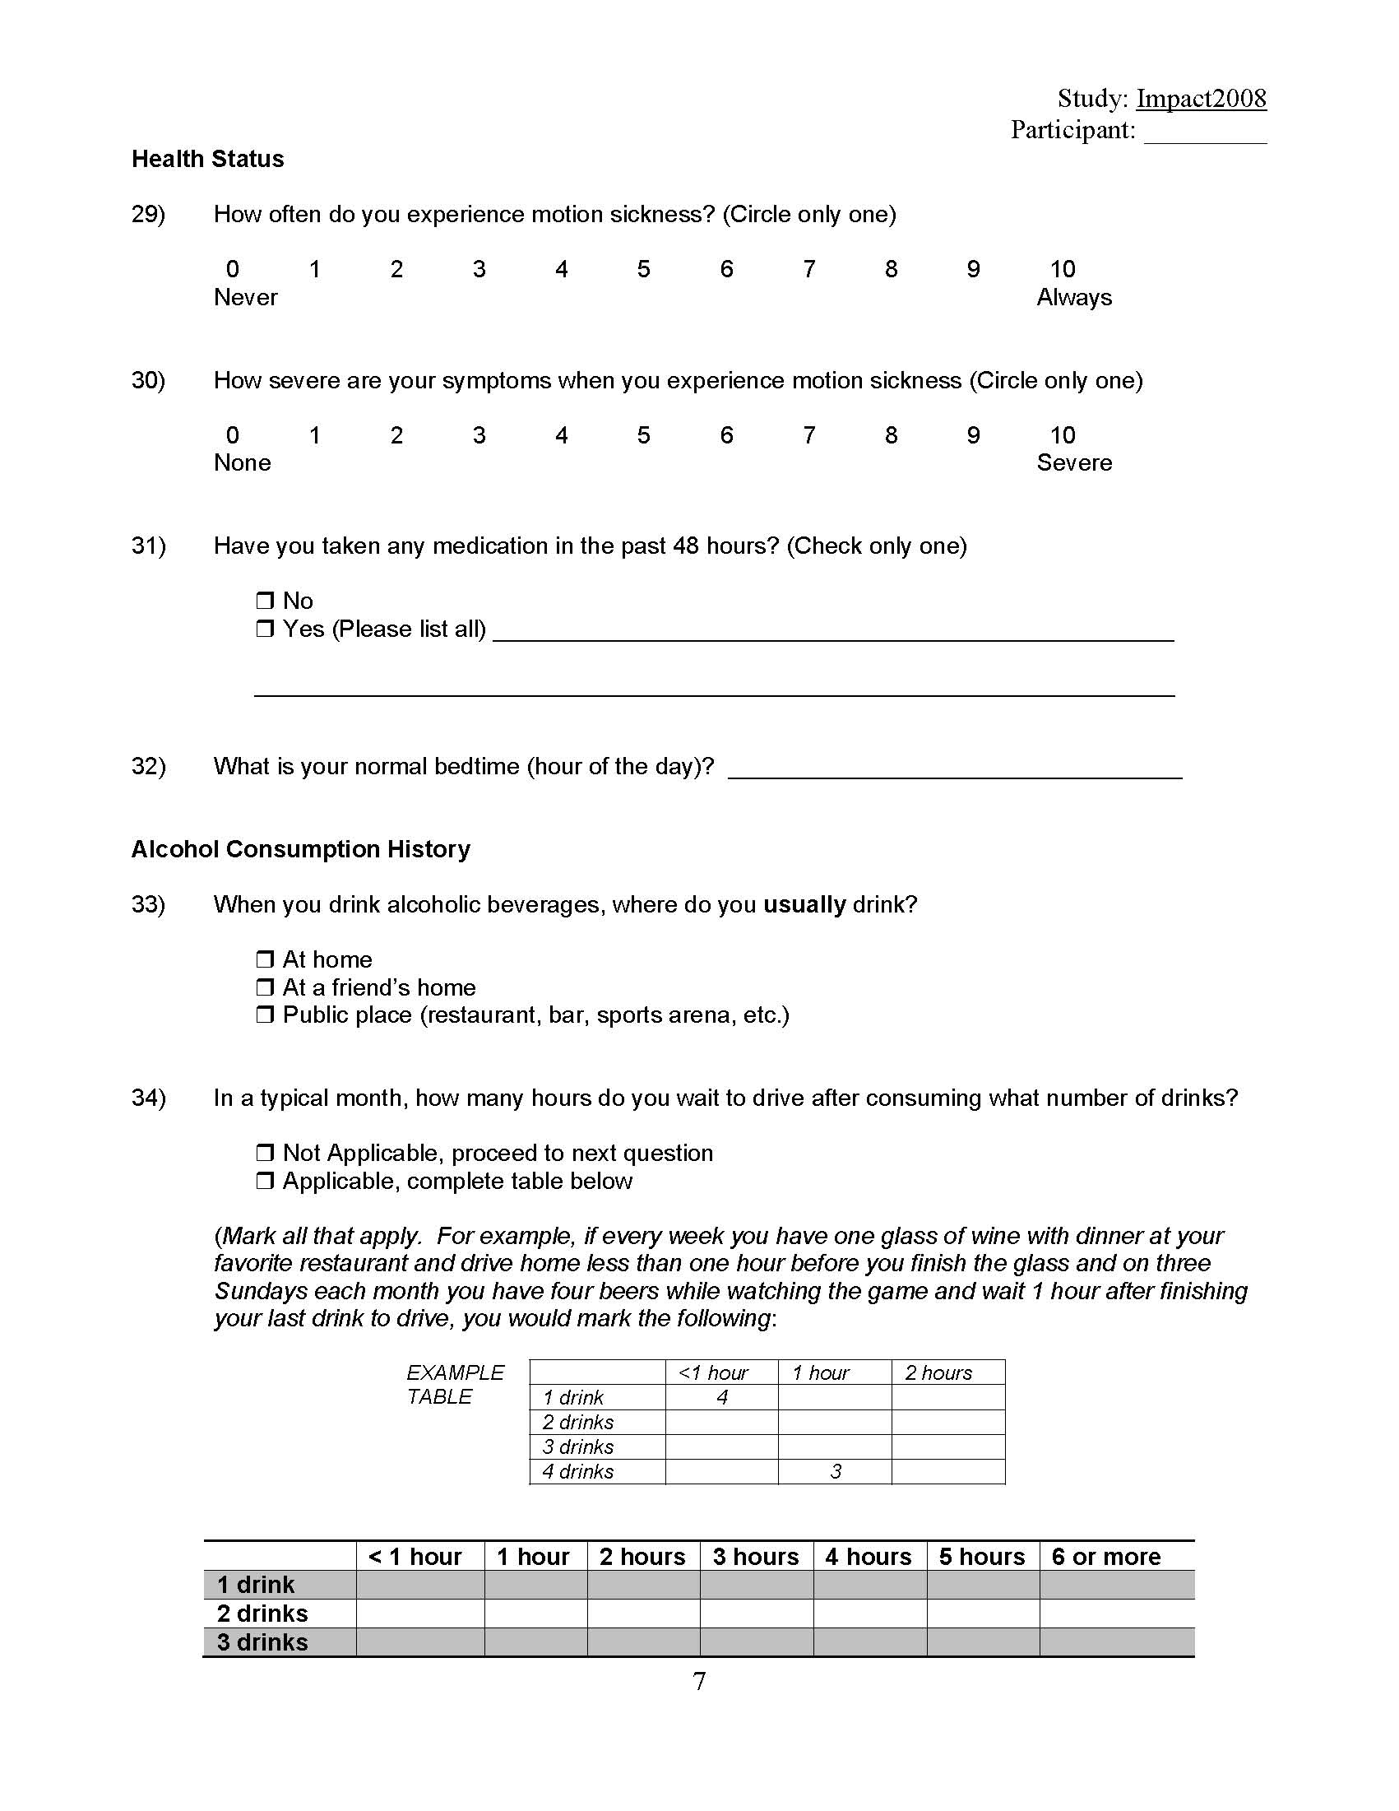
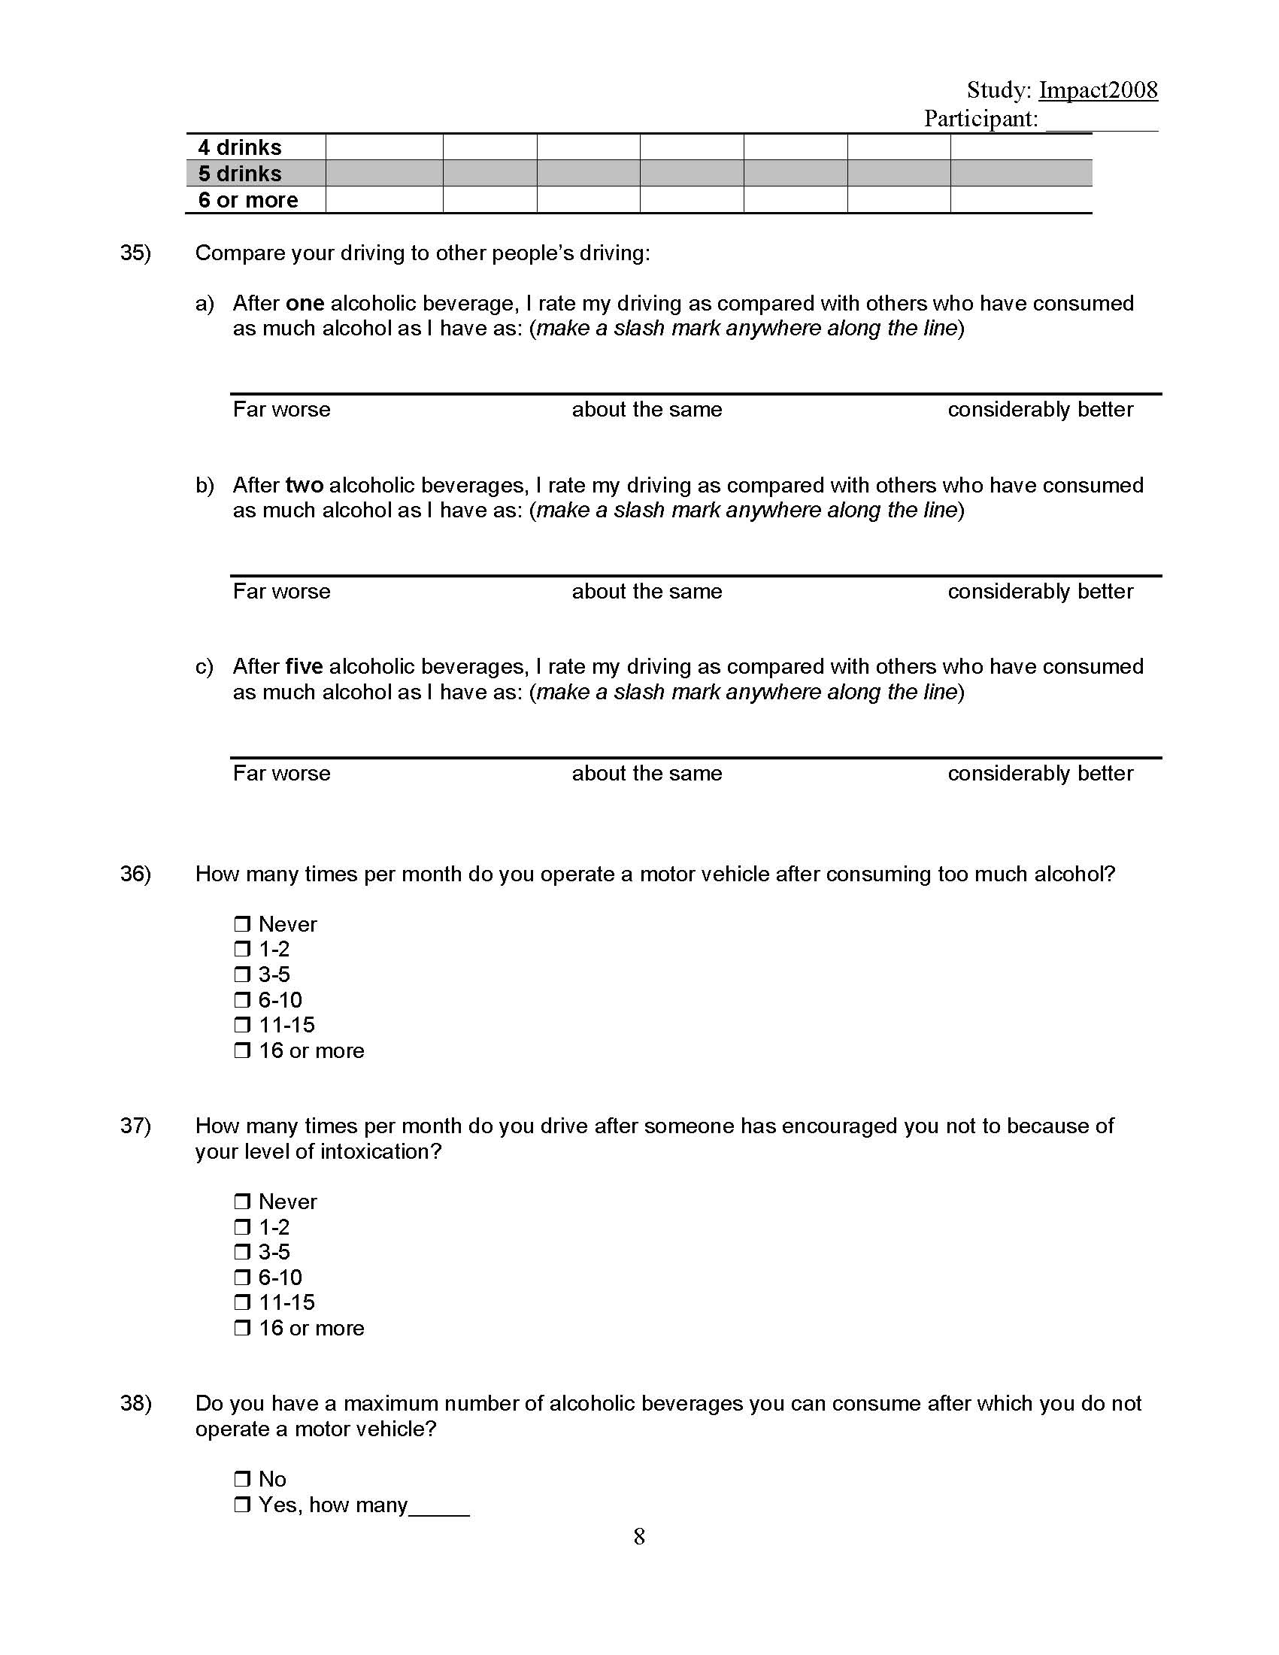
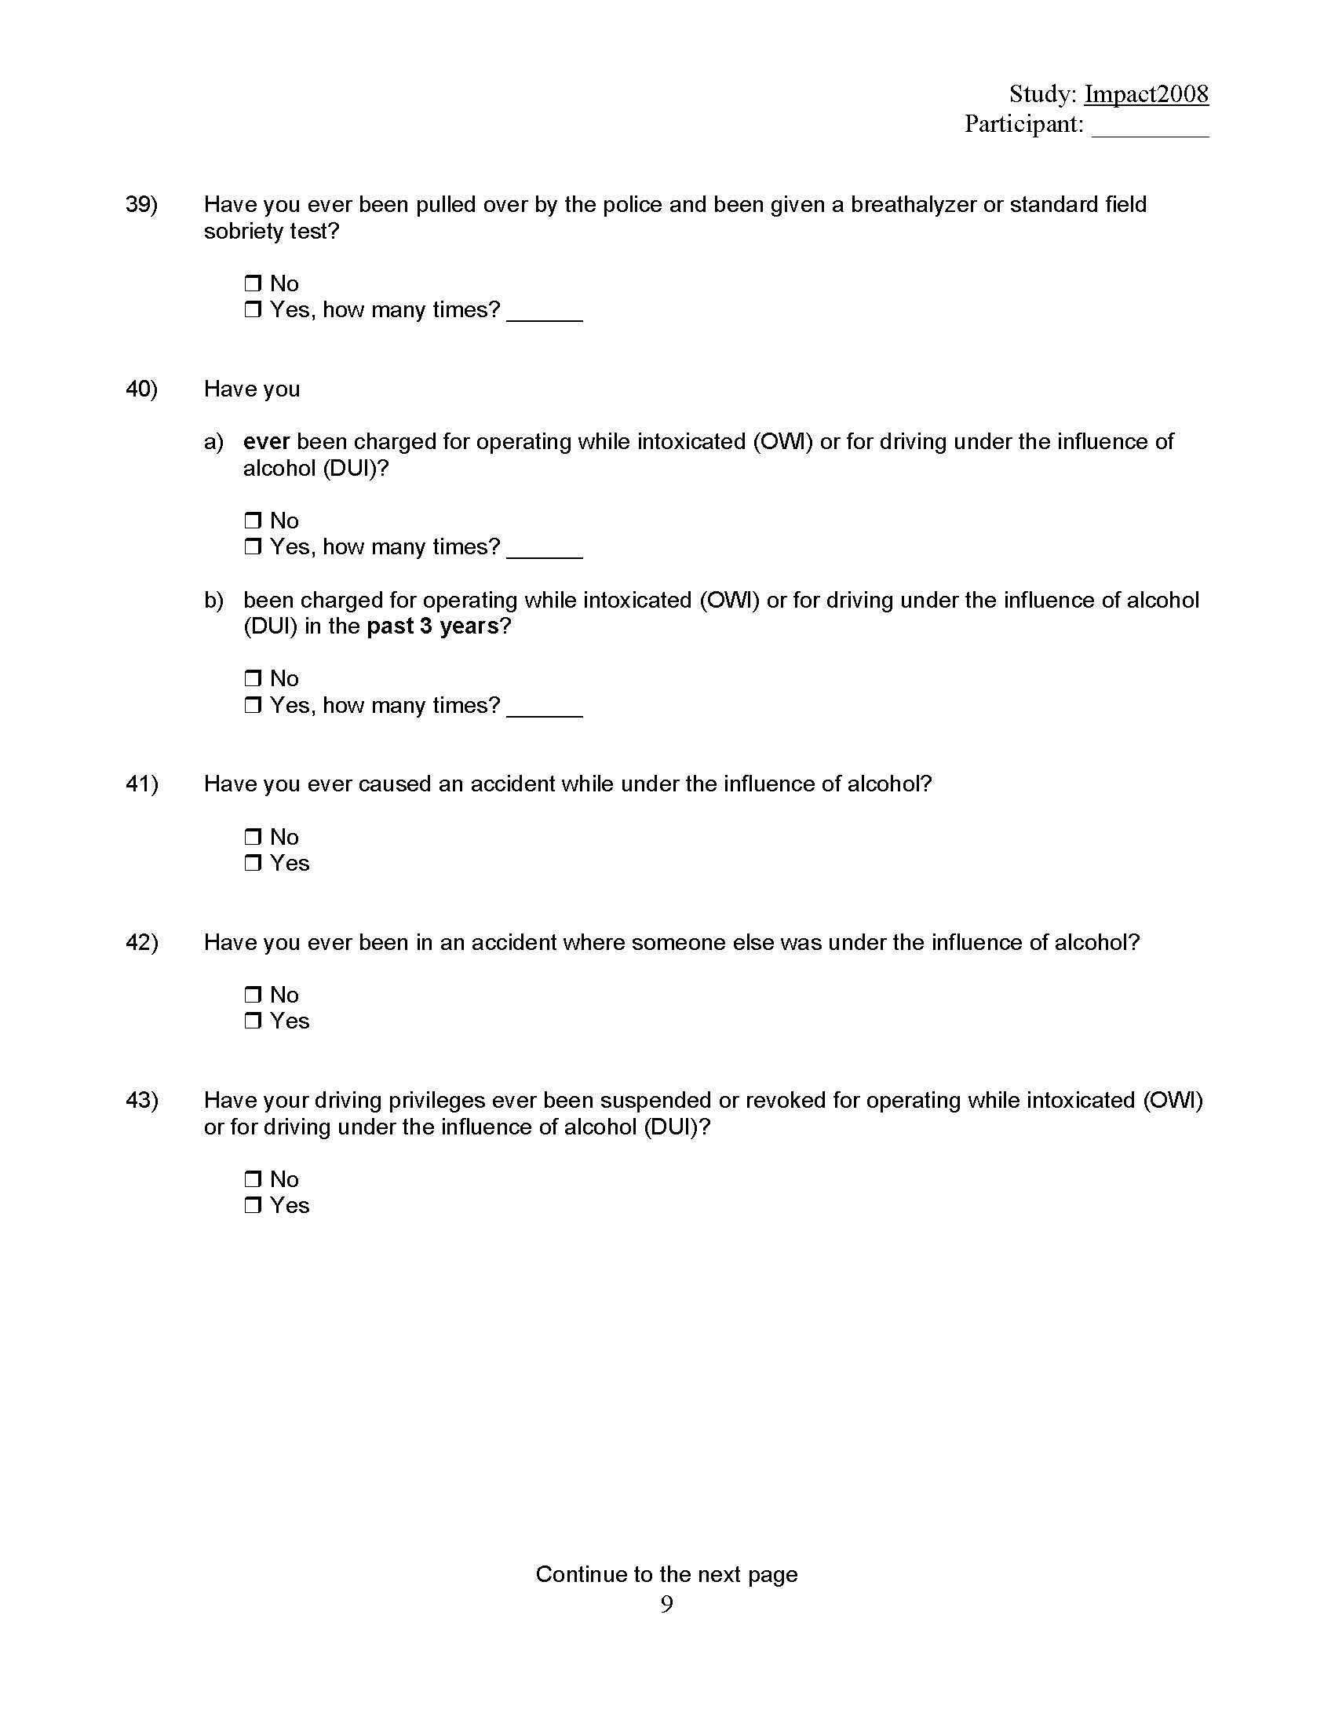
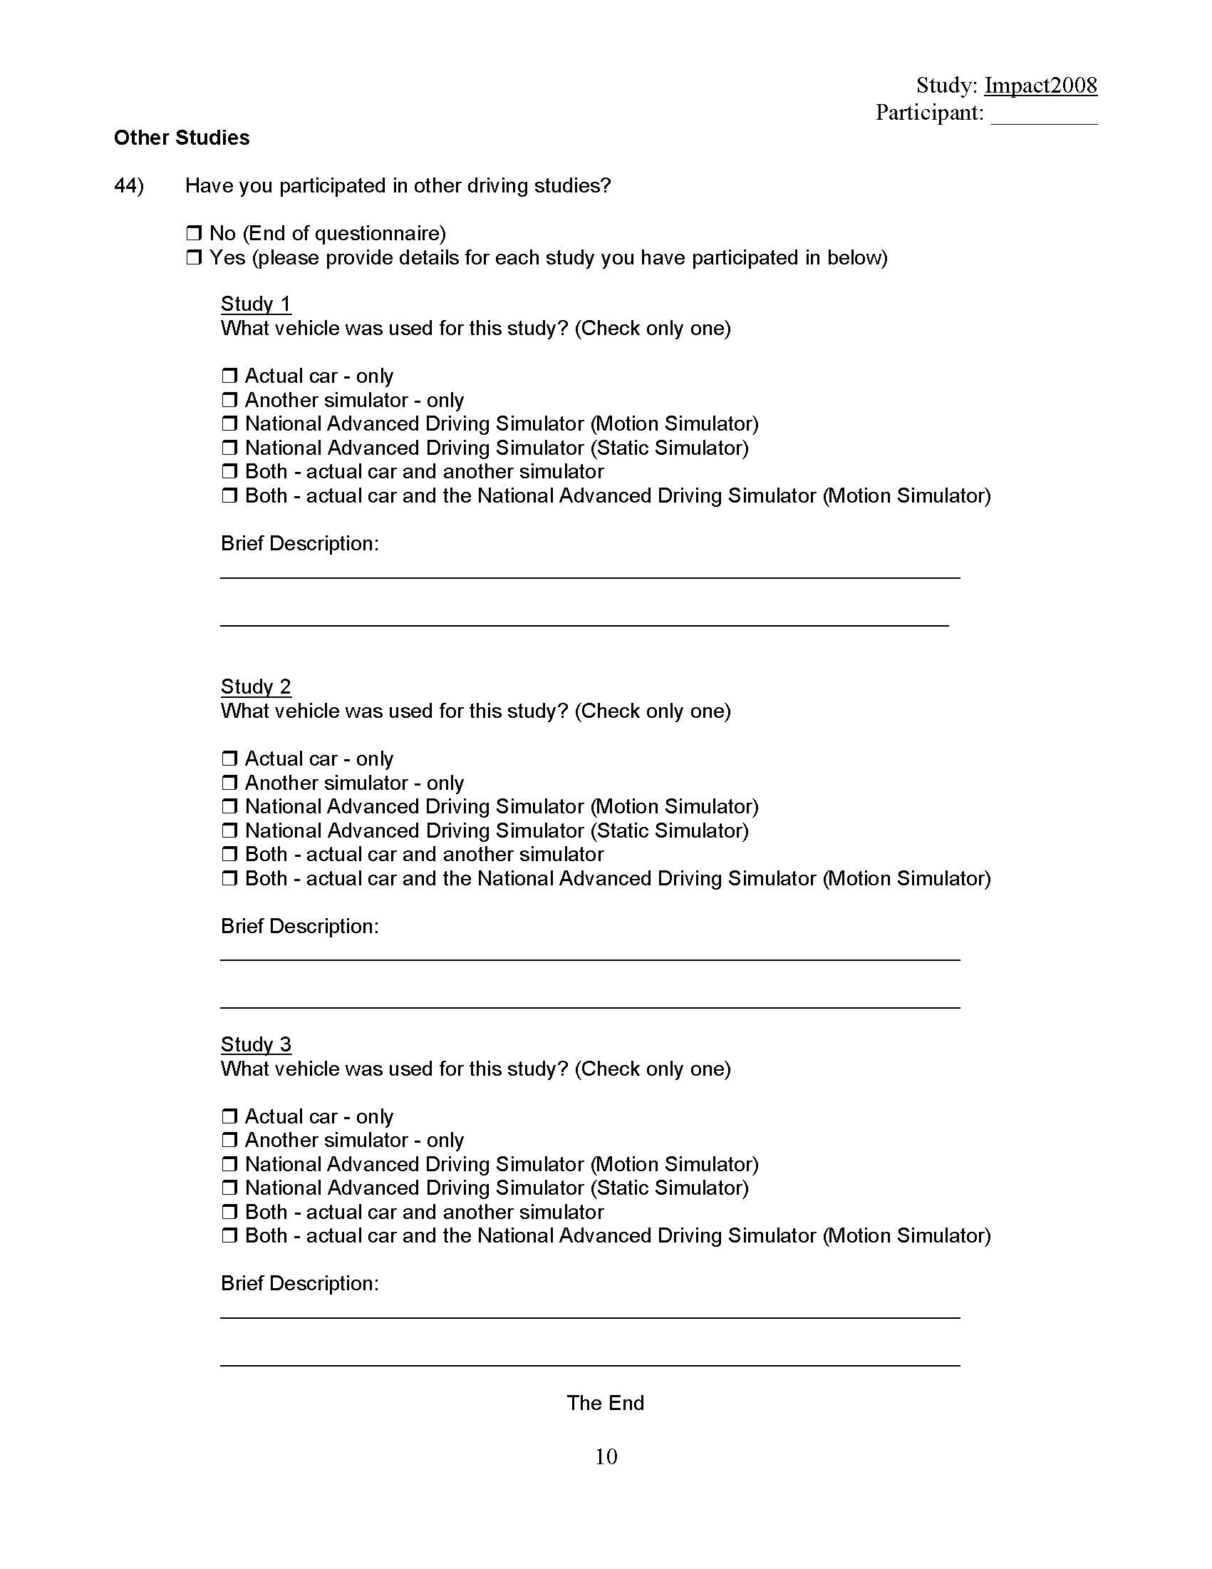

Appendix L: Orientation Presentation
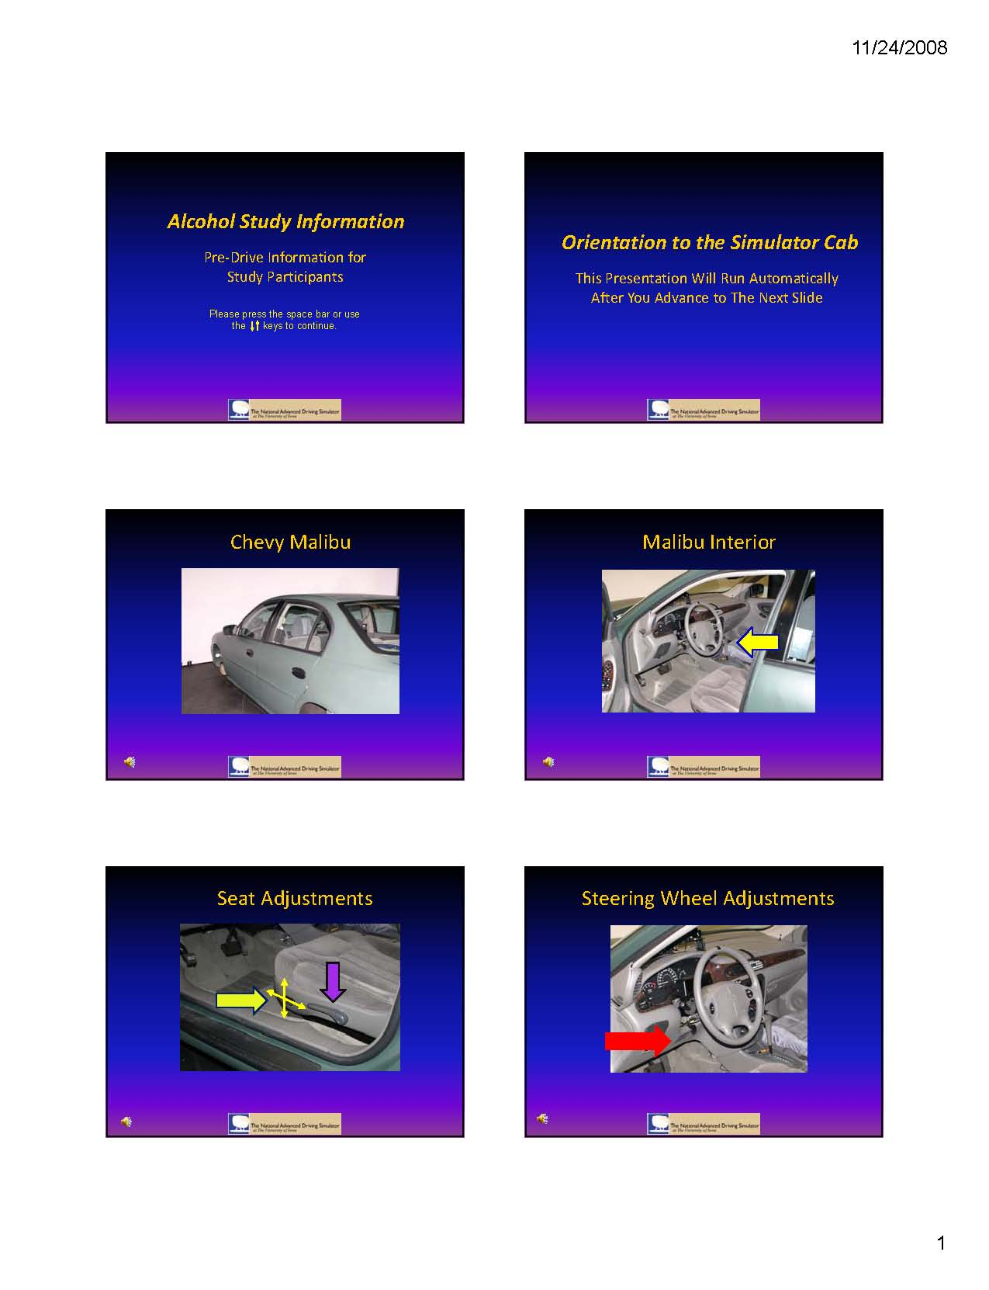
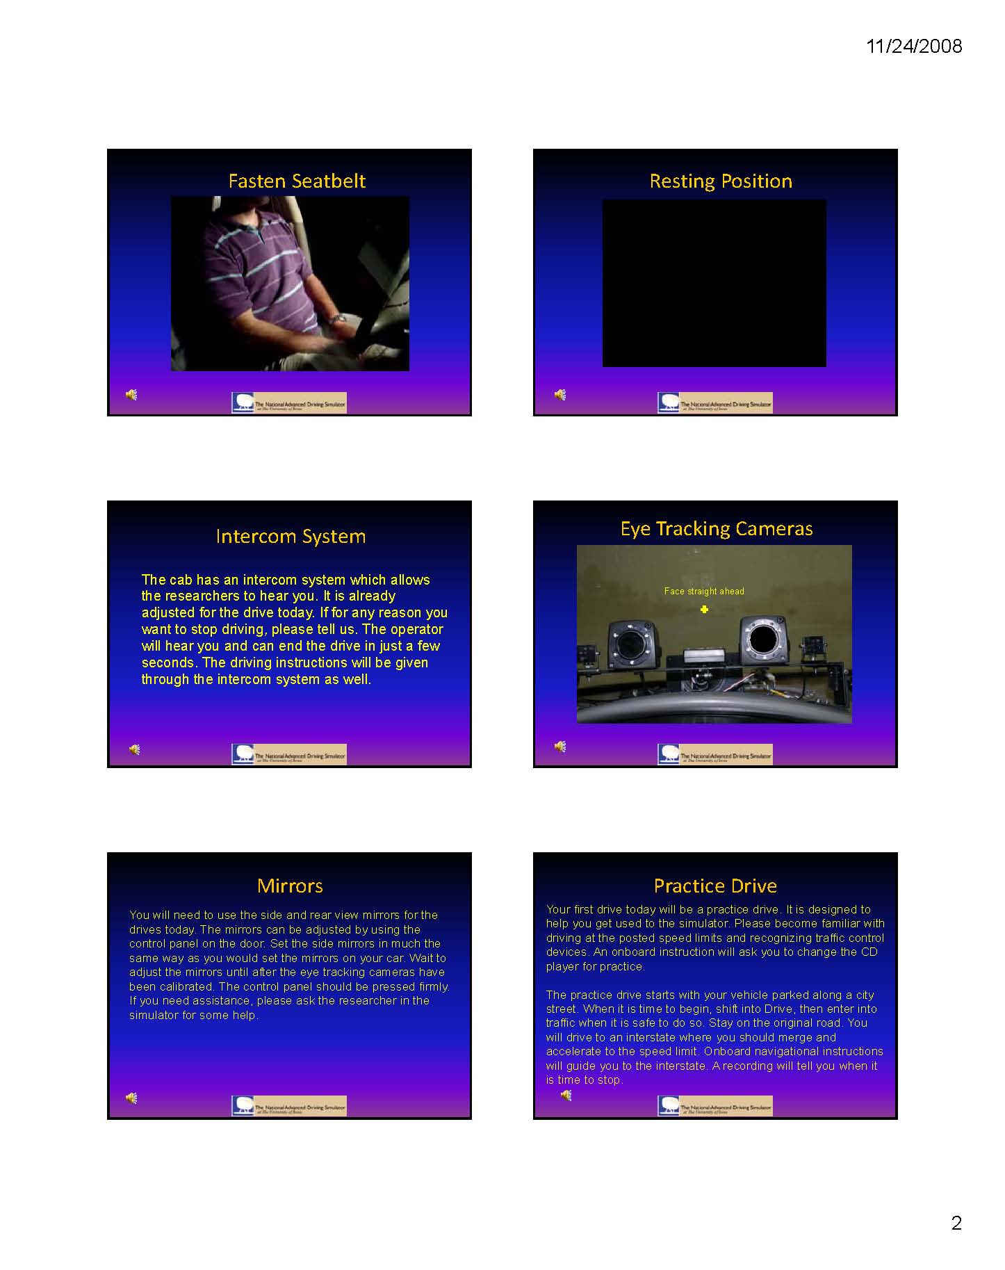
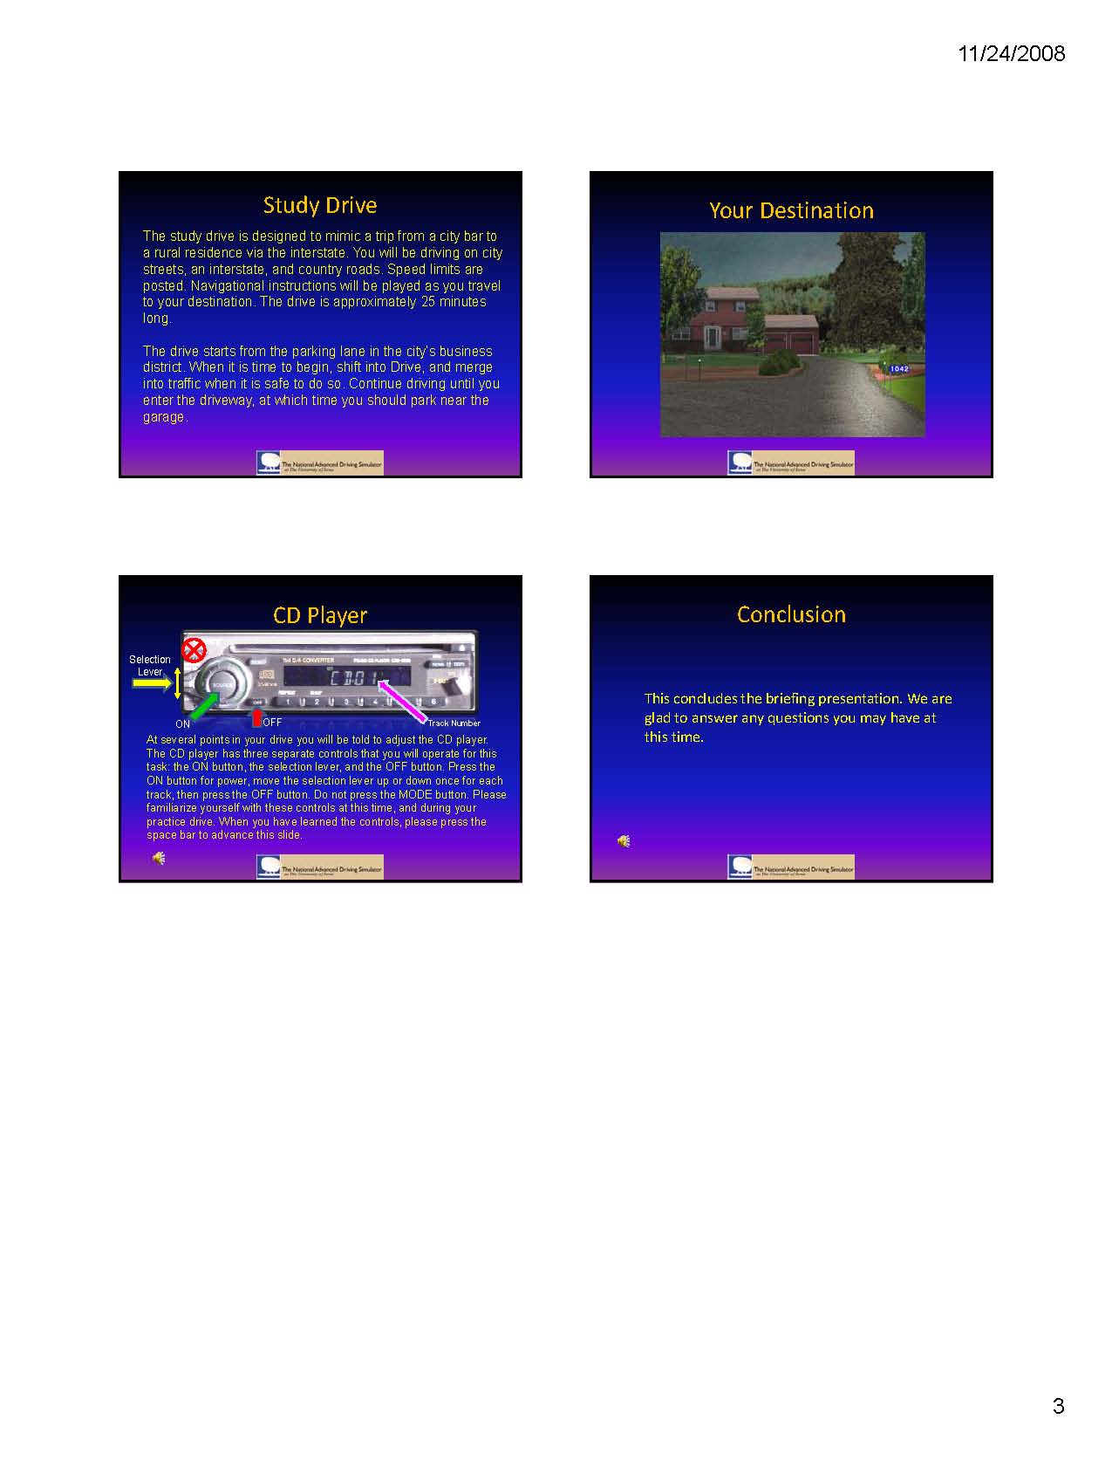

Appendix M: Wellness Survey
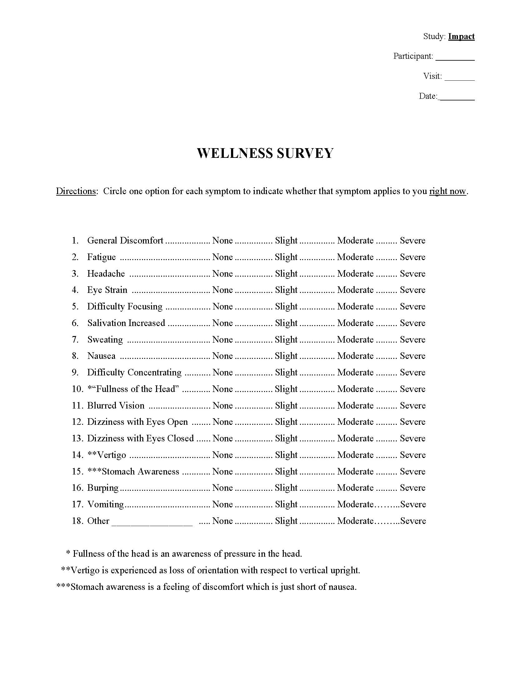

Appendix N: Realism Survey
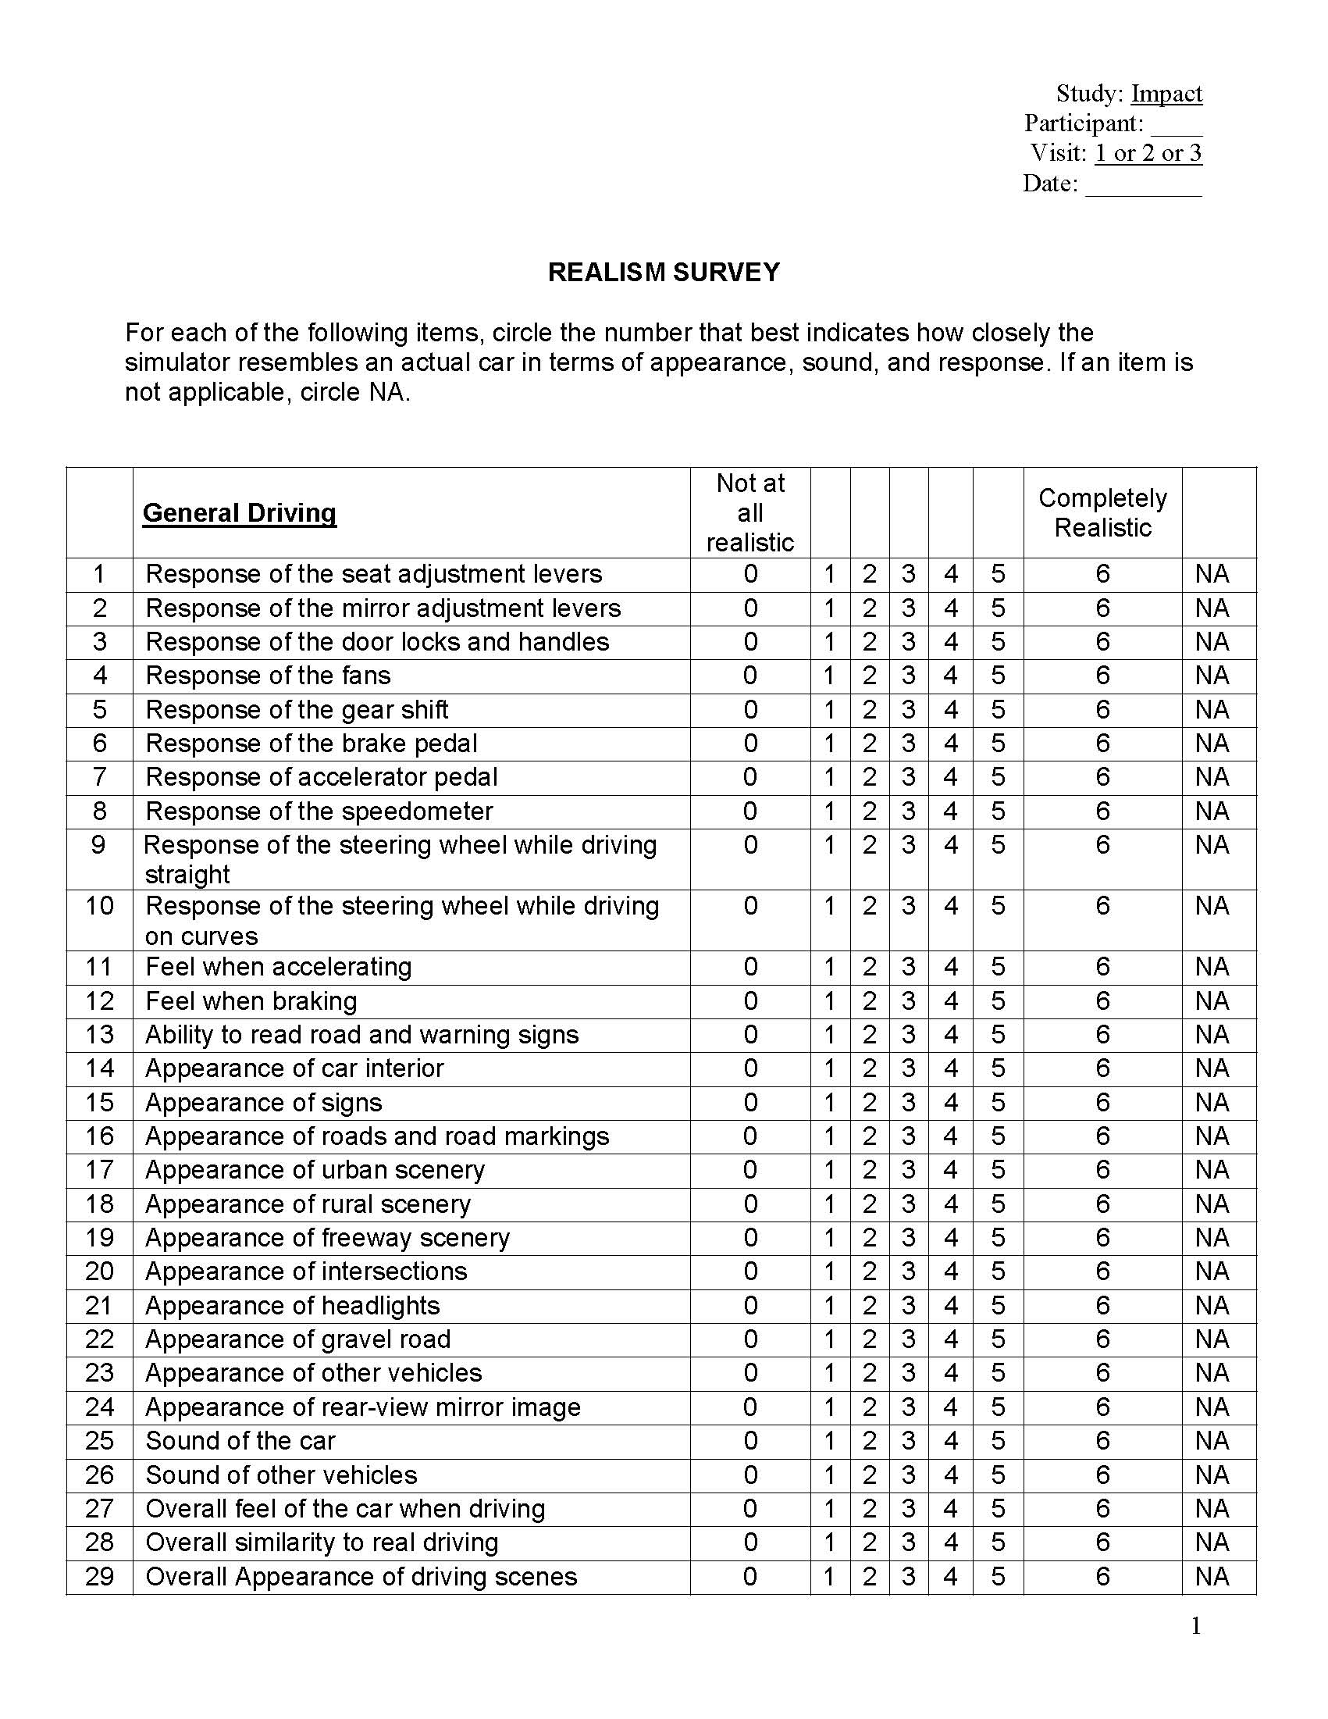
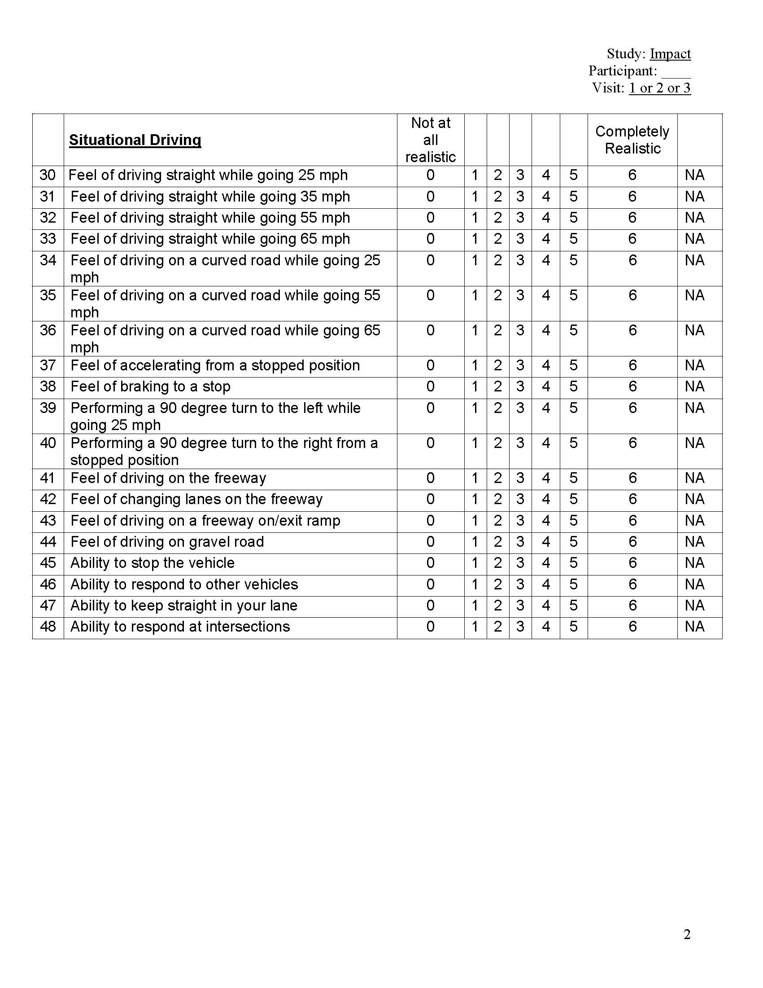

Appendix O: Sleep and Food Intake Survey

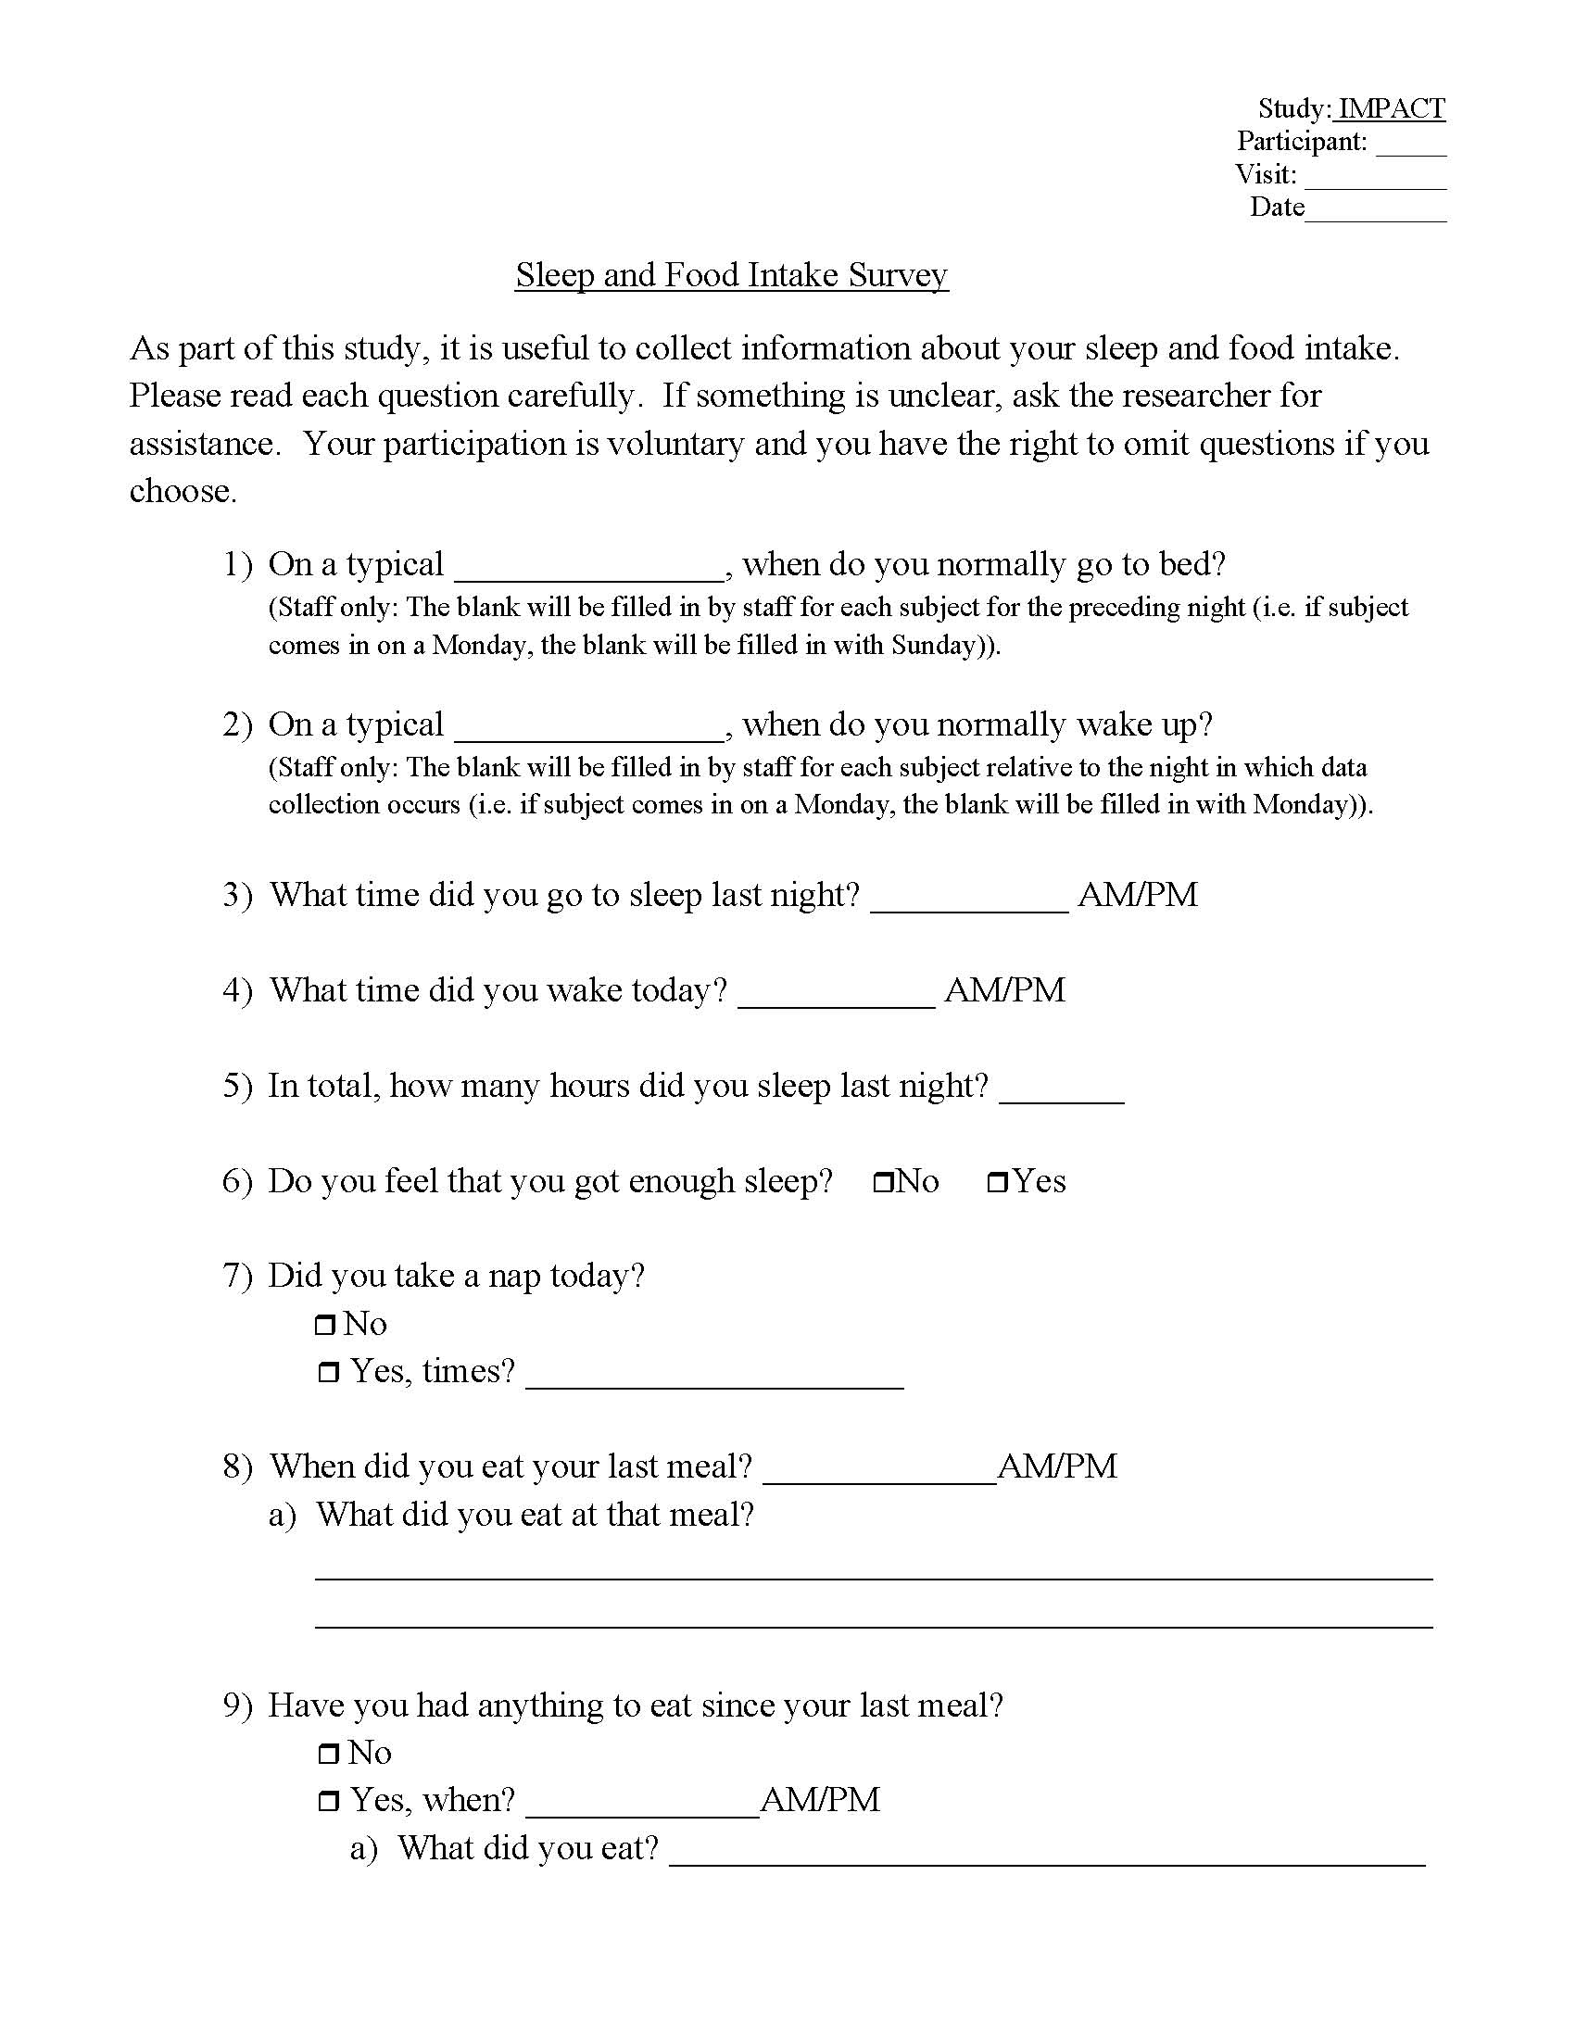
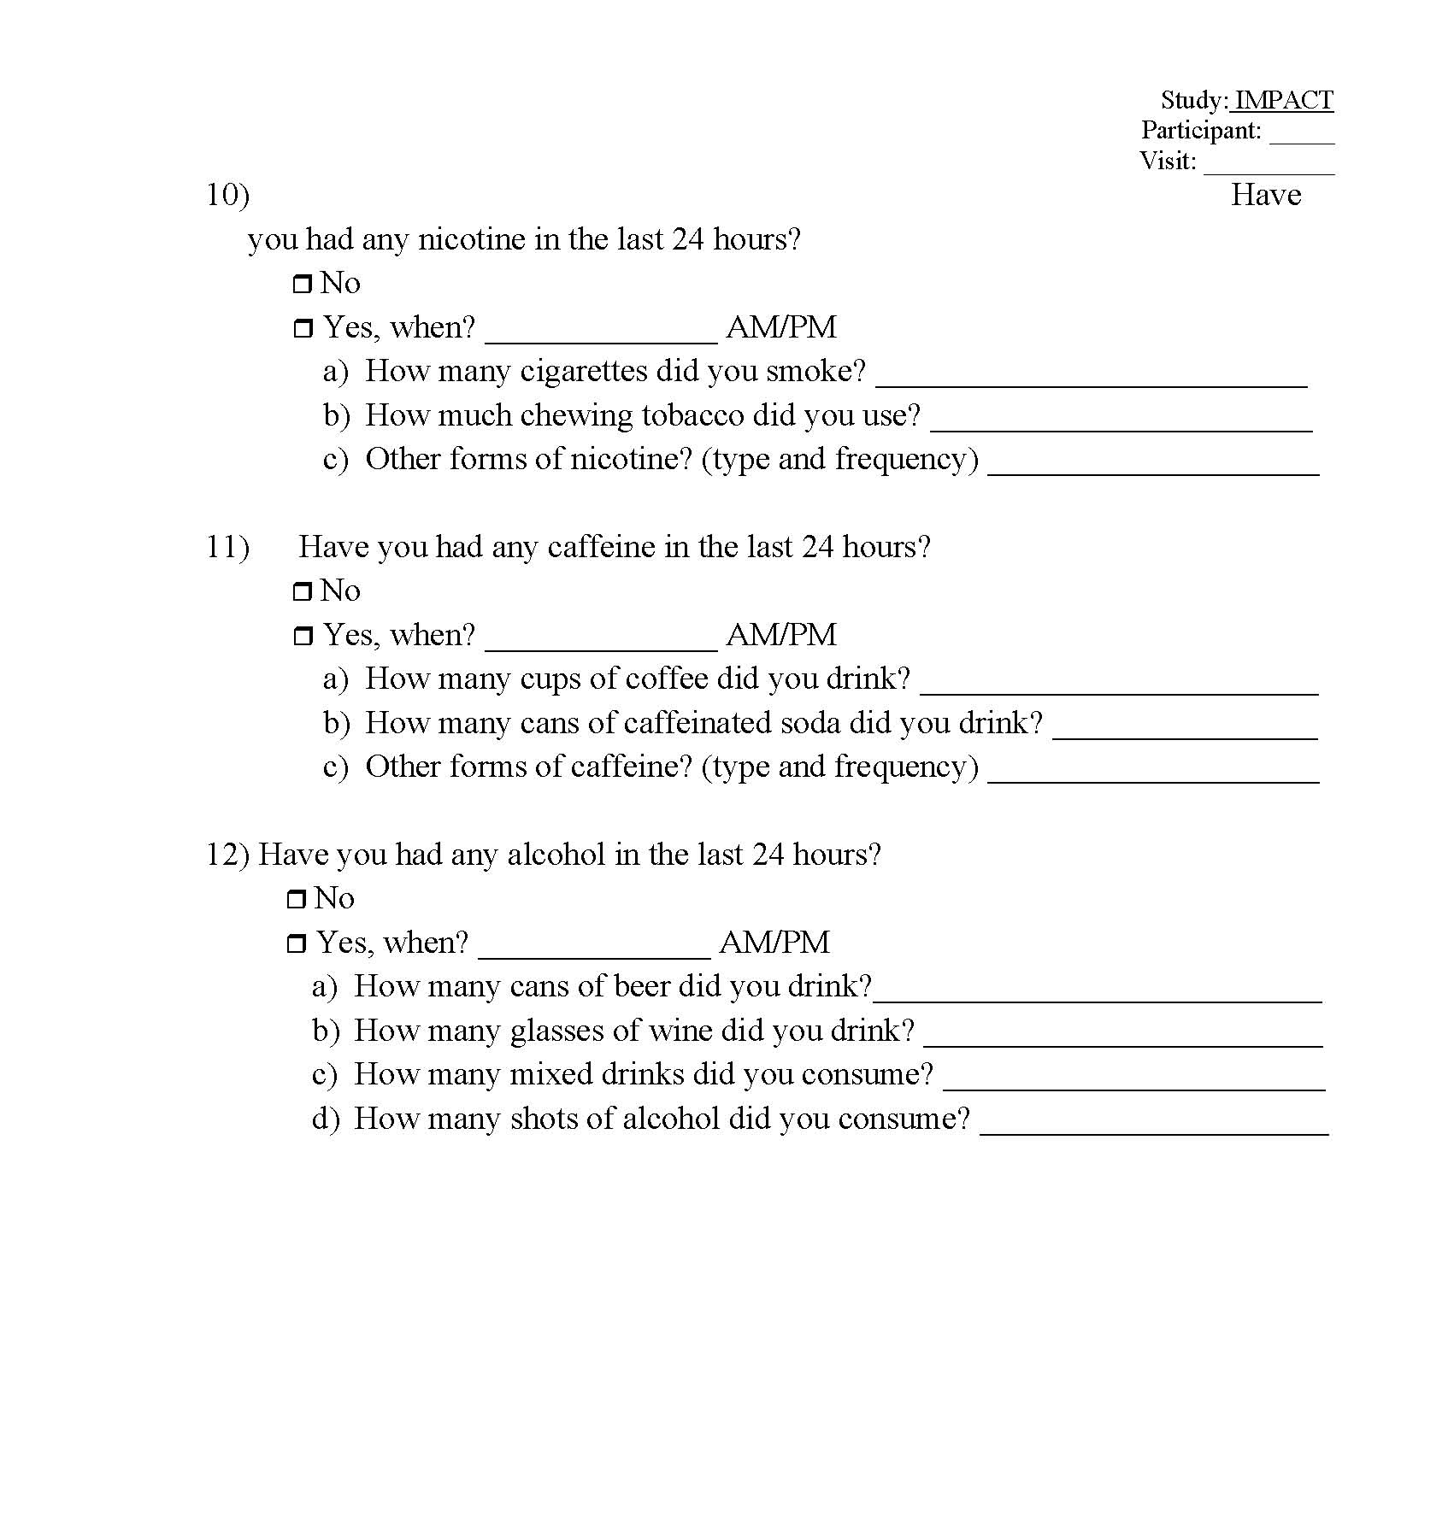

Appendix P: Sample BAC Plots

Appendix Q: Standard Field Sobriety Test
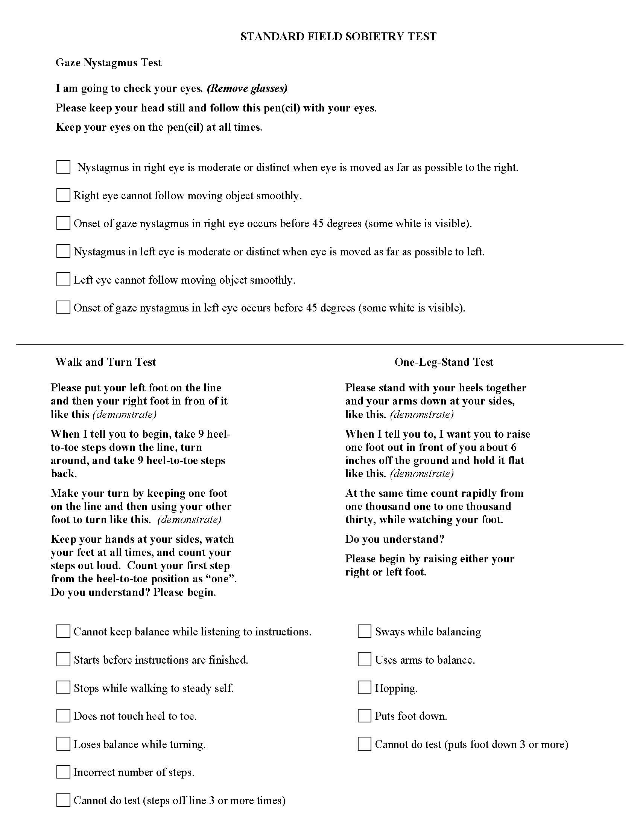

Appendix R: Sleepiness Scale
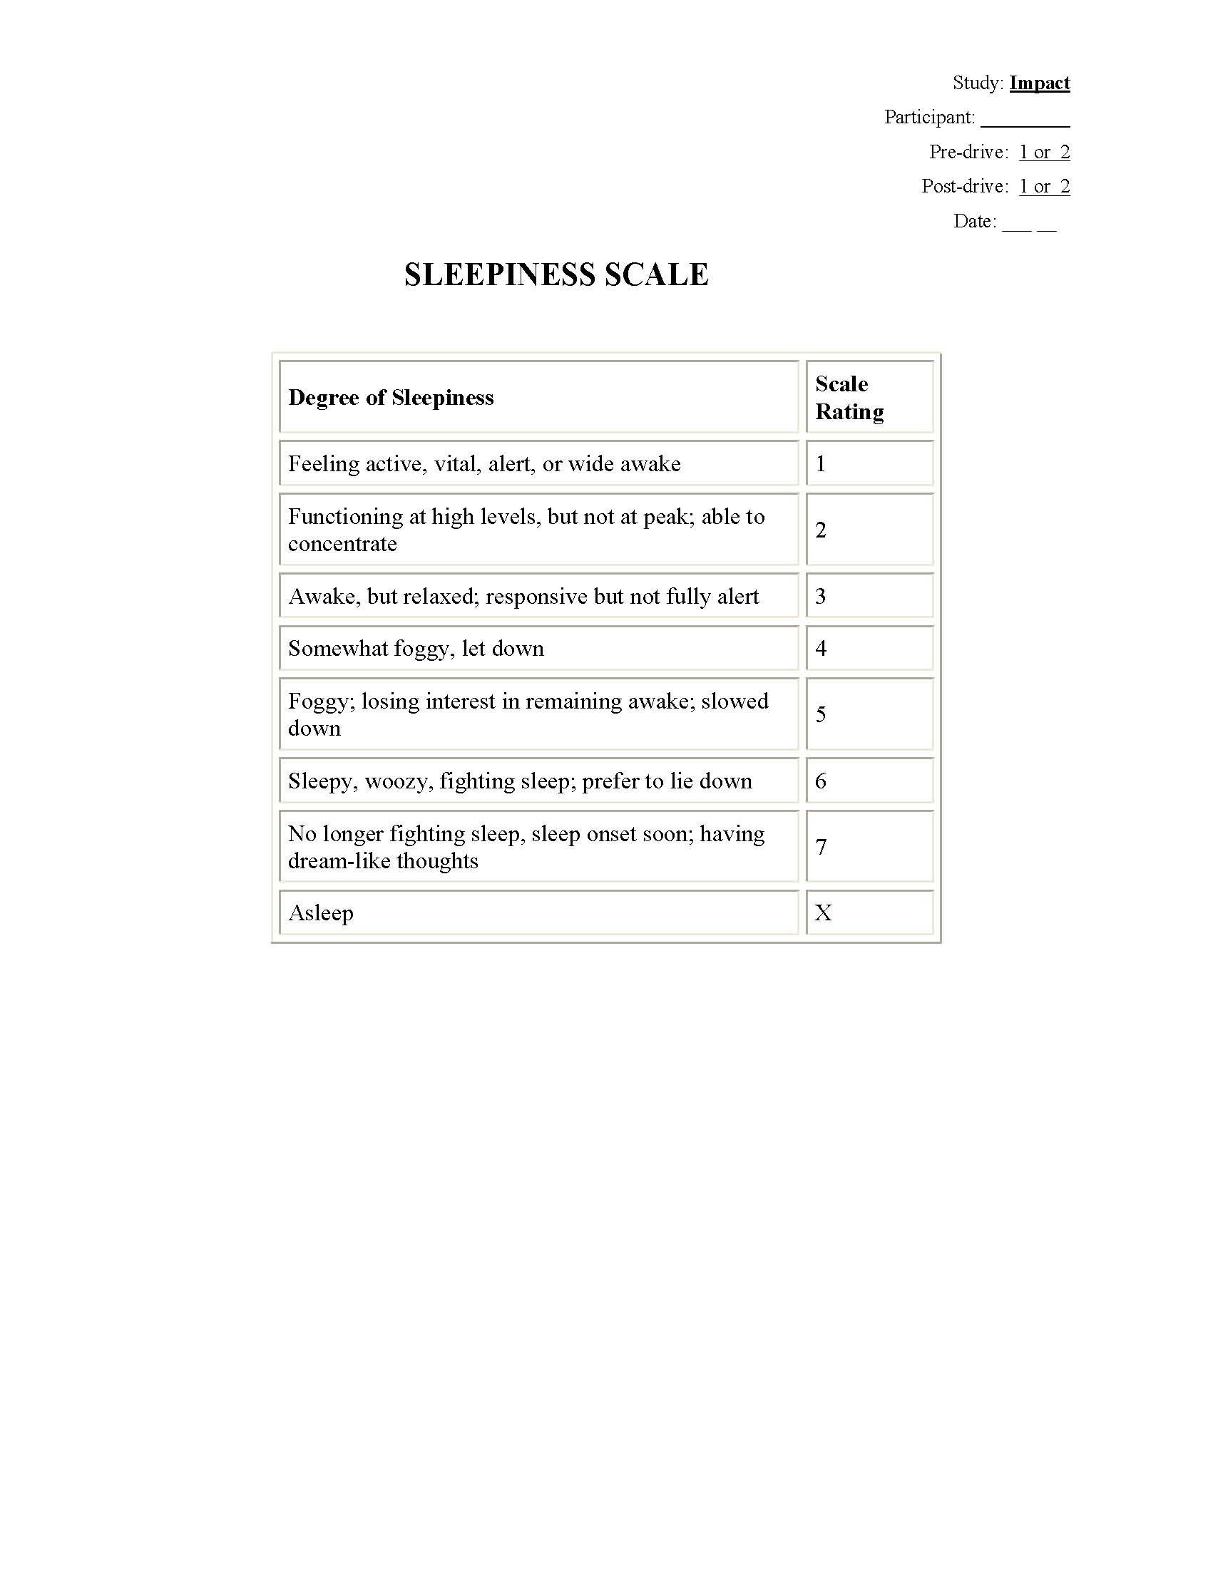

Appendix S: Debriefing Statement

IMPACT Debriefing Statement

When is it safe to drive again?

At the time you will be transported home from completing this study visit, your Blood Alcohol Concentration (BAC) level will be at or less than 0.03%. Although you could legally drive at this level, we ask you to wait 2 hours after you are returned home to drive to ensure your BAC level is 0.00%.

Appendix T: Debriefing Questions

IMPACT Debrief Interview
[Document for research staff only. Interview will include, but is not limited to, the following questions; follow-up questions may be asked. Staff: Mark all boxes that apply for high-level analysis.]
In this interview, I’ll ask you questions regarding impairment, driving, and potential future technologies that could be designed to assist intoxicated drivers. Your participation is voluntary and you have the right to skip questions if you choose. All of your answers will be kept confidential. Throughout the interview when I say “drinking” I’m referring to the consumption of alcohol.
- Have you ever driven after you consumed alcohol but believed you were still able to drive safely?
[ ] Yes [ ] No [ ] Other

  - What factors played a role in your decision to drive or not to drive?
IF PARTICIPANT REPORTS NEVER DRIVING AFTER DRINKING, GO TO QUESTION 5.

- Have you ever driven when you knew you were too intoxicated to drive safely?
[ ] Yes [ ] No [ ] Other

  - What factors played a role in your decision to drive or not to drive after drinking?
  - If there was a point where you were too intoxicated to drive safely, how did you know it was not safe to drive?

- After the occasions when you drank, what differences did you notice in your driving (for example, how you control your driving speed, lane position, etc.)?
[ ] No difference [ ] Lateral control, general [ ] Curves/turns
[ ] Longitudinal control, general [ ] Speed, increase [ ] Speed, decrease
[ ] Reaction time to environment [ ] Reaction time to critical event [ ] Other

  - Can you describe any differences you noticed in the types of things you paid attention to, or in your ability to focus while driving?
[ ] No difference
[ ] Reduced ability to focus or pay attention [ ] Increased ability to focus or pay attention
[ ] Other

  - In what ways did your driving or attention change based on external factors, like passengers in the vehicle or the weather?
[ ] No difference
[ ] Degraded driving performance [ ] Improved driving performance
[ ] Reduced ability to focus or pay attention [ ] Increased ability to focus or pay attention
[ ] Other

  - As your level of intoxication increases how does it affect your driving skills or ability to focus or pay attention to the roadway?
[ ] No difference
[ ] Degraded performance with increased intoxication
[ ] Improved performance with increased intoxication
[ ] Reduced focus or attention with increased intoxication
[ ] Increased focus or attention with increased intoxication
[ ] Other

- How do you adjust your driving after you have been drinking?
[ ] No change [ ] Adjust driving after drinking [ ] Other

  - Do your adjustments change depending on how impaired you are? Please describe.
[ ] Yes [ ] No [ ] Other

- Impairment from alcohol consumption has been shown to decrease drivers’ mental and physical abilities. I’d like to hear your thoughts on the role technology can play in assisting impaired drivers or making the roadway safer for surrounding traffic.

Imagine a system in a vehicle that could detect when a driver is impaired based on the performance or behavior of the driver and vehicle.
  - What are your thoughts about a system that detects when a driver is below or above the legal impairment level with 100% accuracy every time a vehicle is driven?
[ ] Positive [ ] Negative [ ] Mixed [ ] Other

  - What are your thoughts about a system that accurately identifies all impaired drivers but also wrongly identifies some sober drivers as impaired?
[ ] Positive [ ] Negative [ ] Mixed [ ] Other

  - What are your thoughts about a system that represents the opposite extreme – it accurately identifies all sober drivers, but also wrongly identifies some impaired drivers as sober?
[ ] Positive [ ] Negative [ ] Mixed [ ] Other

  - Of the previous two examples, which is more acceptable to you?
[ ] B is more acceptable to me [ ] C is more acceptable to me [ ] Other

  - Which do you think would be more acceptable to the general public? Why?
[ ] Same as question d [ ] Different from question d [ ] Other
- If your vehicle could detect your level of alcohol impairment how would you like it to respond?

Now I’d like to get your feedback on some hypothetical actions that a system designed to detect impairment could take. Let’s assume that the impairment detection system is sufficiently accurate and reliable.

- What do you think about a system that could notify you when you are impaired with an indicator, such as a warning icon on the dash or voice alert?
[ ] Positive [ ] Negative [ ] Mixed [ ] Other
  - If you received this kind of alert, how would you respond?
  - How would it affect your ability to pay attention to driving?
[ ] No change [ ] Distraction [ ] Other

- What do you think about a system that could give you an assessment of your driving after you return home when it detects impairment, like a report card?
[ ] Positive [ ] Negative [ ] Mixed [ ] Other
  - Would it affect your decision to drive or how you drive the next time you drank, and if so, how?
[ ] Yes [ ] No [ ] Other

  - What do you think about a system that could give you an assessment of your driving after you return home whether it indicates impairment or not?
[ ] Positive [ ] Negative [ ] Mixed [ ] Other
- What do you think about a system that could notify a friend or relative to request help when you are impaired?
[ ] Positive [ ] Negative [ ] Mixed [ ] Other
  - What about a system that could notify the police to request assistance?
[ ] Positive [ ] Negative [ ] Mixed [ ] Other
- How would you respond to this system if it were in vehicles?

- What do you think about a system that could automatically take full or partial control over certain functions, like steering or driving speed, when it detected impairment?
[ ] Positive [ ] Negative [ ] Mixed [ ] Other
  - If you had this type of system, how would you respond?

- What do you think about a system that could collect data in something like an airplane’s black box, which could be accessed by insurance companies and/or law enforcement after a crash or serious violation to determine if impairment was a factor?
[ ] Positive [ ] Negative [ ] Mixed [ ] Other
  - How would you respond to this system if it were in vehicles?

- Generally, what do you see as obstacles to implementing these types of driver assistance systems?

- Which of the systems, if any, would make you a safer driver?
[ ] None [ ] Warning alert [ ] Trip report [ ] Notifying friend/relative/police
[ ] Automation [ ] Black box [ ] Other

- Which do you think would reduce crashes?
[ ] None [ ] Warning alert [ ] Trip report [ ] Notifying friend/relative/police
[ ] Automation [ ] Black box [ ] Other

Appendix U: Results

Table U-1
Lane Deviation by Age Group Across Events
 | Age Group
 | 21-34 |  |  | 38-51 |  |  | 55-68 |  |  | Total
Event | M | N | SD | M | N | SD | M | N | SD | M | N | SD
Urban Drive (102) | .81 | 107 | .18 | .83 | 108 | .20 | .81 | 108 | .18 | .82 | 323 | .19
Green Light (103) | .63 | 107 | .23 | .61 | 108 | .21 | .64 | 108 | .21 | .63 | 323 | .21
Yellow Dilemma (104) | .61 | 107 | .25 | .64 | 106 | .30 | .66 | 107 | .28 | .64 | 320 | .28
Urban Curves (106) | .92 | 108 | .16 | .97 | 108 | .20 | .99 | 108 | .20 | .96 | 324 | .19
Interstate Curves (205) | 1.60 | 108 | .59 | 1.52 | 107 | .37 | 1.64 | 105 | .56 | 1.59 | 320 | .52
Lighted Rural (302) | .44 | 108 | .26 | .45 | 108 | .24 | .45 | 108 | .23 | .45 | 324 | .24
Transition to Dark Rural (303) | .73 | 108 | .29 | .82 | 108 | .27 | .76 | 108 | .27 | .77 | 324 | .28
Dark Rural (304) | 1.03 | 107 | .22 | 1.15 | 108 | .24 | 1.12 | 107 | .26 | 1.10 | 322 | .25
Dark Rural Hairpin Curve (304) | .92 | 107 | .31 | .95 | 108 | .33 | .89 | 107 | .30 | .92 | 322 | .31
Gravel Rural (306) | .82 | 107 | .26 | .82 | 108 | .23 | .78 | 107 | .24 | .81 | 322 | .24
Composite | 48.72 | 105 | 9.87 | 50.83 | 105 | 10.43 | 50.46 | 103 | 9.64 | 50.00 | 313 | 10.00

Table U-2
Lane Deviation by Gender Across Events
 | Gender
 | Female |  |  | Male |  |  | Total
Event | M | N | SD | M | N | SD | M | N | SD
Urban Drive (102) | .83 | 161 | .19 | .81 | 162 | .19 | .82 | 323 | .19
Green Light (103) | .61 | 161 | .20 | .64 | 162 | .22 | .63 | 323 | .21
Yellow Dilemma (104) | .65 | 160 | .28 | .63 | 160 | .27 | .64 | 320 | .28
Urban Curves (106) | .98 | 162 | .21 | .93 | 162 | .17 | .96 | 324 | .19
Interstate Curves (205) | 1.50 | 160 | .50 | 1.68 | 160 | .52 | 1.59 | 320 | .52
Lighted Rural (302) | .45 | 162 | .24 | .45 | 162 | .25 | .45 | 324 | .24
Transition to Dark Rural (303) | .77 | 162 | .26 | .78 | 162 | .30 | .77 | 324 | .28
Dark Rural (304) | 1.04 | 161 | .20 | 1.16 | 161 | .27 | 1.10 | 322 | .25
Dark Rural Hairpin Curve (304) | .89 | 161 | .27 | .95 | 161 | .35 | .92 | 322 | .31
Gravel Rural (306) | .81 | 161 | .23 | .81 | 161 | .26 | .81 | 322 | .24
Composite | 49.27 | 156 | 9.64 | 50.73 | 157 | 10.32 | 50.00 | 313 | 10.00

Table U-3
Average Speed by Age Group Across Events
 | Age Group
 | 21-34 |  |  | 38-51 |  |  | 55-68 |  |  | Total
Event | M | N | SD | M | N | SD | M | N | SD | M | N | SD
Urban Drive (102) | 28.28 | 107 | 3.62 | 28.10 | 108 | 3.38 | 26.66 | 108 | 3.48 | 27.68 | 323 | 3.56
Green Light (103) | 29.12 | 107 | 4.34 | 28.20 | 108 | 3.17 | 26.77 | 108 | 4.43 | 28.02 | 323 | 4.12
Yellow Dilemma (104) | 17.15 | 108 | 12.09 | 18.68 | 108 | 11.11 | 18.55 | 108 | 11.25 | 18.13 | 324 | 11.48
Left Turn (105) | 19.04 | 108 | 4.77 | 18.63 | 108 | 4.77 | 18.16 | 108 | 4.23 | 18.61 | 324 | 4.60
Urban Curves (106) | 34.66 | 108 | 3.58 | 34.53 | 108 | 2.61 | 33.38 | 108 | 3.69 | 34.19 | 324 | 3.37
Interstate Curves (205) | 68.08 | 108 | 4.26 | 66.75 | 107 | 4.50 | 63.99 | 105 | 4.25 | 66.29 | 320 | 4.64
Exit Ramp (206) | 36.94 | 108 | 5.34 | 34.03 | 108 | 4.07 | 30.42 | 108 | 3.52 | 33.80 | 324 | 5.11
Lighted Rural (302) | 55.78 | 108 | 3.33 | 55.08 | 108 | 3.31 | 54.57 | 108 | 2.78 | 55.14 | 324 | 3.18
Transition to Dark Rural (303) | 55.71 | 108 | 4.10 | 54.64 | 108 | 3.70 | 53.97 | 108 | 3.48 | 54.77 | 324 | 3.82
Dark Rural (304) | 53.45 | 107 | 3.36 | 53.00 | 108 | 3.11 | 50.99 | 108 | 3.29 | 52.48 | 323 | 3.41
Dark Rural Hairpin Curve (304) | 46.45 | 107 | 5.00 | 46.29 | 108 | 3.58 | 43.42 | 108 | 3.94 | 45.38 | 323 | 4.42
Gravel Transition (305) | 47.57 | 107 | 6.08 | 45.09 | 108 | 5.58 | 40.69 | 108 | 7.12 | 44.44 | 323 | 6.89
Gravel Rural (306) | 45.63 | 107 | 7.81 | 43.38 | 108 | 6.57 | 41.22 | 107 | 7.49 | 43.41 | 322 | 7.50
Composite | 46.29 | 108 | 10.25 | 49.03 | 108 | 8.37 | 54.68 | 108 | 9.47 | 50.00 | 324 | 10.00

Table U-4
Average Speed by Gender Across Events
 | Gender
 | Female |  |  | Male |  |  | Total
Event | M | N | SD | M | N | SD | M | N | SD
Urban Drive (102) | 28.15 | 161 | 3.64 | 27.22 | 162 | 3.42 | 27.68 | 323 | 3.56
Green Light (103) | 28.57 | 161 | 4.27 | 27.48 | 162 | 3.92 | 28.02 | 323 | 4.12
Yellow Dilemma (104) | 20.25 | 162 | 11.65 | 16.00 | 162 | 10.94 | 18.13 | 324 | 11.48
Left Turn (105) | 18.86 | 162 | 4.58 | 18.35 | 162 | 4.62 | 18.61 | 324 | 4.60
Urban Curves (106) | 34.80 | 162 | 3.49 | 33.58 | 162 | 3.14 | 34.19 | 324 | 3.37
Interstate Curves (205) | 65.40 | 160 | 4.50 | 67.18 | 160 | 4.63 | 66.29 | 320 | 4.64
Exit Ramp (206) | 32.99 | 162 | 4.65 | 34.60 | 162 | 5.43 | 33.80 | 324 | 5.11
Lighted Rural (302) | 54.62 | 162 | 3.29 | 55.67 | 162 | 2.98 | 55.14 | 324 | 3.18
Transition to Dark Rural (303) | 54.09 | 162 | 4.10 | 55.46 | 162 | 3.40 | 54.77 | 324 | 3.82
Dark Rural (304) | 51.60 | 161 | 3.52 | 53.35 | 162 | 3.08 | 52.48 | 323 | 3.41
Dark Rural Hairpin Curve (304) | 44.22 | 161 | 4.37 | 46.53 | 162 | 4.18 | 45.38 | 323 | 4.42
Gravel Transition (305) | 42.99 | 161 | 6.41 | 45.88 | 162 | 7.07 | 44.44 | 323 | 6.89
Gravel Rural (306) | 42.06 | 161 | 7.30 | 44.76 | 161 | 7.49 | 43.41 | 322 | 7.50
Composite | 51.02 | 162 | 9.83 | 48.98 | 162 | 10.09 | 50.00 | 324 | 10.00

Table U-5
Speed Deviation by Age Group Across Events
 | Age Group
 | 21-34 |  |  | 38-51 |  |  | 55-68 |  |  | Total
Event | M | N | SD | M | N | SD | M | N | SD | M | N | SD
Urban Drive (102) | 3.09 | 107 | 2.20 | 3.42 | 108 | 2.09 | 3.29 | 108 | 1.81 | 3.27 | 323 | 2.04
Green Light (103) | 1.28 | 107 | .78 | 1.44 | 108 | .75 | 1.36 | 108 | .72 | 1.36 | 323 | .75
Yellow Dilemma (104) | 4.97 | 108 | 4.25 | 4.35 | 108 | 4.20 | 3.45 | 108 | 3.74 | 4.25 | 324 | 4.11
Urban Curves (106) | 2.77 | 108 | .77 | 2.78 | 108 | .71 | 2.96 | 108 | .98 | 2.84 | 324 | .83
Interstate Curves (205) | 1.99 | 108 | 1.19 | 2.08 | 107 | .88 | 2.26 | 105 | .95 | 2.11 | 320 | 1.02
Lighted Rural (302) | .53 | 108 | .43 | .60 | 108 | .45 | .52 | 108 | .40 | .55 | 324 | .43
Transition to Dark Rural (303) | .75 | 108 | .53 | .94 | 108 | .69 | 1.05 | 108 | .77 | .91 | 324 | .68
Dark Rural (304) | 4.58 | 107 | 1.15 | 4.69 | 108 | 1.19 | 5.00 | 108 | .89 | 4.76 | 323 | 1.10
Dark Rural Hairpin Curve (304) | 2.82 | 107 | 1.17 | 2.42 | 108 | 1.02 | 2.66 | 108 | 1.33 | 2.63 | 323 | 1.19
Gravel Transition (305) | 3.26 | 107 | 1.88 | 3.30 | 108 | 1.43 | 4.16 | 108 | 2.07 | 3.57 | 323 | 1.85
Gravel Rural (306) | 2.57 | 107 | 1.07 | 2.81 | 108 | 1.06 | 2.84 | 107 | 1.11 | 2.74 | 322 | 1.08
Composite | 51.78 | 108 | 9.97 | 50.13 | 108 | 9.72 | 48.09 | 108 | 10.06 | 50.00 | 324 | 10.00

Table U-6
Speed Deviation by Gender Across Events
 | Gender
 | Female |  |  | Male |  |  | Total
Event | M | N | SD | M | N | SD | M | N | SD
Urban Drive (102) | 3.43 | 161 | 2.17 | 3.10 | 162 | 1.89 | 3.27 | 323 | 2.04
Green Light (103) | 1.41 | 161 | .84 | 1.32 | 162 | .65 | 1.36 | 323 | .75
Yellow Dilemma (104) | 3.66 | 162 | 4.04 | 4.85 | 162 | 4.09 | 4.25 | 324 | 4.11
Urban Curves (106) | 2.90 | 162 | .84 | 2.78 | 162 | .81 | 2.84 | 324 | .83
Interstate Curves (205) | 2.18 | 160 | 1.06 | 2.04 | 160 | .98 | 2.11 | 320 | 1.02
Lighted Rural (302) | .58 | 162 | .43 | .52 | 162 | .42 | .55 | 324 | .43
Transition to Dark Rural (303) | 1.04 | 162 | .77 | .79 | 162 | .55 | .91 | 324 | .68
Dark Rural (304) | 5.15 | 161 | 1.10 | 4.36 | 162 | .93 | 4.76 | 323 | 1.10
Dark Rural Hairpin Curve (304) | 2.73 | 161 | 1.09 | 2.53 | 162 | 1.27 | 2.63 | 323 | 1.19
Gravel Transition (305) | 3.75 | 161 | 1.74 | 3.40 | 162 | 1.95 | 3.57 | 323 | 1.85
Gravel Rural (306) | 2.84 | 161 | 1.05 | 2.64 | 161 | 1.11 | 2.74 | 322 | 1.08
Composite | 47.77 | 162 | 9.26 | 52.23 | 162 | 10.25 | 50.00 | 324 | 10.00

Table U-7
Lane Deviation Composite Score by BAC, Age Group, and Gender
BAC | Age Group | Gender | M | SD | N
.00% | 21-34 | Male | 46.99 | 8.39 | 15
 |  | Female | 44.76 | 8.76 | 18
 |  | Total | 45.77 | 8.54 | 33
 | 38-51 | Male | 44.26 | 8.55 | 18
 |  | Female | 49.68 | 8.35 | 15
 |  | Total | 46.72 | 8.76 | 33
 | 55-68 | Male | 47.07 | 8.45 | 15
 |  | Female | 48.67 | 6.81 | 16
 |  | Total | 47.89 | 7.56 | 31
 | Total | Male | 45.99 | 8.40 | 48
 |  | Female | 47.54 | 8.17 | 49
 |  | Total | 46.77 | 8.28 | 97
.05% | 21-34 | Male | 46.74 | 6.63 | 15
 |  | Female | 50.28 | 10.31 | 18
 |  | Total | 48.67 | 8.88 | 33
 | 38-51 | Male | 48.98 | 11.63 | 18
 |  | Female | 54.03 | 10.27 | 15
 |  | Total | 51.27 | 11.16 | 33
 | 55-68 | Male | 49.84 | 8.63 | 15
 |  | Female | 48.96 | 10.88 | 16
 |  | Total | 49.38 | 9.71 | 31
 | Total | Male | 48.55 | 9.27 | 48
 |  | Female | 51.00 | 10.48 | 49
 |  | Total | 49.79 | 9.93 | 97
.10% | 21-34 | Male | 54.32 | 11.78 | 15
 |  | Female | 50.54 | 10.07 | 18
 |  | Total | 52.26 | 10.88 | 33
 | 38-51 | Male | 51.29 | 6.63 | 18
 |  | Female | 59.40 | 12.21 | 15
 |  | Total | 54.98 | 10.26 | 33
 | 55-68 | Male | 56.37 | 11.02 | 15
 |  | Female | 55.27 | 9.86 | 16
 |  | Total | 55.80 | 10.28 | 31
 | Total | Male | 53.82 | 9.90 | 48
 |  | Female | 54.80 | 11.10 | 49
 |  | Total | 54.31 | 10.48 | 97

Table U-8
Average Speed Composite Score by BAC, Age Group, and Gender
BAC | Age Group | Gender | M | SD | N
.00% | 21-34 | Male | 48.03 | 7.56 | 18
 |  | Female | 45.37 | 11.11 | 18
 |  | Total | 46.70 | 9.46 | 36
 | 38-51 | Male | 51.09 | 9.77 | 18
 |  | Female | 50.43 | 7.29 | 18
 |  | Total | 50.76 | 8.50 | 36
 | 55-68 | Male | 56.24 | 10.13 | 18
 |  | Female | 55.98 | 7.48 | 18
 |  | Total | 56.11 | 8.78 | 36
 | Total | Male | 51.79 | 9.67 | 54
 |  | Female | 50.59 | 9.68 | 54
 |  | Total | 51.19 | 9.65 | 108
.05% | 21-34 | Male | 48.25 | 9.91 | 18
 |  | Female | 44.96 | 10.67 | 18
 |  | Total | 46.60 | 10.29 | 36
 | 38-51 | Male | 49.87 | 8.07 | 18
 |  | Female | 47.55 | 7.30 | 18
 |  | Total | 48.71 | 7.67 | 36
 | 55-68 | Male | 55.72 | 8.52 | 18
 |  | Female | 53.55 | 8.77 | 18
 |  | Total | 54.63 | 8.59 | 36
 | Total | Male | 51.28 | 9.28 | 54
 |  | Female | 48.69 | 9.56 | 54
 |  | Total | 49.98 | 9.47 | 108
.10% | 21-34 | Male | 47.06 | 10.51 | 18
 |  | Female | 44.06 | 11.92 | 18
 |  | Total | 45.56 | 11.18 | 36
 | 38-51 | Male | 48.64 | 9.08 | 18
 |  | Female | 46.59 | 8.68 | 18
 |  | Total | 47.62 | 8.82 | 36
 | 55-68 | Male | 54.32 | 11.22 | 18
 |  | Female | 52.30 | 10.85 | 18
 |  | Total | 53.31 | 10.93 | 36
 | Total | Male | 50.01 | 10.59 | 54
 |  | Female | 47.65 | 10.94 | 54
 |  | Total | 48.83 | 10.78 | 108

Table U-9
Speed Deviation Composite Score by BAC, Age Group, and Gender
BAC | Age Group | Gender | M | SD | N
.00% | 21-34 | Male | 48.59 | 9.33 | 18
 |  | Female | 54.89 | 5.19 | 18
 |  | Total | 51.74 | 8.09 | 36
 | 38-51 | Male | 49.07 | 7.74 | 18
 |  | Female | 53.54 | 7.92 | 18
 |  | Total | 51.31 | 8.04 | 36
 | 55-68 | Male | 47.51 | 8.33 | 18
 |  | Female | 49.58 | 11.09 | 18
 |  | Total | 48.54 | 9.72 | 36
 | Total | Male | 48.39 | 8.35 | 54
 |  | Female | 52.67 | 8.57 | 54
 |  | Total | 50.53 | 8.69 | 108
.05% | 21-34 | Male | 50.18 | 6.52 | 18
 |  | Female | 53.16 | 12.01 | 18
 |  | Total | 51.67 | 9.64 | 36
 | 38-51 | Male | 49.34 | 8.84 | 18
 |  | Female | 53.87 | 10.61 | 18
 |  | Total | 51.61 | 9.90 | 36
 | 55-68 | Male | 47.60 | 9.50 | 18
 |  | Female | 50.47 | 11.28 | 18
 |  | Total | 49.03 | 10.38 | 36
 | Total | Male | 49.04 | 8.30 | 54
 |  | Female | 52.50 | 11.20 | 54
 |  | Total | 50.77 | 9.96 | 108
.10% | 21-34 | Male | 48.26 | 13.51 | 18
 |  | Female | 55.60 | 9.41 | 18
 |  | Total | 51.93 | 12.06 | 36
 | 38-51 | Male | 45.68 | 8.51 | 18
 |  | Female | 49.27 | 12.56 | 18
 |  | Total | 47.48 | 10.73 | 36
 | 55-68 | Male | 43.73 | 9.78 | 18
 |  | Female | 49.68 | 9.95 | 18
 |  | Total | 46.71 | 10.18 | 36
 | Total | Male | 45.89 | 10.77 | 54
 |  | Female | 51.52 | 10.92 | 54
 |  | Total | 48.70 | 11.16 | 108

Table U-10
Lane Deviation by BAC Status Across Events
 | BAC Status
 | BAC < .08% |  |  | BAC ≥ .08% |  |  | Total
Event | M | N | SD | M | N | SD | M | N | SD
Urban Drive (102) | .80 | 223 | .19 | .85 | 89 | .17 | .82 | 312 | .19
Green Light (103) | .61 | 223 | .21 | .66 | 89 | .23 | .62 | 312 | .21
Yellow Dilemma (104) | .61 | 223 | .26 | .69 | 86 | .31 | .63 | 309 | .28
Urban Curves (106) | .92 | 224 | .17 | 1.05 | 89 | .21 | .96 | 313 | .19
Interstate Curves (205) | 1.51 | 223 | .32 | 1.76 | 86 | .75 | 1.58 | 309 | .49
Lighted Rural (302) | .44 | 224 | .24 | .45 | 89 | .25 | .44 | 313 | .24
Transition to Dark Rural (303) | .77 | 224 | .28 | .77 | 89 | .26 | .77 | 313 | .27
Dark Rural (304) | 1.05 | 223 | .22 | 1.20 | 89 | .28 | 1.10 | 312 | .24
Dark Rural Hairpin Curve (304) | .91 | 223 | .30 | .94 | 89 | .33 | .92 | 312 | .31
Gravel Rural (306) | .78 | 223 | .22 | .88 | 89 | .28 | .81 | 312 | .24
Composite | 48.14 | 220 | 9.12 | 54.32 | 83 | 10.60 | 49.83 | 303 | 9.92
Note. BAC differences shown in bold are statistically significant at p < .05.

Table U-11
Average Speed by BAC Status Across Events
 | BAC Status
 | BAC < .08% |  |  | BAC ≥ .08% |  |  | Total
Event | M | N | SD | M | N | SD | M | N | SD
Urban Drive (102) | 27.34 | 223 | 3.33 | 28.46 | 89 | 3.92 | 27.66 | 312 | 3.54
Green Light (103) | 27.65 | 223 | 3.69 | 28.85 | 89 | 4.94 | 27.99 | 312 | 4.11
Yellow Dilemma (104) | 17.20 | 224 | 11.63 | 20.09 | 89 | 11.17 | 18.02 | 313 | 11.56
Left Turn (105) | 18.48 | 224 | 4.57 | 19.07 | 89 | 4.73 | 18.65 | 313 | 4.61
Urban Curves (106) | 34.09 | 224 | 3.25 | 34.43 | 89 | 3.74 | 34.19 | 313 | 3.39
Interstate Curves (205) | 66.09 | 223 | 4.87 | 66.66 | 86 | 4.18 | 66.25 | 309 | 4.69
Exit Ramp (206) | 33.52 | 224 | 5.10 | 34.40 | 89 | 5.18 | 33.77 | 313 | 5.13
Lighted Rural (302) | 55.18 | 224 | 3.26 | 54.83 | 89 | 3.03 | 55.08 | 313 | 3.19
Transition to Dark Rural (303) | 54.94 | 224 | 3.76 | 54.07 | 89 | 3.91 | 54.70 | 313 | 3.82
Dark Rural (304) | 52.32 | 223 | 3.29 | 52.50 | 89 | 3.54 | 52.37 | 312 | 3.36
Dark Rural Hairpin Curve (304) | 45.36 | 223 | 4.31 | 45.38 | 89 | 4.75 | 45.37 | 312 | 4.43
Gravel Transition (305) | 44.28 | 223 | 6.61 | 45.10 | 89 | 6.89 | 44.52 | 312 | 6.69
Gravel Rural (306) | 43.19 | 223 | 7.16 | 43.90 | 89 | 8.13 | 43.39 | 312 | 7.44
Composite | 50.53 | 224 | 9.61 | 49.04 | 89 | 10.81 | 50.11 | 313 | 9.97
Note. BAC differences shown in bold are statistically significant at p < .05.

Table U-12
Speed Deviation by BAC Status Across Events
 | BAC Status
 | BAC < .08% |  |  | BAC ≥ .08% |  |  | Total
Event | M | N | SD | M | N | SD | M | N | SD
Urban Drive (102) | 3.16 | 223 | 1.93 | 3.53 | 89 | 2.28 | 3.27 | 312 | 2.04
Green Light (103) | 1.37 | 223 | .78 | 1.38 | 89 | .70 | 1.38 | 312 | .76
Yellow Dilemma (104) | 4.29 | 224 | 3.97 | 4.22 | 89 | 4.41 | 4.27 | 313 | 4.09
Urban Curves (106) | 2.82 | 224 | .84 | 2.84 | 89 | .79 | 2.82 | 313 | .82
Interstate Curves (205) | 2.09 | 223 | .98 | 2.14 | 86 | 1.13 | 2.11 | 309 | 1.03
Lighted Rural (302) | .52 | 224 | .36 | .60 | 89 | .52 | .55 | 313 | .42
Transition to Dark Rural (303) | .86 | 224 | .64 | 1.03 | 89 | .77 | .91 | 313 | .68
Dark Rural (304) | 4.78 | 223 | 1.02 | 4.68 | 89 | 1.14 | 4.75 | 312 | 1.06
DarkRural (304) (HP) | 2.66 | 223 | 1.19 | 2.52 | 89 | 1.17 | 2.62 | 312 | 1.19
Gravel Transition (305) | 3.44 | 223 | 1.79 | 3.67 | 89 | 1.77 | 3.51 | 312 | 1.78
Gravel Rural (306) | 2.71 | 223 | 1.08 | 2.79 | 89 | 1.11 | 2.73 | 312 | 1.08
Composite | 50.55 | 224 | 9.51 | 49.13 | 89 | 11.10 | 50.15 | 313 | 9.99

